|  |
| --- |
| Online marketing institute & training pvt ltd |
| O.M.i.T - Assignment |
| Social Media/SEO/SEM |
|  |
|  |
|  |

|  |
| --- |
| Submitting the assignment as given by the faculty of O.M.i.T |

**Assignment - 1 DATE:27/5/19**

**Assignment Name: Social Media/SEO/SEM**

**Faculty- NIKAHATH**

**Q1. Business analysis for orient flight aviation academy**

**A1.** ORIENT FLIGHT AVIATION ACADEMY

1. OBJECTIVE : Orient Flight Aviation Academy are providing 2 types of orientation courses they are Aviation and Civil Aviation courses
2. Aviation: Aviation is the study of aeronautics and the grandeur of academic metamorphosis

Civil Aviation:

* Cabin Crew Training
* Ground Staff Training
* Certificate Course in Dangerous Goods and Cargo
* Flight Dispatches Training Program
* RTR (Radio Telephony Restricted)
* Airline Ticketing

1. Target Audience : For Aviation: 10th/ plus two (physics ,Mathematics , English)or equivalent

Civil Aviation: plus two, graduate, 12th diploma

1. LOCATION: Aviation : Mysore & Civil Aviation : Chennai
2. Age Group : aviation: 18 years completed Civil Aviation : 18 & 26
3. Gender : male & female

KEYWORDS:

* Orientation courses in Bangalore
* Aviation course in Bangalore
* Best orientation courses in Bangalore
* Orientation courses near me
* Aviation summer courses
* How to apply aviation courses
* Best cabin crew training
* How to apply cabin crew
* Good authorized aviation training center
* Good authorized cabin crew training center

**Assignment - 2 DATE:27/5/19**

**Assignment Name: ORM**

**Faculty- Nikahath**

**Q1. Find relevant keywords for the digital marketing agency CITRIC IDM from google keyword planner**

**A1.** Keyword search is orm agency

**ORM - ONLINE REPUTATION MANAGEMENT**

* ORM COMPANY 10-100 LOW
* REPUTATION MANAGEMENT SERVICES 100-1K MEDIUM
* ONLINE MARKETING COMPANIES 1K-10K MEDIUM
* ONLINE REPUTATION MANAGEMENT SERVICES 10-1K LOW
* REPUTATION MANAGEMENT SERVICE 100-1K MEDIUM
* REPUTATION SERVICES 10-100 LOW
* ONLINE REPUTATION MANAGEMENT SERVICE FOR INDIVIDUALS 10-100 LOW
* ONLINE REPUATATION MANAGEMENT SERVICES INDIA 100-1K LOW
* BRAND REPUTATION MANAGEMENT SERVICES 10-100 MEDIUM
* ONLINE REPUTATION MANAGEMENT SERVICE PROVIDER 10-100 MEDIUM

**Assignment - 3 DATE:27/5/19**

**Assignment Name: SEO**

**Faculty- NIkahath**

**Q1. Q1. Find relevant keywords for the digital marketing agency CITRIC IDM from google keyword planner**

**A1.** Keyword search is orm agency

Keyword (by relevance)

* SEO agency
* SEO service provider agency
* SEO
* Search engine optimization service provider
* Search optimization
* SEO service provider
* SEO optimization service
* Marketing SEO service
* Website SEO service
* Search optimization company

SMM SOCIAL MEDIA MARKETING

* SOCIAL MEDIA ANALYSIS LOW 100-1K
* SOCIAL MEDIA CONSULTANT LOW 100-1K
* SOCIAL MEDIA MARKETING AGENCY LOW 100K-1M
* SOCIAL MEDIA OPTIMIZATION LOW 1K-10K
* SOCIAL MEDIA MARKETING MEDIUM 10K-100K
* SOCIAL MEDIA MARKETING WEBSITE MEDIUM 10-100
* ONLINE SOCIAL MEDIA MARKETING HIGH 10-100
* SMM LOW 1K-10K
* SOCIAL MEDIA SERVICS LOW 100-1K
* SOCIAL MEDIA MARKETING WEBSITE MEDIUM 10-100

**Assignment - 5 DATE: 28/5/19**

**Assignment Name:**

**Faculty- NIKAHATH**

**Q1.**

**A1.** Title tag for citric idm

* Digital marketing agency and services in Bangalore|citric idm
* Orm agency in bangalore|best orm services|citric idm
* social media company and best social media statergy-citric idm
* content marketing agency |services-citric idm
* Best seo company in Bangalore| seo agency-citric idm

**Assignment - 6 DATE: 29/5/19**

**Assignment Name: SEO**

**Faculty- NIKAHATH**

**Q1.**

**A1.**META DESCRIPTION FOR TITLE TAG

|  |  |
| --- | --- |
| Title Tag | Meta description |
| Digital marketing agency and services in Bangalore|citric idm | Digital marketing agency with service like SMM,SEM,SEO,CONTENT MARKETING are included in citric idm |
| Orm agency in bangalore|best orm services|citric idm | ORM agency with best ORM services in Bangalore LISTING,REVIEW  MANAGEMENT,SEARECH,REPUTATION are included in citric idm |
| social media company and best social media statergy-citric idm | Social media company and provide best social media statergy. Top SMM services are provide in citric idm |
| content marketing agency |services-citric idm | Creavtive Content marketing agency in Bangalore top content marketing services provided by citric idm |
| Best seo company in Bangalore| seo agency-citric idm | Best SEO agency in Bangalore SEO and optimization service provided by citric idm |

**Assignment – 7 DATE: 29/5/19**

**Assignment Name:**

**Faculty- NIKAHATH**

**Q1.**

**A1.**

H1- Citric IDM - Digital Marketing Agency

H2- WHO We- WORK FOR- Excited to partner with brands in their digital marketing journey

Our- Digital Marketing Services

Search Engine Optimization (SEO)- We provide complete SEO services to get your business to reach and retain a higher position and get a better ROI

Search Engine Marketing (SEM)- Citric IDM gives you SEM services involving intensive research to give you a better ROI with each click

ORM Services- We understand the importance of reputation hence we have ORM experts to enhance the ORM of your Business

Content Marketing Services- We make sure that any content we write for you will get customers to engage more with your business

Social Media Services- We look after Monitoring, Strategizing and Executing a creative and effective Social Media plan for your business

Web Development Services- We don’t only develop your website, we craft it with passion to ensure a great platform for you to interact with your customers

H3- Presenting CITRIC IDM

More than Just a Digital Marketing Company

Passion for Unlimited Creativity

Quick Links

Citric IDM - Digital Marketing Company

#4, Adithya Chambers, 1 st Main Road, 2 nd Block, 3 rd Phase, Basaveshwaranagar, Bengaluru,

H4- Ravikiran J -CEO, OMiT

M. Nirneeth Reddy CEO, Timeforpet

H5- SEO

SEM

SOCIAL MEDIA

Orm

Web development

CONTENT MARKETING

Get ready to join our community!

H6- Quick Enquiry

**Assignment – 8 DATE: 30/5/19**

**Assignment Name:**

**Faculty- NIKAHATH**

**Q1. Content creation about beauty store**

**A1.**

**HEADING - BE BEAUTY**

**TAGLINE - “BEAUTY IN YOUR HANDS”**

Every girl wish to have a good skin and a pretty appearance. Introducing be beauty to help you in selecting skincare and beauty products. Beauty is an extremely overwhelming world and there are more products available than you could ever possibly use or need in a lifetime.

Before choosing a foundations and concealers, get yourself a nice basic skincare routine because no makeup looks good on bad skin.

Some of the beauty products

1. Good vibes – shea butter deep moisturizing body lotion

Loaded with vitamins and fatty acids shea butter nourishes skin incredibly. created for all and highly recommended for dry skin

2. Innsfree - aloe revital soothing gel

A soothing multi-purpose aloe gel that clams down your skin extensively. can be used for hair care as well.

3. Laneige - lip sleeping mask

This product is meant to intensely, moisturize your lips

4, Clinique - hydrating gel

Clinique moisture surge 72-hour auto – replenishing hydrator is a refreshing gel cream that gives your skin the power to rehydrate itself.

5, Kama – Ayurveda toner

Rose water is a natural astringent .it balances and restores skin’s PH level and helps tighten pores . rose water is also a good non-alcoholic toner

6,plum- hello aloe caring day moisturizer

Purest natural ingredients . soft, glowing skin every day! plum’s 1 organic best seller . say goodbye to dryness irritation and dullness .this day cream is a light moisturizer to keep your face hydrated, nourished, and most importantly,happy!

A recent society of dermatology skincare specialists (SDSS) study shows that 88% of women don’t know the right products ‘for their skin’.itsnot surprising given the incredible amount of skincare ‘must haves’ and ‘must-do’ solutions available in the market. This blog will tell you how to care yourself…….choose right things for your skin..

**Assignment – 9 DATE: 3/6/19**

**Assignment Name:**

**Faculty- NIKAHATH**

**Q1. Content creation about beauty store**

**A1.**

**HEADING - NATURAL BEAUTY TIPS**

**TAGLINE - “BEAUTY IN NATURE”**

Now a days everyone is spending more time and cash for skin care in beauty salons. But without chemical treatment it is possible to protect the skin with natural home remedies. From home itself we can do the beauty care without side effects with the help of natural home remedy which helps to make the skin better.

Natural home remedies does not causes any side effect. It only makes skin better it is possible to do natural skin care from itself with the organic products available. In olden days girls used the natural home remedy for skin care like turmeric, sandal, etc. now a days Ayurveda skin products are more expensive and in demand than the chemical products .various skin care problems can be solved using the skin care remedy.

* NATURAL SCRUB – mix rice flour with some yogurt and apply it all over your face. Scrub it gentle. twice a week to see healthy glow
* Mix honey with some turmeric and apply it over your face for 20 mins.to remove tan from your face
* Apply chilled aloe Vera gel on your face twice everyday consistently to fade away acne marks and sun spots. Regular usage gives hydrated and plump skin.
* Dip a towel in warm water and squeeze out the excess. Wrap it around your hair for 10 min. and then follow up by applying a mask made of banana and yogurt. After 2 hours. Wash your hair with a mild shampoo to make your hair silky and shine over time.
* Apply a layer of freshly squeezed orange juice all over your face and let it sit for 30 min. wash it off with warm water to cure dullness & acne scars
* Steam your face for 5-10 min. and follow up by applying a thick layer of clay mask all over your face to clear out blackheads and achieve clear skin.

We have lot of home remedy in our nature. Avoid chemical product and use home DIYs and paraben free products.go for natural remedy love your skin.

**Assignment – 10 DATE: 3/6/19**

**Assignment Name:**

**Faculty- NIKAHATH**

**Q1. - FIND ALT TAG FOR CITRIC IDM WEBSITE**

**A1.**

**HEADING -**

**TAGLINE –**

**IMAGE SOURCE ALT TAGS**

1. "[img/logo.png](https://www.citricidm.com/img/logo.png" \t "_blank)" "CITRIC IDM"
2. <img src="img/header.jpg" "Digital Marketing

services"

1. <img src="img/avengers\_logo.png" "Online Marketing Services"
2. <img src="[img/slider/header.png](https://www.citricidm.com/img/slider/header.png" \t "_blank)" "Digital Marketing Agency in Bangalore"
3. <img src="[img/slider/Seo.jpg](https://www.citricidm.com/img/slider/Seo.jpg" \t "_blank)" "Digital Marketing Services"
4. <img src="[img/slider/Sem.jpg](https://www.citricidm.com/img/slider/Sem.jpg" \t "_blank)" "Digital Marketing Company"
5. <img src="[img/slider/ORM.jpg](https://www.citricidm.com/img/slider/ORM.jpg" \t "_blank)" "Digital Marketing Agency"
6. <img src="[img/slider/content.jpg](https://www.citricidm.com/img/slider/content.jpg" \t "_blank)" "Online Marketing Agency"
7. <img src="[img/slider/Social\_Media.jpg](https://www.citricidm.com/img/slider/Social_Media.jpg" \t "_blank)" "Online Marketing Company"
8. <img src="[img/slider/web.jpg](https://www.citricidm.com/img/slider/web.jpg" \t "_blank)" "Web marketing agency"
9. <img src="[img/red.png](https://www.citricidm.com/img/red.png" \t "_blank)" "SEO Services"
10. <img src="[img/orange.png](https://www.citricidm.com/img/orange.png" \t "_blank)" "SEM Services"
11. <img src="[img/blue.png](https://www.citricidm.com/img/blue.png" \t "_blank)" "social media services"
12. <img src="[img/green.png](https://www.citricidm.com/img/green.png" \t "_blank)" "online reputation management”
13. <img src="[img/yellow.png](https://www.citricidm.com/img/yellow.png" \t "_blank)" "Web Development services"
14. <img src="[img/purple.png](https://www.citricidm.com/img/purple.png" \t "_blank)" "Content Marketing Services"
15. <img src="[img/bg-imagemap.jpg](https://www.citricidm.com/img/bg-imagemap.jpg" \t "_blank)" ""
16. <img class="ri-loading-image" "Digital Marketing Company"
17. <img src="[img/services/thor.png](https://www.citricidm.com/img/services/thor.png" \t "_blank)" "digital marketing solutions"
18. <img src="[img/services/thor.png](https://www.citricidm.com/img/services/thor.png" \t "_blank)" "digital marketing companies in Bangalore"
19. <img src="[img/services/ironman.png](https://www.citricidm.com/img/services/ironman.png" \t "_blank)" "digital marketing agency in Bangalore"
20. <img src="[img/services/ironman.png](https://www.citricidm.com/img/services/ironman.png" \t "_blank)" "online marketing company"
21. <img src="[img/services/captain.png](https://www.citricidm.com/img/services/captain.png" \t "_blank)" "digital marketing services in Bangalore"
22. <img src="[img/services/captain.png](https://www.citricidm.com/img/services/captain.png" \t "_blank)" "best digital marketing company"
23. <img src="[img/services/hulk.png](https://www.citricidm.com/img/services/hulk.png" \t "_blank)" "best digital marketing agency in bangalore"
24. <img src="[img/services/hulk.png](https://www.citricidm.com/img/services/hulk.png" \t "_blank)" "best digital marketing agency"
25. <img src="[img/services/spiderman.png](https://www.citricidm.com/img/services/spiderman.png" \t "_blank)" "top digital marketing companies in Bangalore"
26. <img src="[img/services/spiderman.png](https://www.citricidm.com/img/services/spiderman.png" \t "_blank)" "digital marketing services company"
27. <img src="[img/services/doctorstrange.png](https://www.citricidm.com/img/services/doctorstrange.png" \t "_blank)" "digital marketing agency Bangalore"
28. <img src="[img/services/doctorstrange.png](https://www.citricidm.com/img/services/doctorstrange.png" \t "_blank)" "Online Marketing company Bangalore"
29. <img src="[img/karnatakaMap.png](https://www.citricidm.com/img/karnatakaMap.png" \t "_blank) "Karnataka Map"
30. <img src="[img/socialicons/1.png](https://www.citricidm.com/img/socialicons/1.png" \t "_blank)" "CitricIDM-Pinterest"
31. <img src="[img/socialicons/8.png](https://www.citricidm.com/img/socialicons/8.png" \t "_blank)" "CitricIDM-Twitter"
32. <img src="[img/socialicons/4.png](https://www.citricidm.com/img/socialicons/4.png" \t "_blank)" "CitricIDM- Linkedin" /></a></li>
33. <img src="[img/socialicons/5.png](https://www.citricidm.com/img/socialicons/5.png" \t "_blank)" "CitricIDM-YouTube"
34. <img src="[img/socialicons/6.png](https://www.citricidm.com/img/socialicons/6.png" \t "_blank)" "CitricIDM-Google+"
35. <img src="[img/socialicons/7.png](https://www.citricidm.com/img/socialicons/7.png" \t "_blank)" "CitricIDM-Facebook"
36. <img src="[img/mail.png](https://www.citricidm.com/img/mail.png" \t "_blank)" "Quick Enquiry"
37. <img src="[img/location.png](https://www.citricidm.com/img/location.png" \t "_blank)" "Quick Enquiry"
38. <img height="1" width="1" ""

**Assignment – 11 DATE: 11/6/19**

**Assignment Name:**

**Faculty- NIKAHATH**

**Q1. - find relevant keywords for the online wine store kinvah from goggle keyword planner**

**A1.**

**Keyword average monthly search competition**

1. Best wine 1k-10k medium
2. Spanish red wine 100-1k low
3. Spanish wine 100-1k low

**Assignment – 12 DATE: 11/6/19**

**Assignment Name:**

**Faculty- NIKAHATH**

**Q1. -**

**A1.**

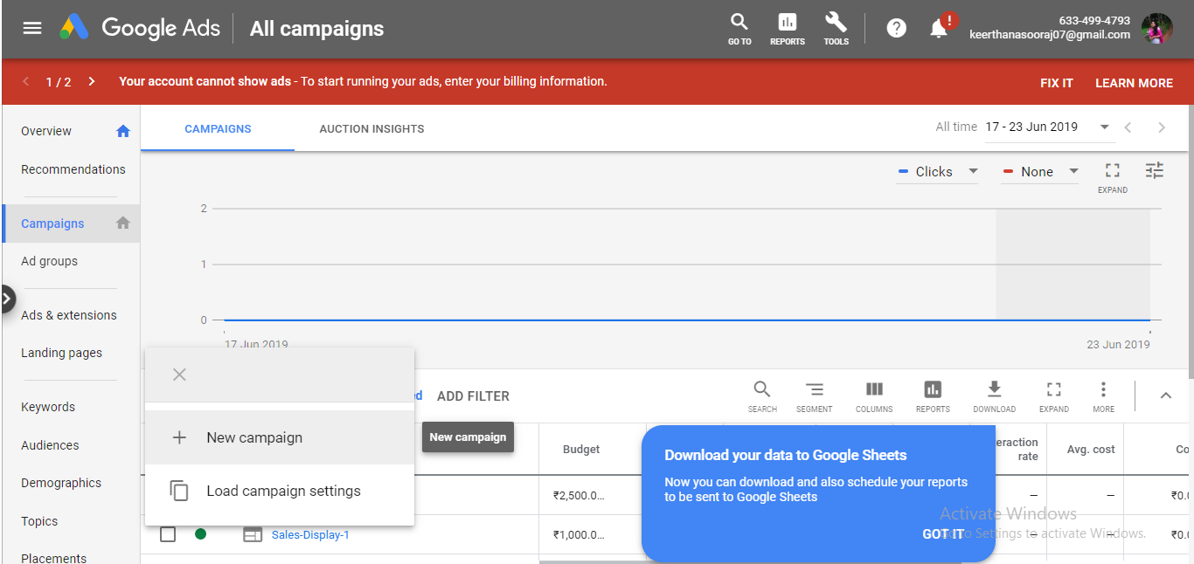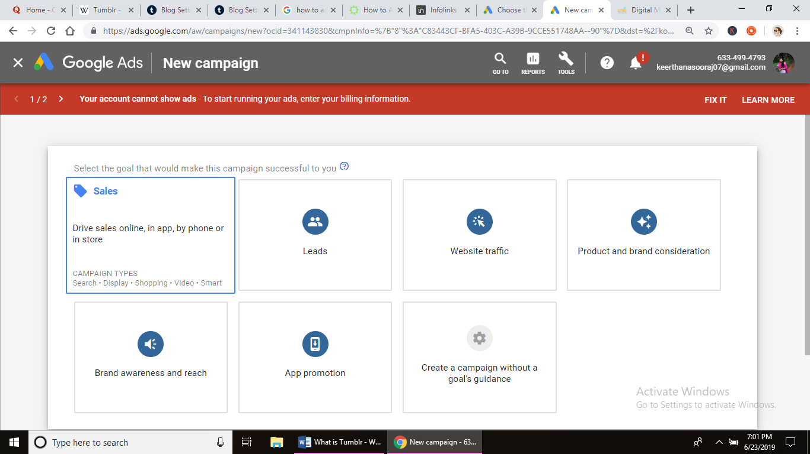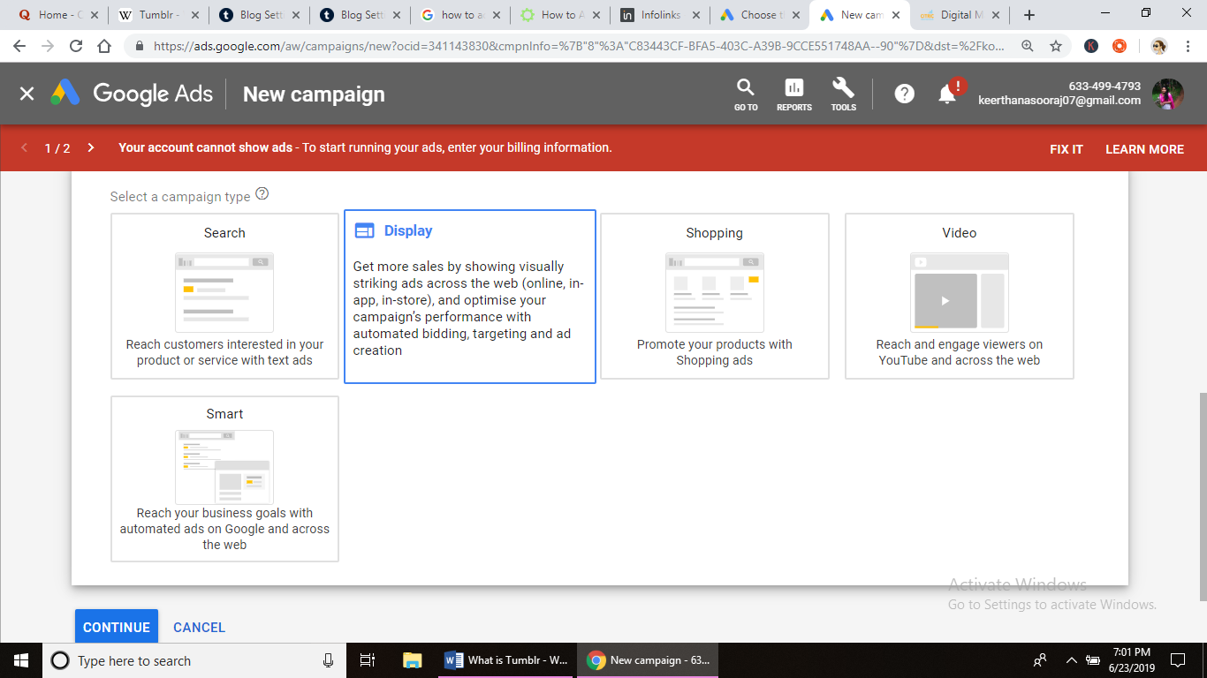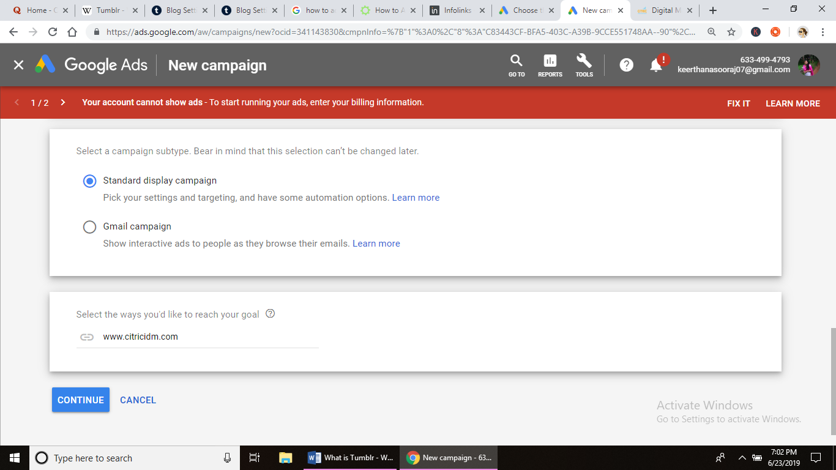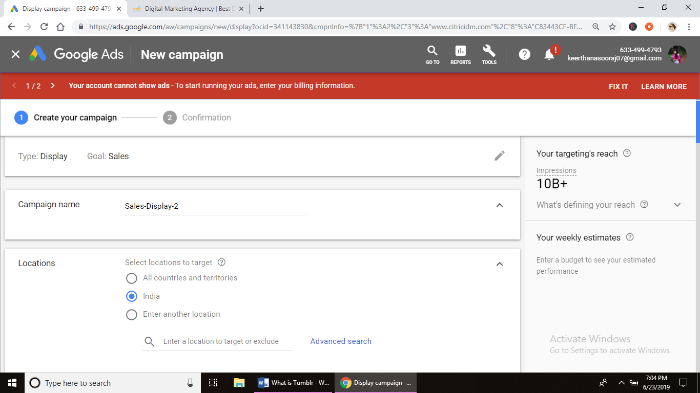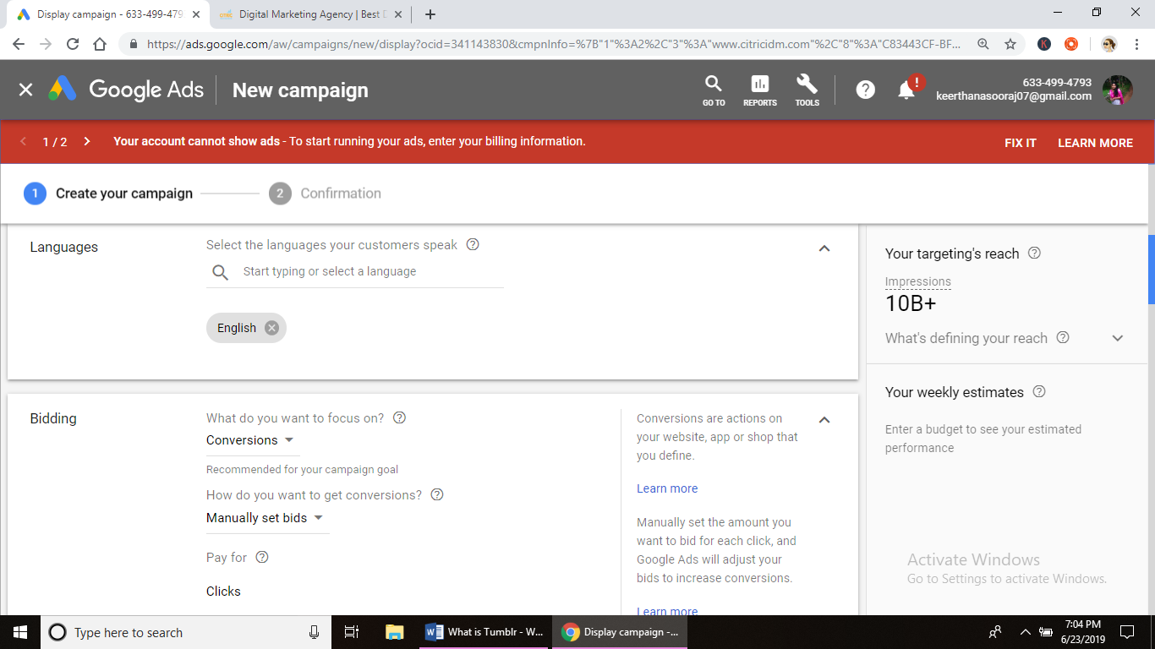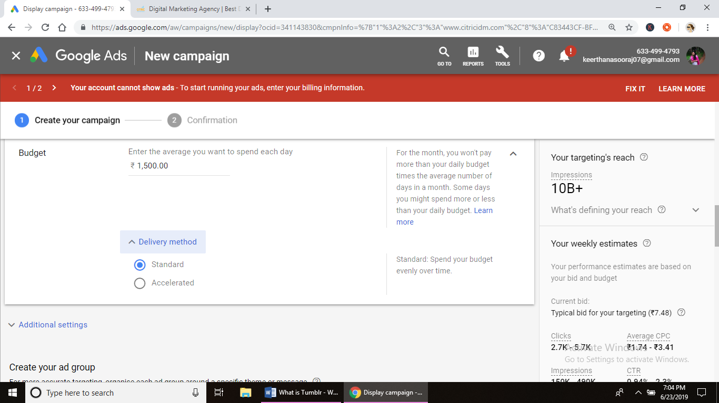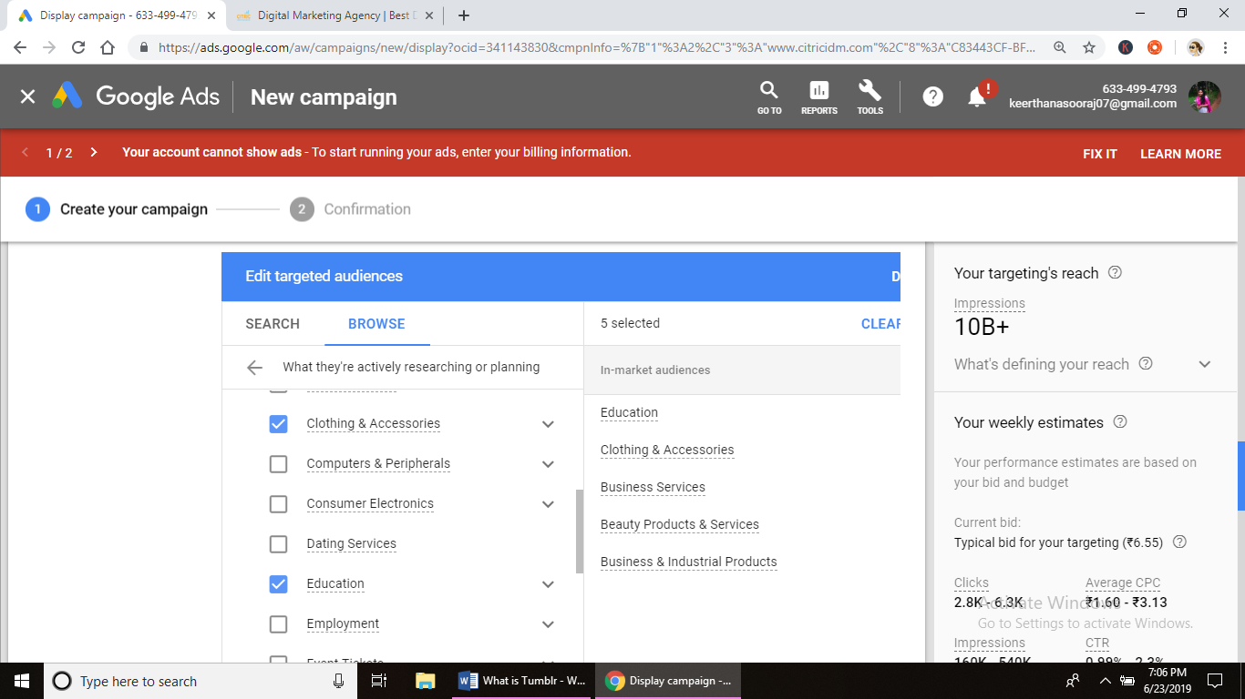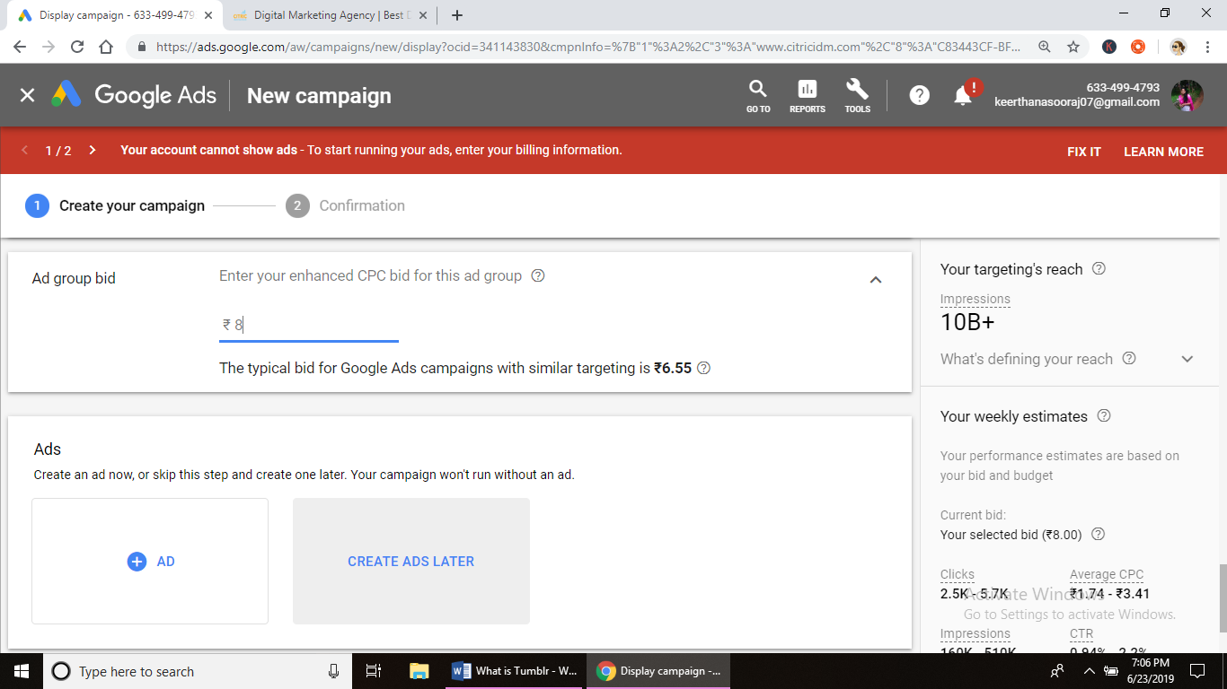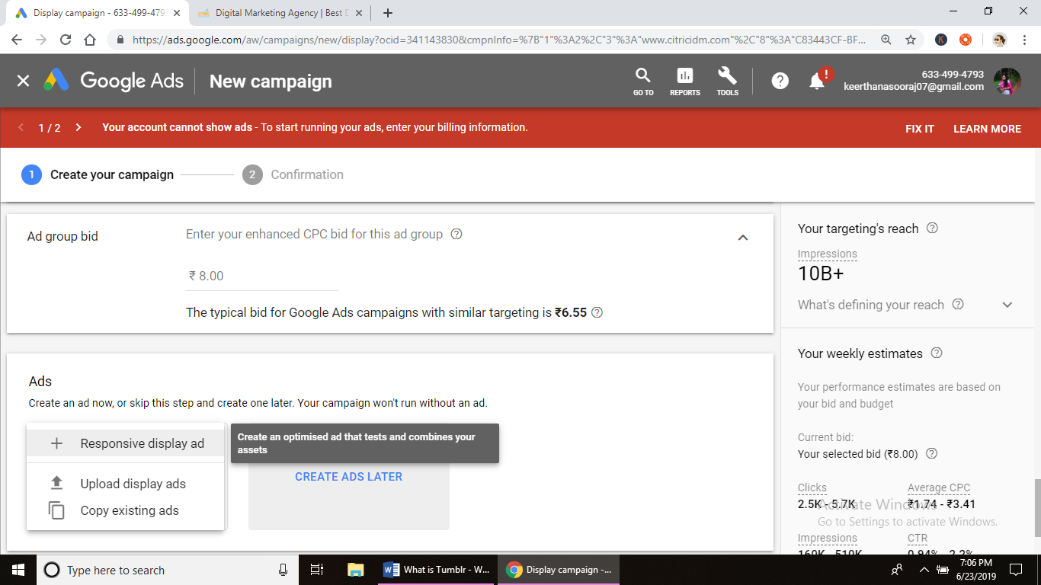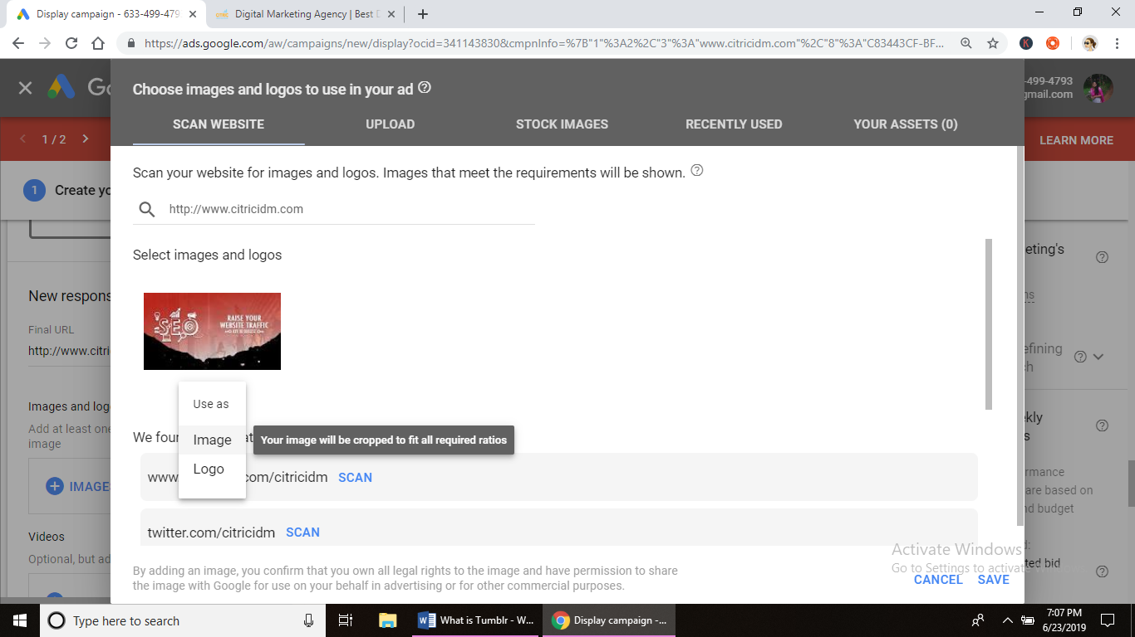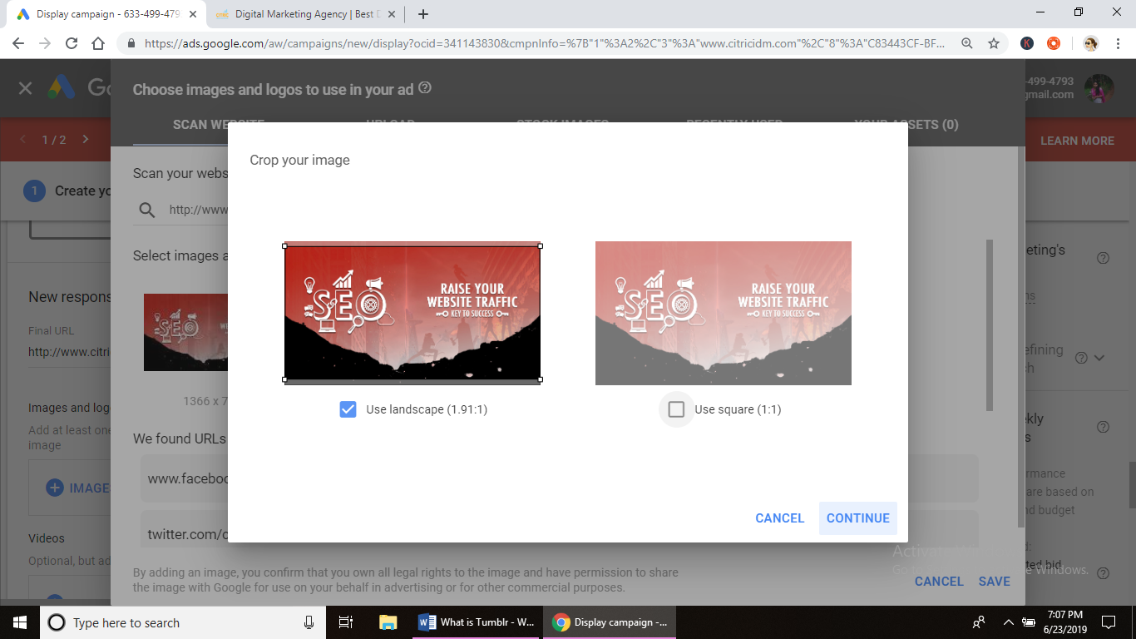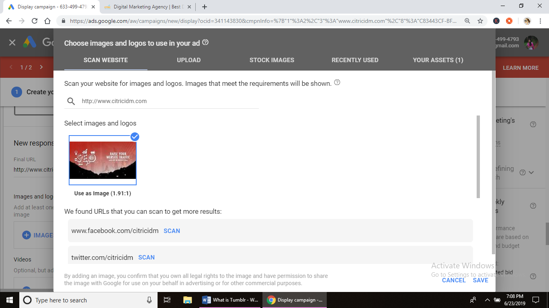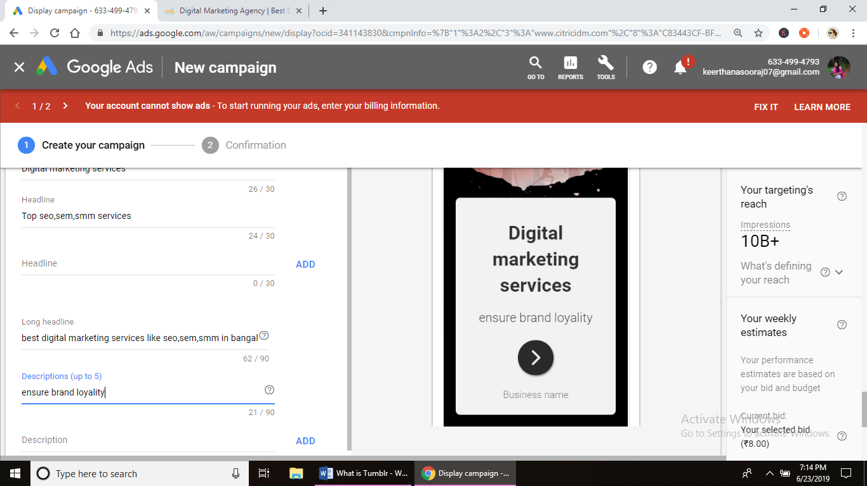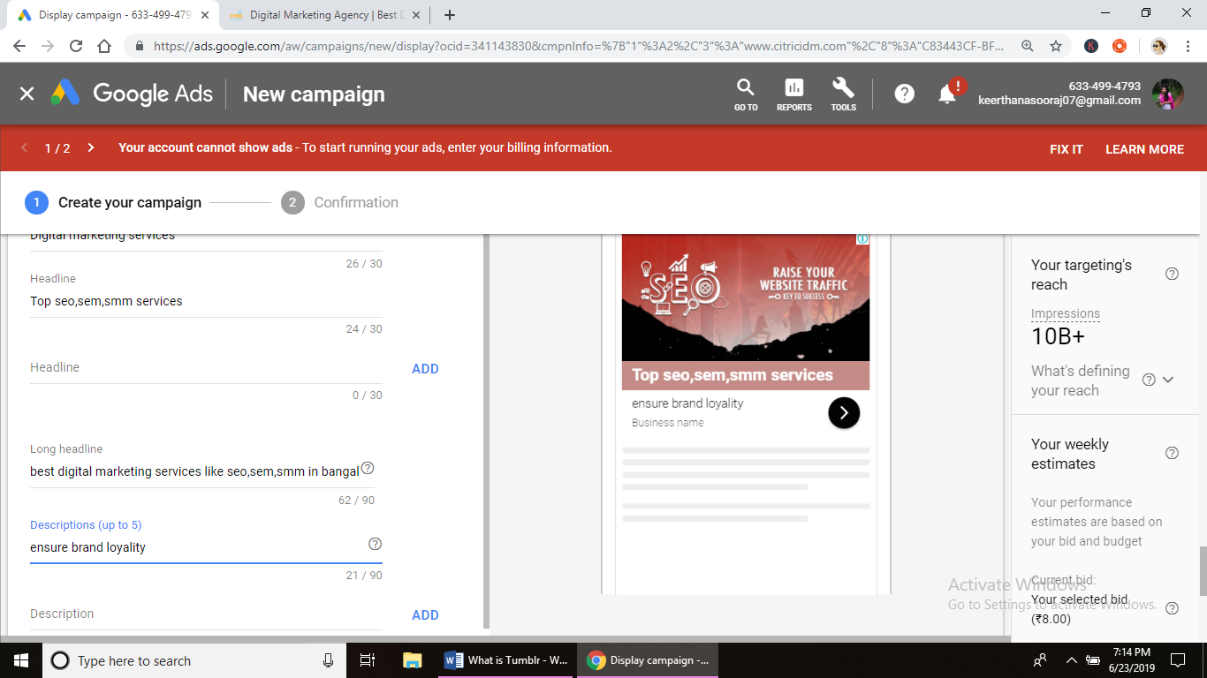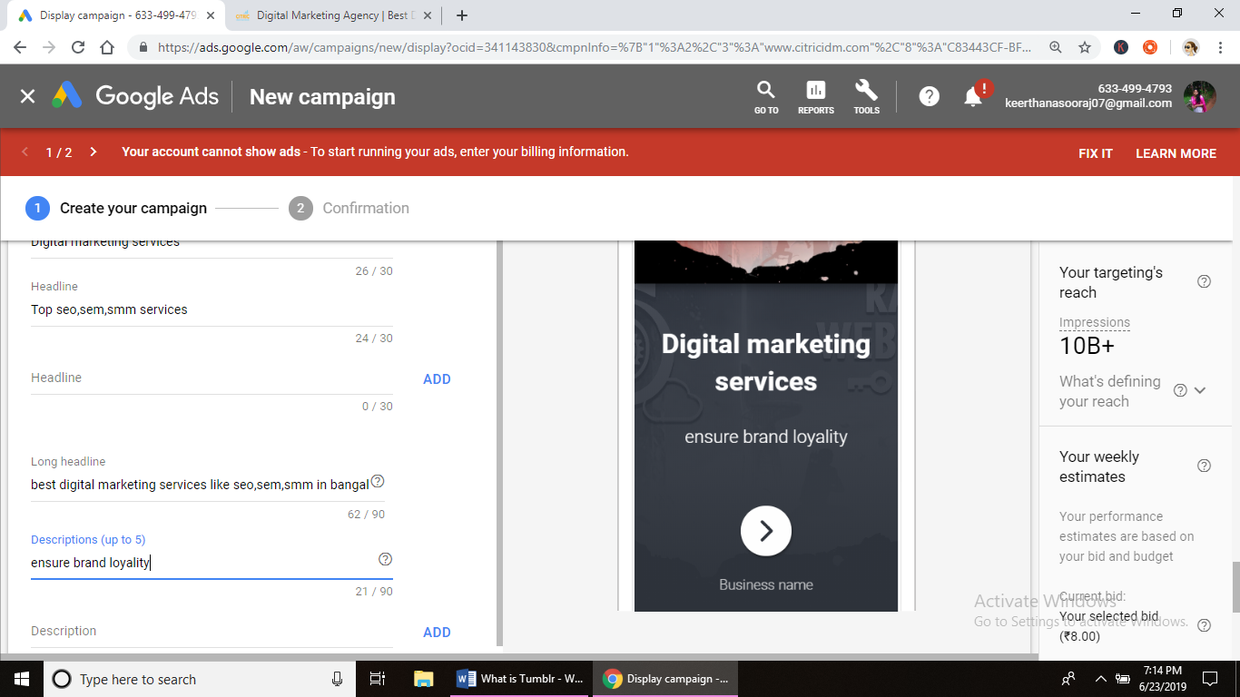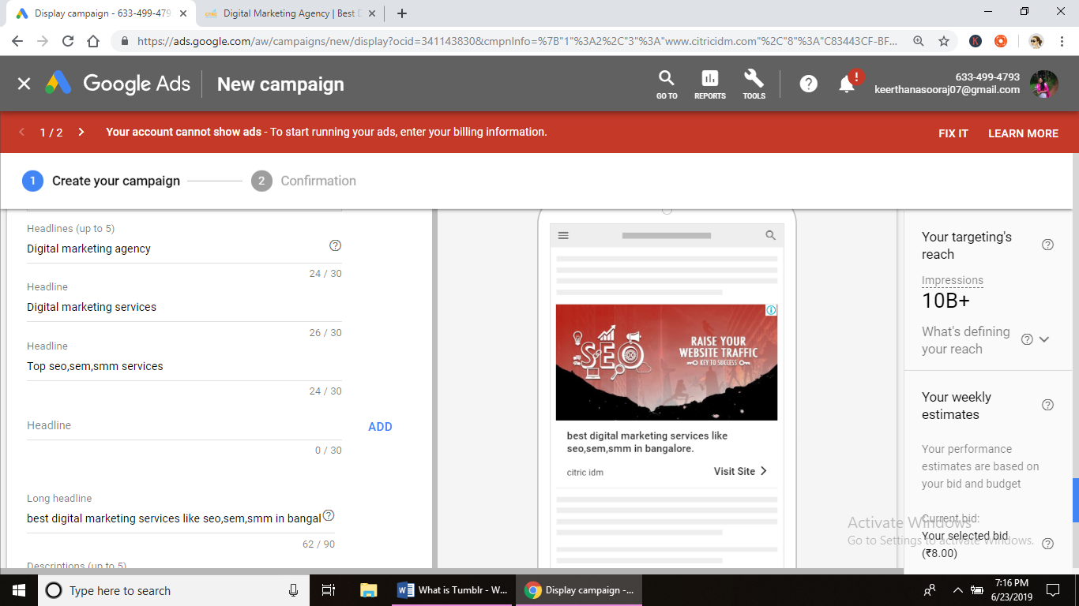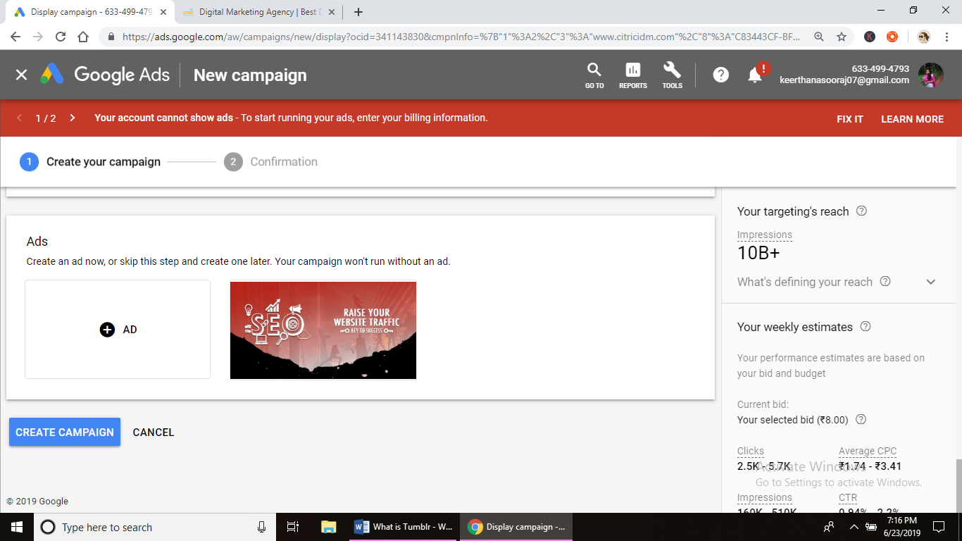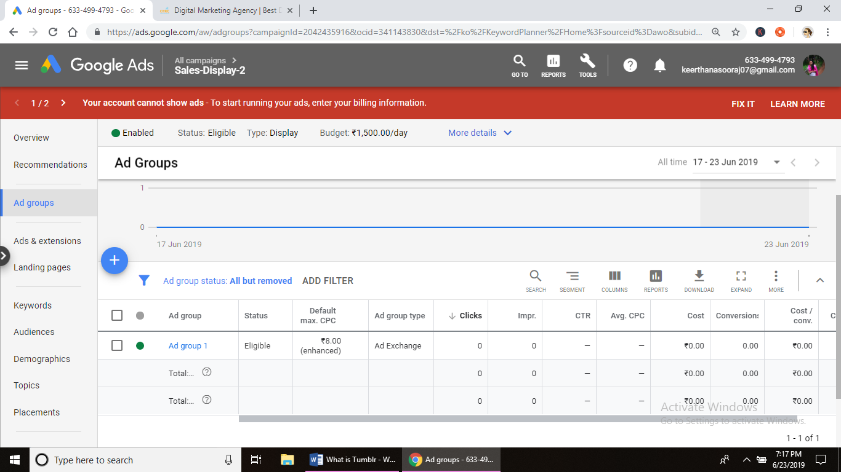

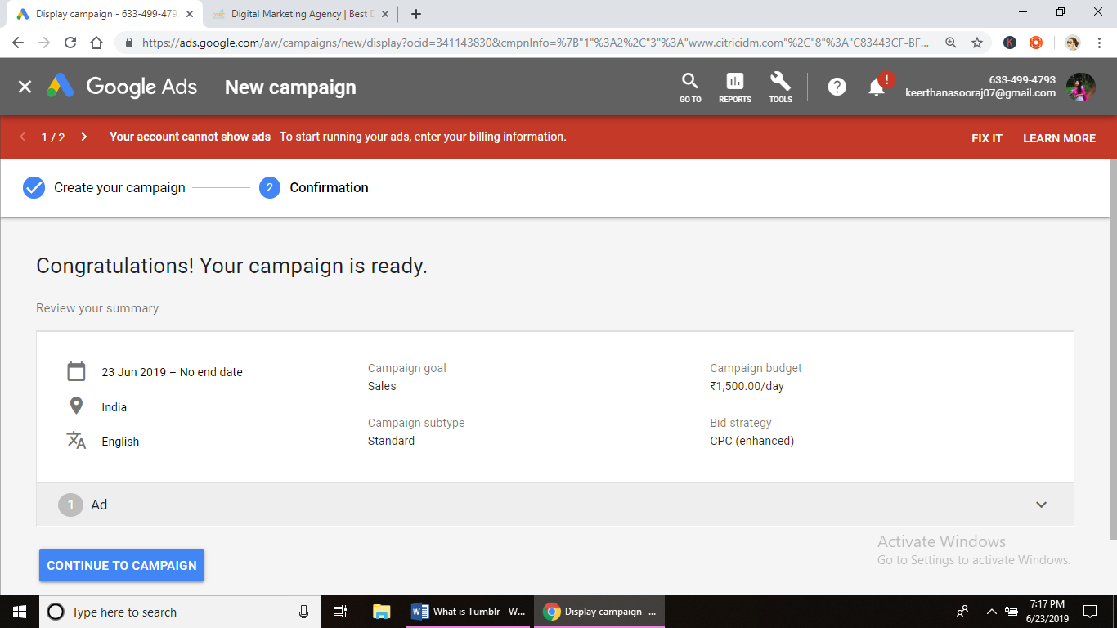

**Assignment – 13 DATE: 11/6/19**

**Assignment Name:**

**Faculty- NIKAHATH**

**Q1. -**

**A1.**

**What is Tumblr?**

Tumblr is a microblogging and social networking website founded by David Karp in 2007 and owned by Media. The service allows users to post multimedia and other content to a short-form [blog](https://en.wikipedia.org/wiki/Blog). Users can follow other users' blogs. Bloggers can also make their blogs private. Many of the website's features are accessed from a "dashboard" interface.

**Features**

**Dashboard:** The dashboard is the primary tool for the typical Tumblr user. It is a live feed of recent posts from blogs that they follow. Through the dashboard, users are able to comment, reblog, and like posts from other blogs that appear on their dashboard. The dashboard allows the user to upload text posts, images, video, quotes, or links to their blog with a click of a button displayed at the top of the dashboard.

**Queue:** Users are able to set up a schedule to delay posts that they make. They can spread their posts over several hours or even days

**Tags:** Users can help their audience find posts about certain topics by adding tags.

**HTML editing:** Tumblr allows users to edit their blog's theme HTML coding to control the appearance of their blog.

**Mobile Apps:** Other than website app for Android, IOS, and Windows Phone is also available.

**Inbox and messaging** : On November 10, 2015, Tumblr introduced an integrated instant messaging function, allowing users to chat between other Tumblr users. The ability to send posts to others via the Dashboard was added the following month.

**How to add ads to tumblr post.**

1. Create an Account on an Advertising Platform

Visit the home page of [Google AdSense](https://www.google.com/adsense), [Bing Ads](https://bingads.microsoft.com/) or [Infolinks](http://www.infolinks.com/) -- three of the largest online advertising platforms -- and complete the account creation process. Wait for the platform to approve your account.

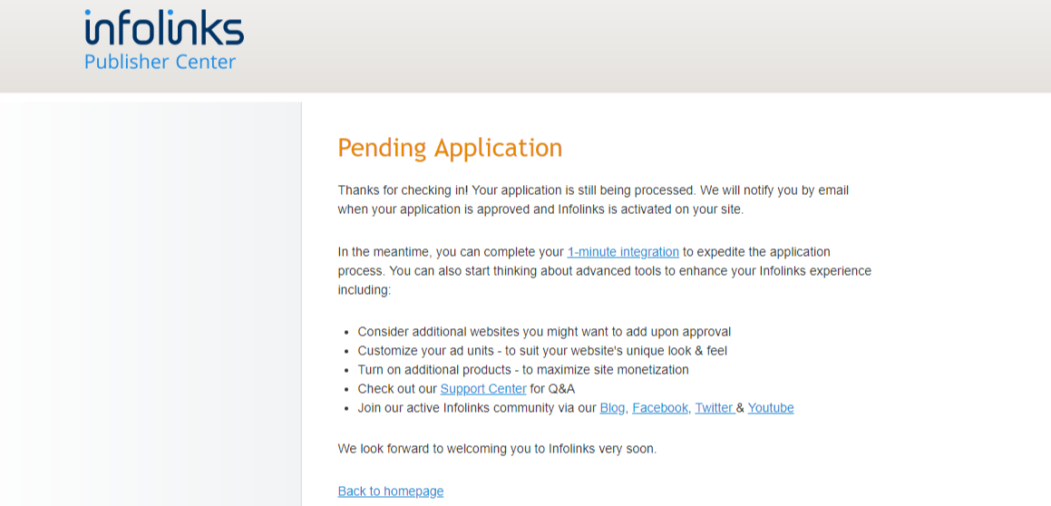

1. Copy the HTML code supplied by the platform into your Windows clipboard.

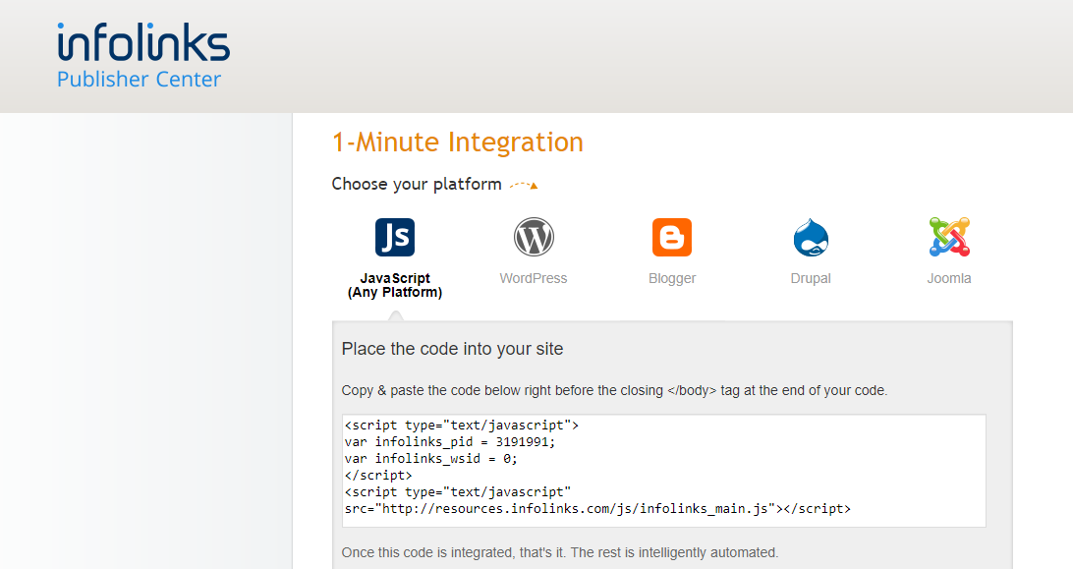

1. Paste the Code Snippet in Your Blog's HTML Code.
2. Select **Edit Appearance** from the **Account** menu on your [Tumblr dashboard](https://www.tumblr.com/dashboard).

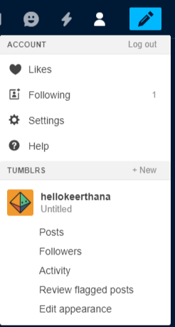

1. Click the **Edit Theme** button.

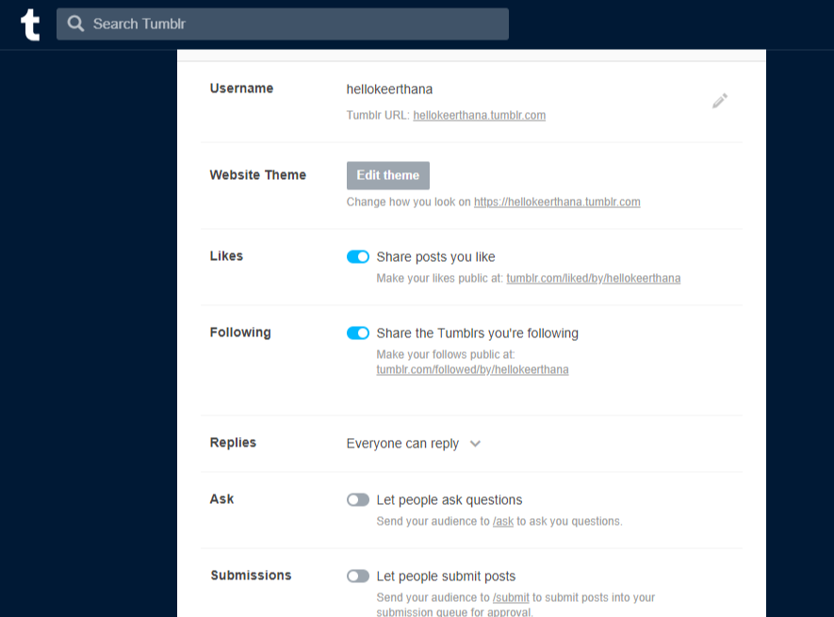

Click the **Edit HTML** link to reveal your blog's source code.

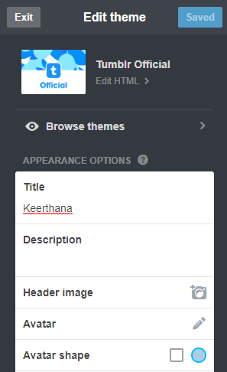

1. Paste the HTML code snippet supplied by the ad platform into your blog's source code at the place where you want the ad to appear. Click the **Update Preview** button and use the preview pane to check whether your ad displays correctly.

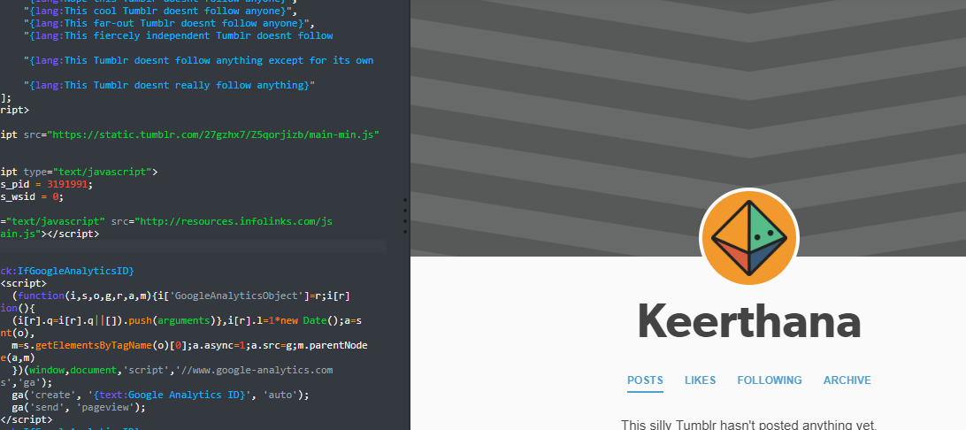

1. Click the **Save** button to save and publish your changes.

**Assignment – 14 DATE: 26/6/19**

**Assignment Name: types of video ad**

**Faculty- NIKAHATH**

**Q1. -**

**A1.**

1. **BUMBER (SKIP) – SKIPABLE ADS**

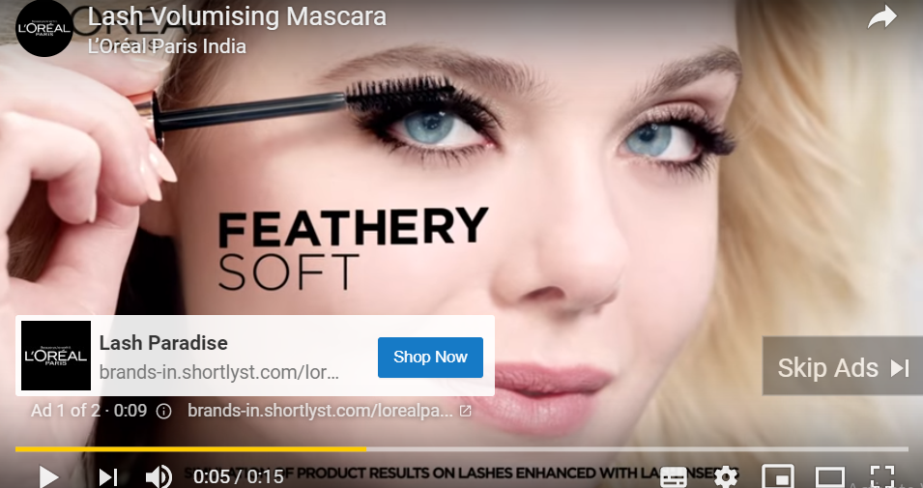

A **bumper ad** is a six-second video format ideal for driving brand reach and frequency. They are available through Google **Ads**1 as an add-on to traditional campaigns and sold on a CPM basis. **Bumper ads** can both extend the reach of an existing campaign and complement broader messaging.

1. **ROLLOVER ADS**

**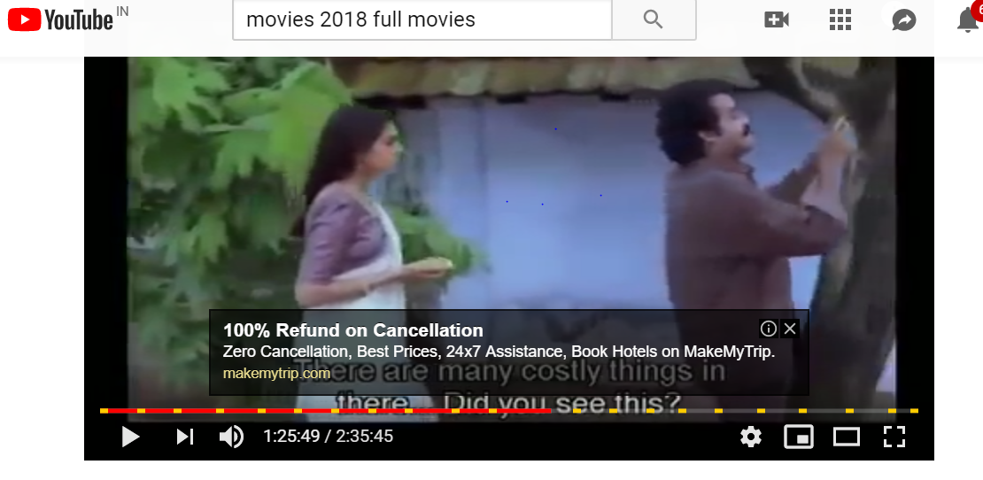**

A **rollover ad** (sometimes called a mouse-over **ad**) is an online **advertisement** that appears to be a static image until the cursor touches the image and activates it. Movement of the cursor over the image is known as a **rollover**. In the case of a**rollover ad**, activation usually causes an expansion of the **ad**.

1. **IN DISPLAY ADS**

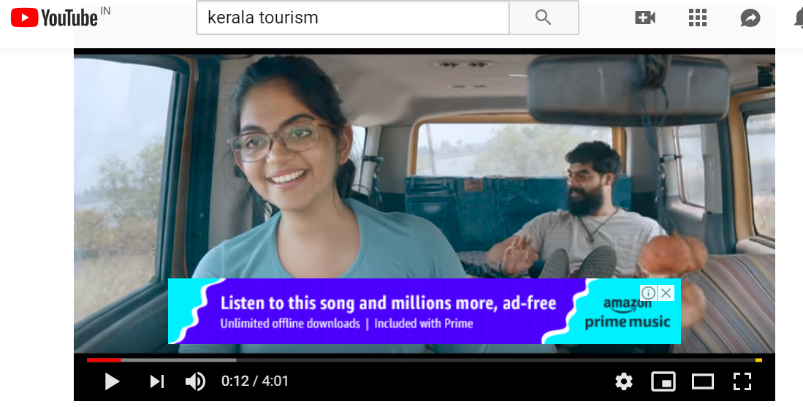

* Appear inside YouTube with small text

1. **MASTER HEAD**

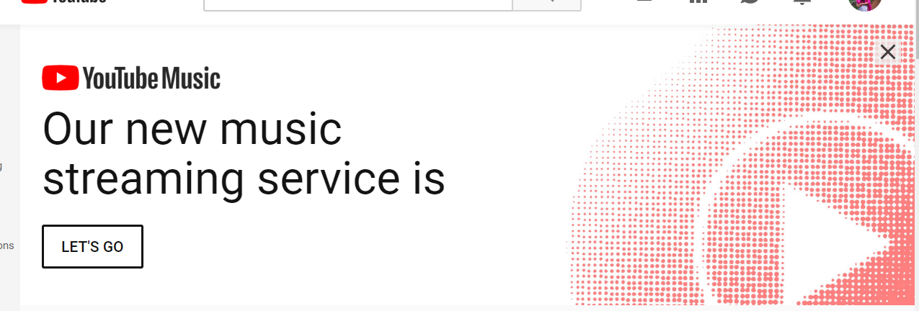

The **YouTube Masthead** is living proof that marketers are still taking advantage of outbound marketing tactics. A **YouTube Masthead** is a digital billboard placed on**YouTube's** homepage for 24 hours, reaching roughly 60 million people (**YouTube**receives 1.8 billion users/month).

1. **In search / true view**

**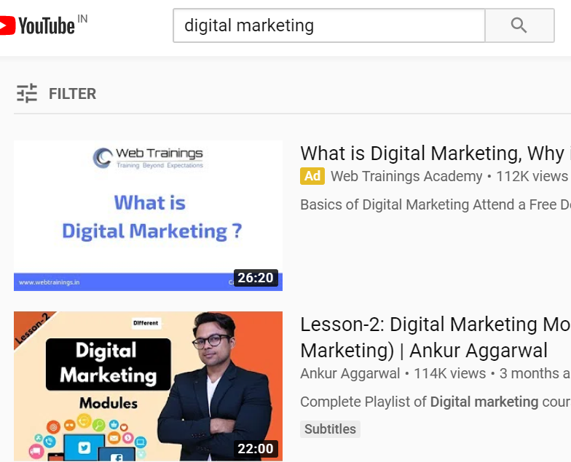**

**TrueView** is a YouTube video **ad** format that gives the viewer options, the most common of which is the ability to skip the advertisement after five seconds. ... Sponsors pay only for **ads** that are viewed in their entirety or until 30 seconds have elapsed. In-stream **ads** are suitable for short or long video content.

**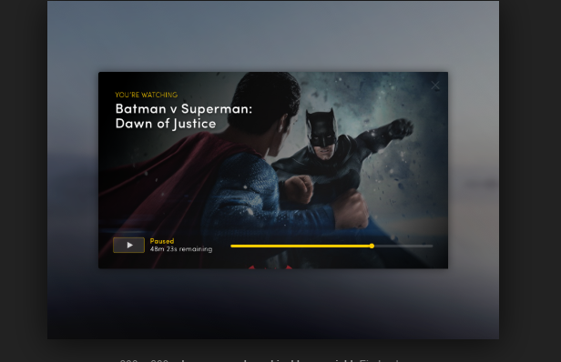**

1. **Non skip able ad**

The **non**-**skippable** video **ad** is an **ad** format that may appear pre-, mid-, or post-roll while viewing partner content. ... Viewers must watch the **ad** before they're able to watch the selected video. A smaller, 300 x 60-pixel **ad** may also be shown next to YouTube videos that show **non**-**skippable** video **ads** on desktop.

ASSIGNMENT 15

: Create app promotion on google search

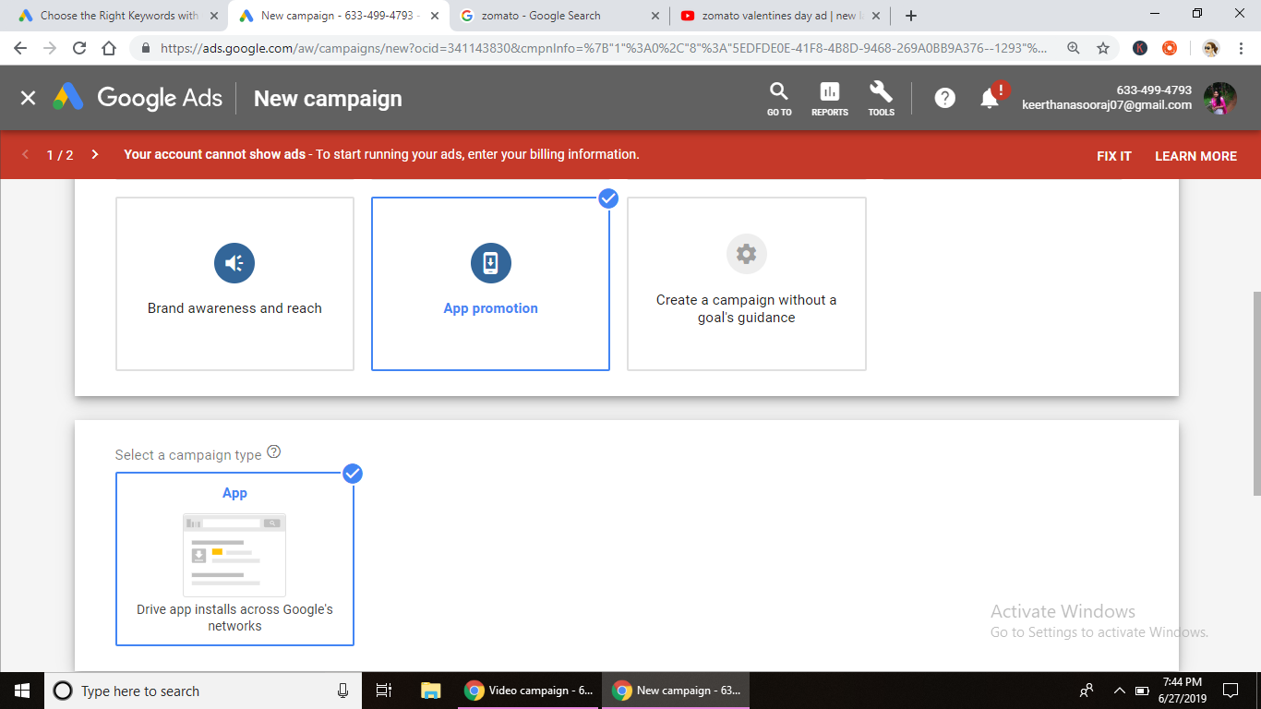

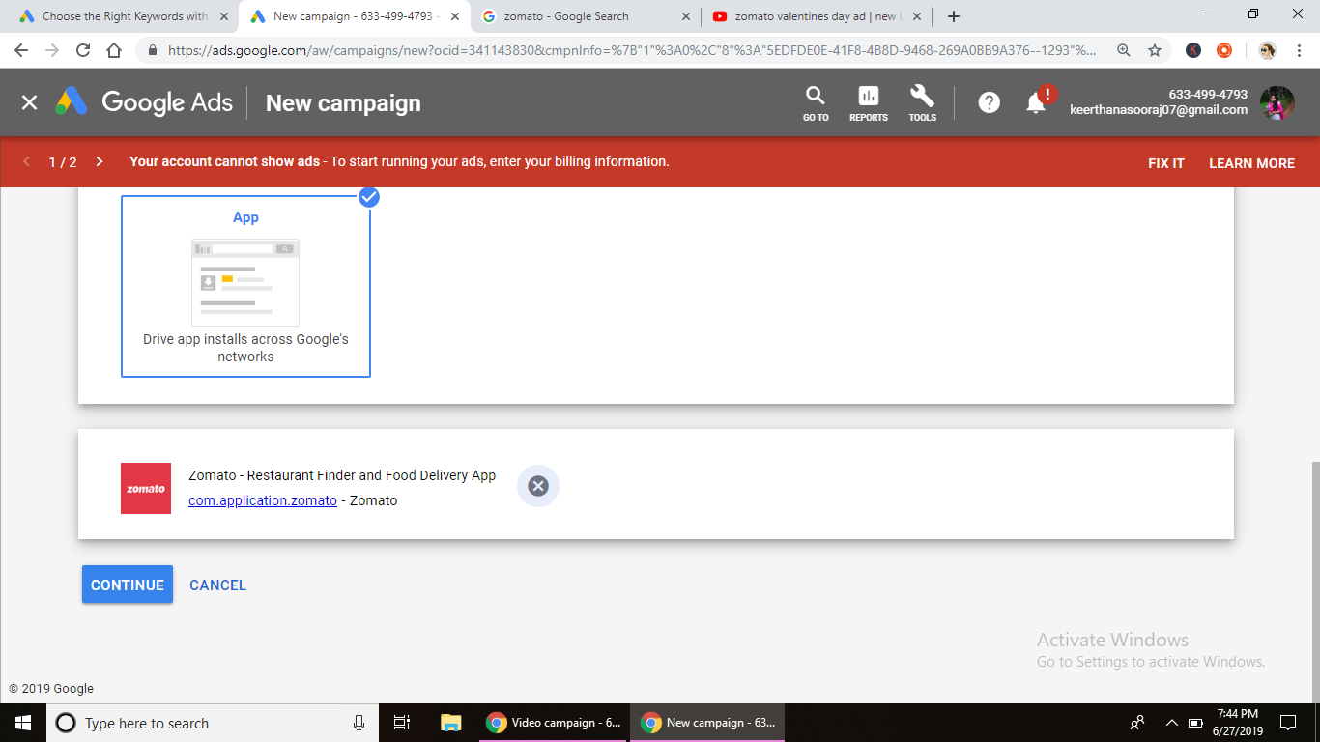

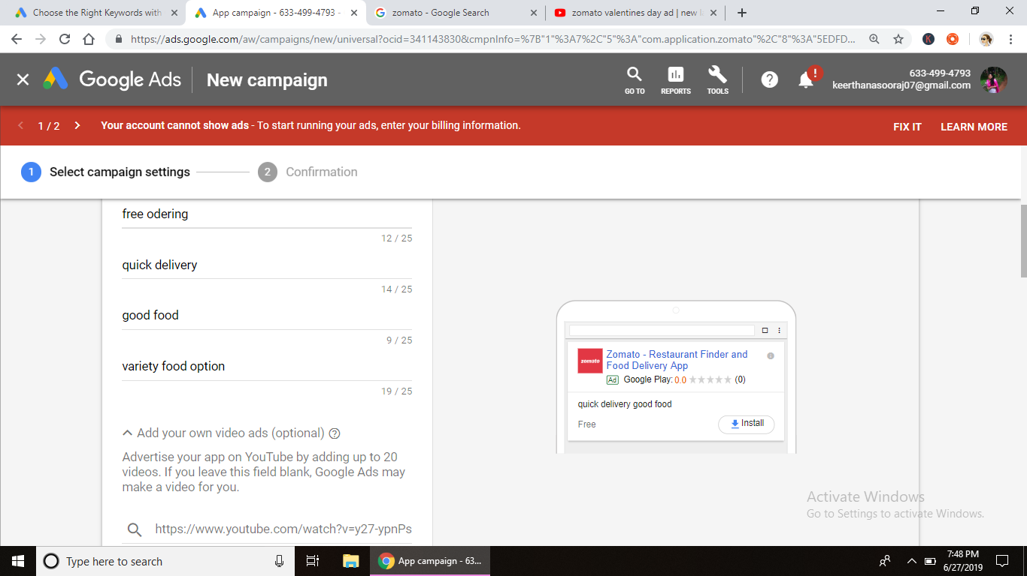

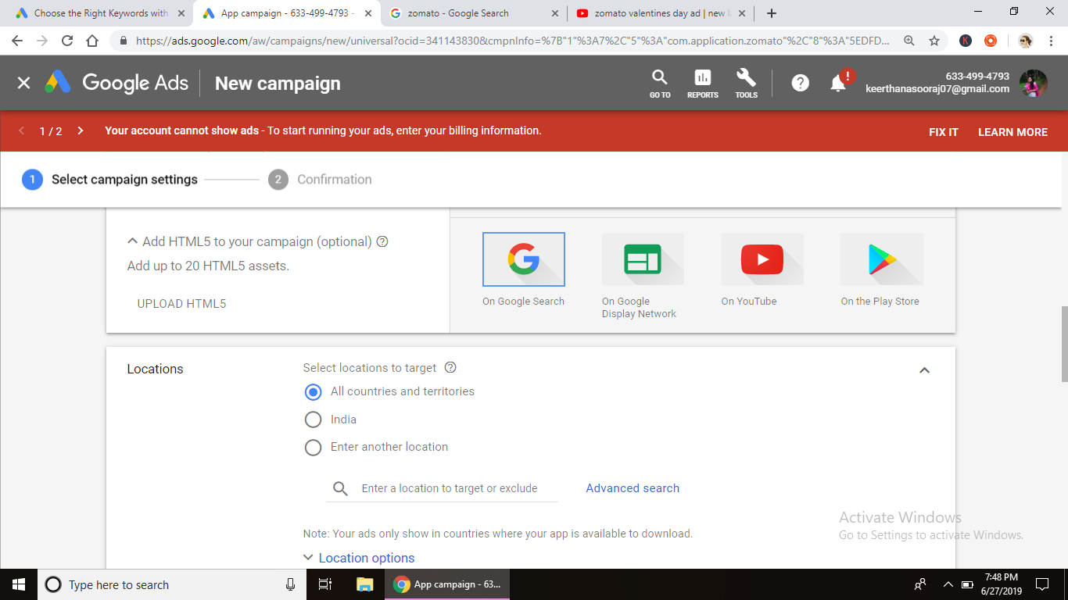

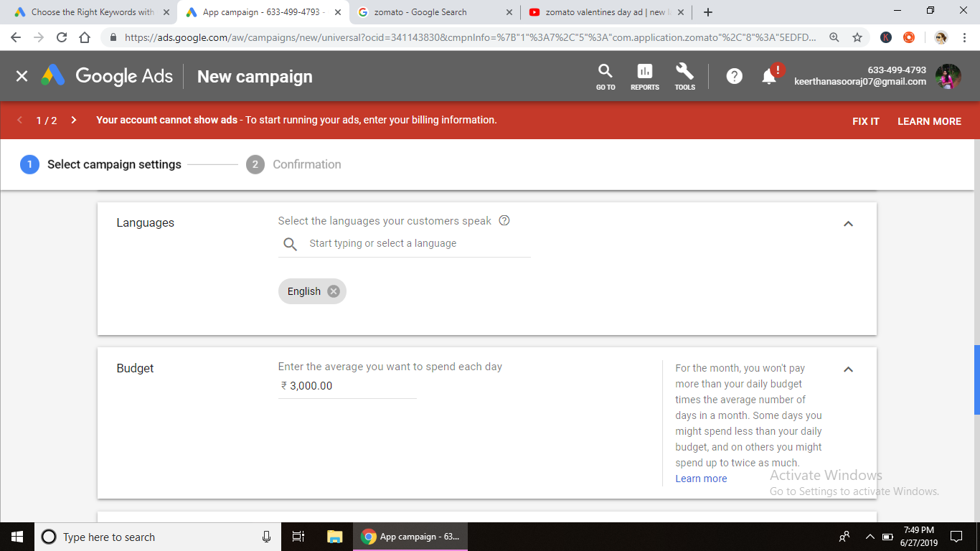

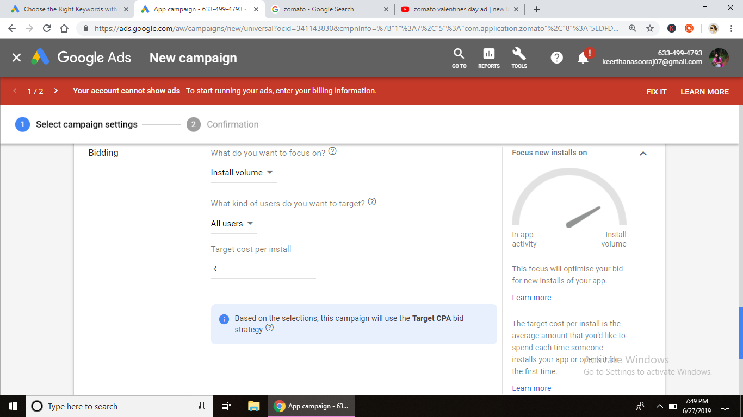

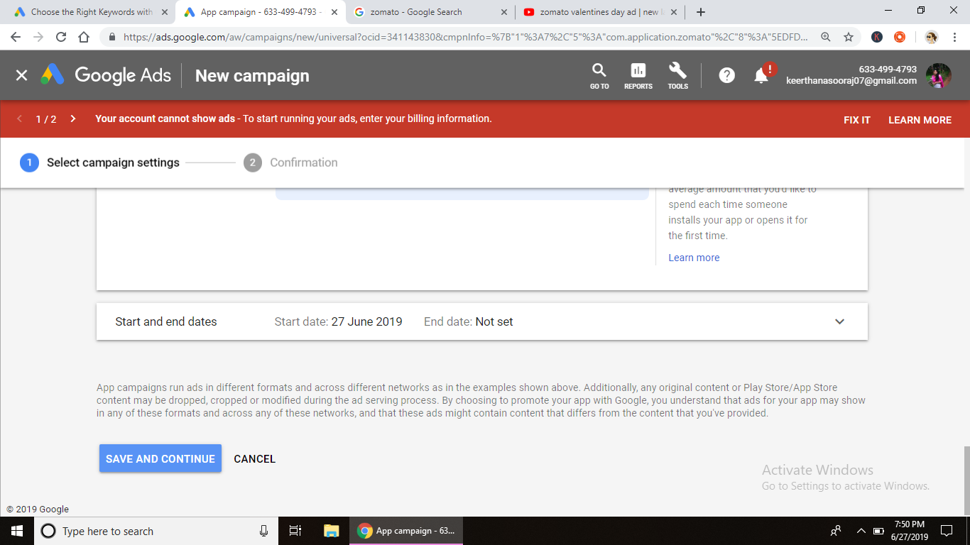

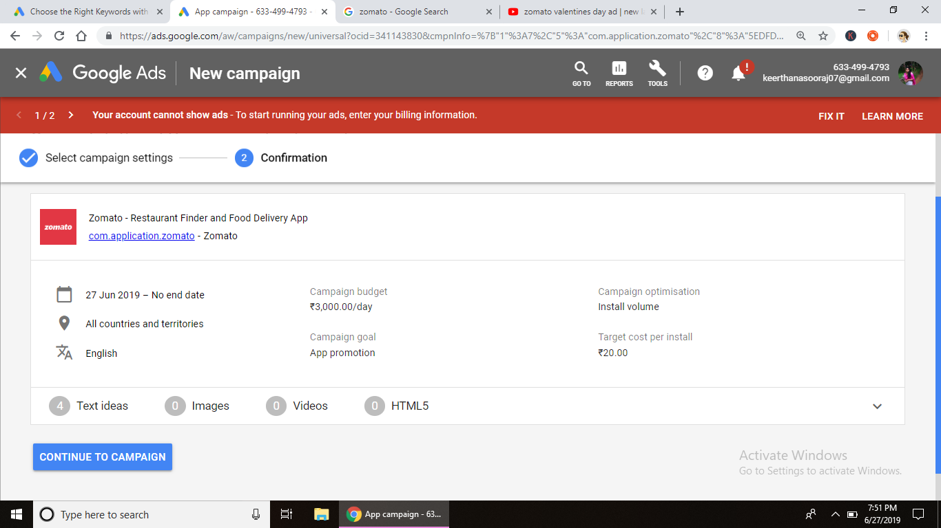

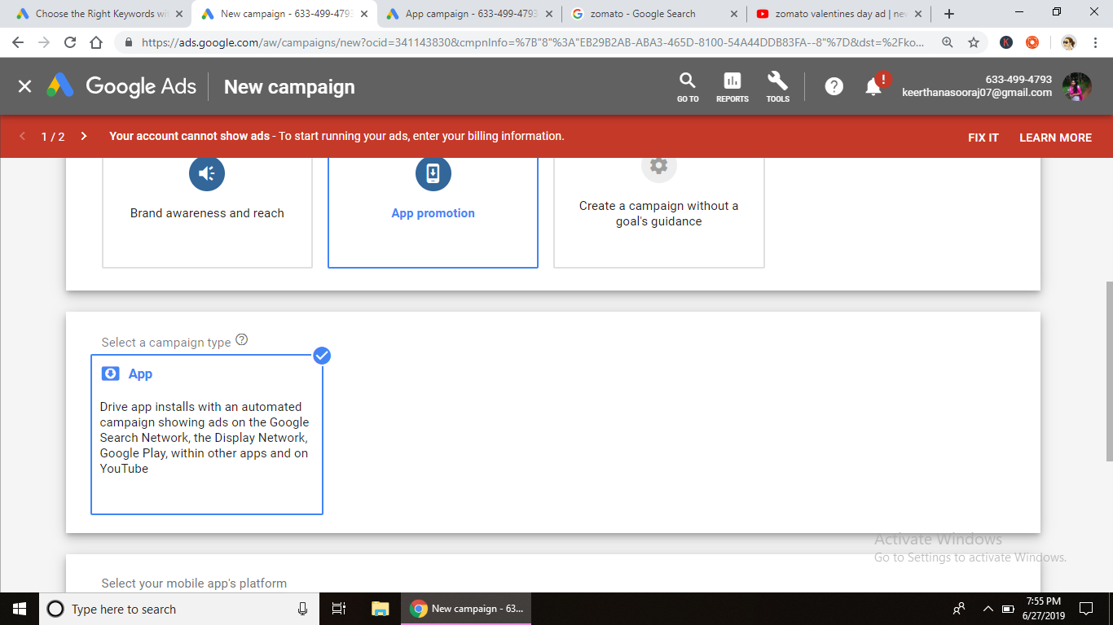

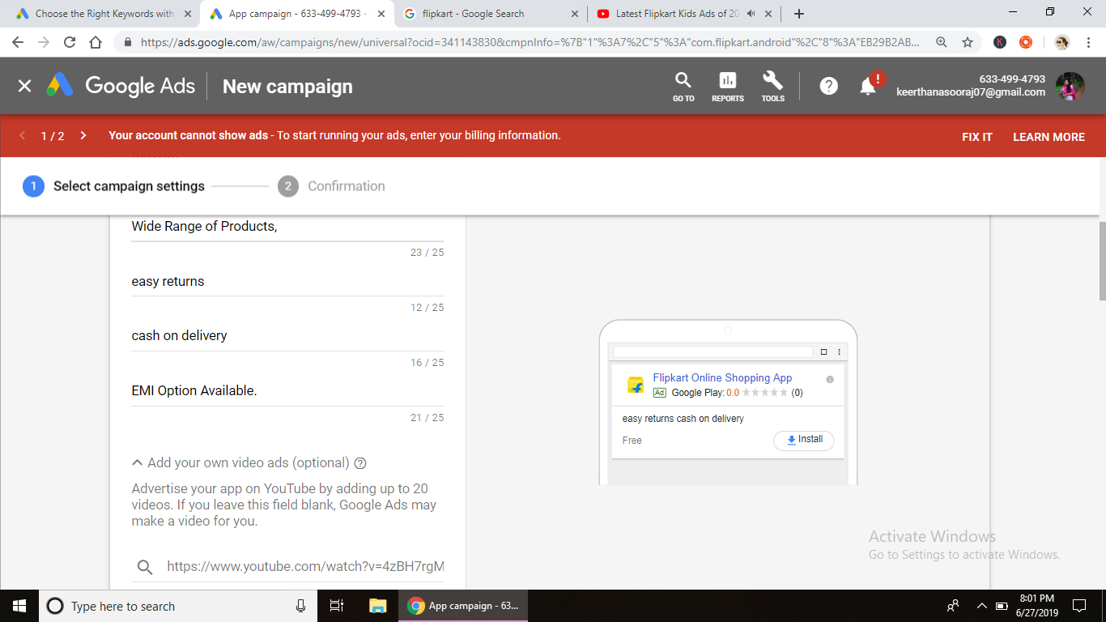

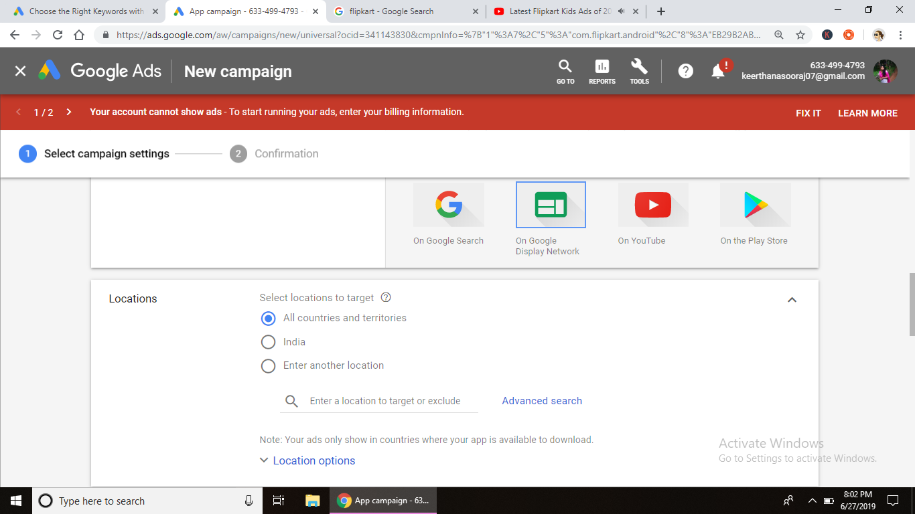

ASSIGNMENT 16

Create app promotion on Google display network

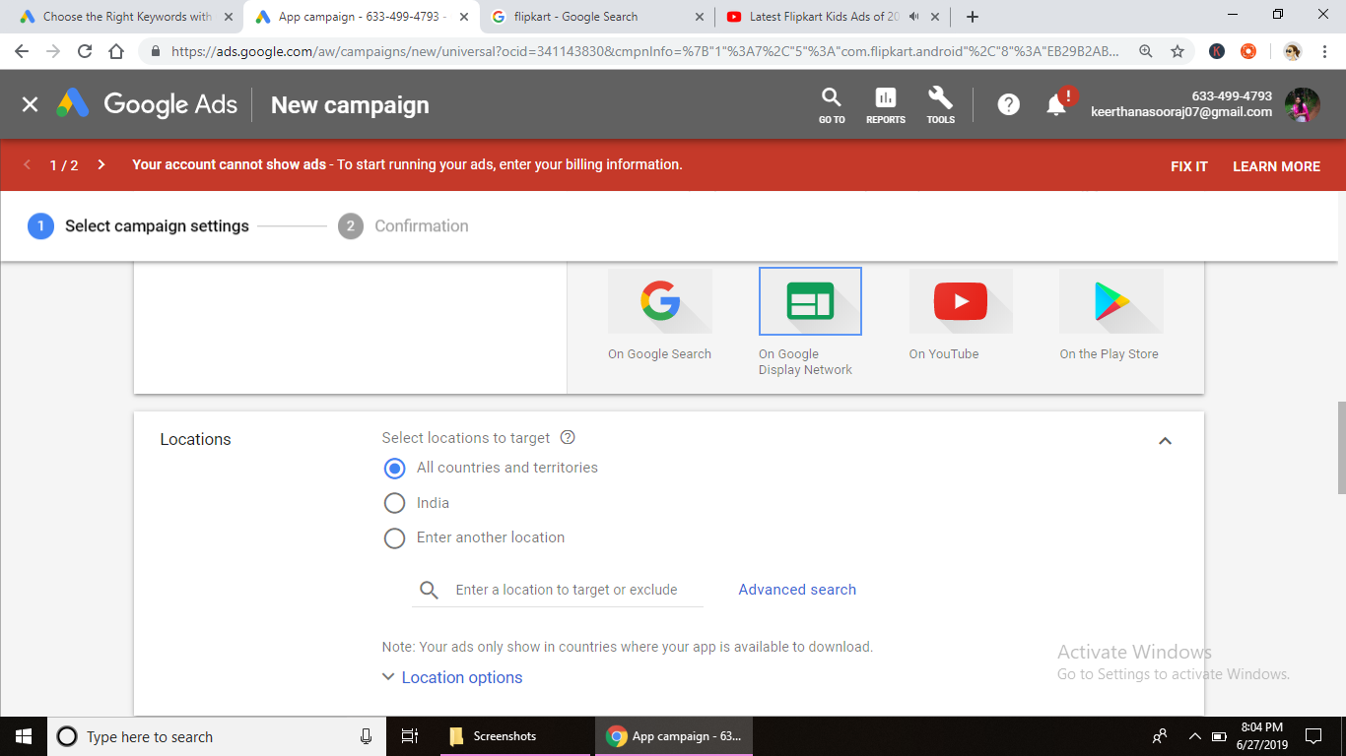

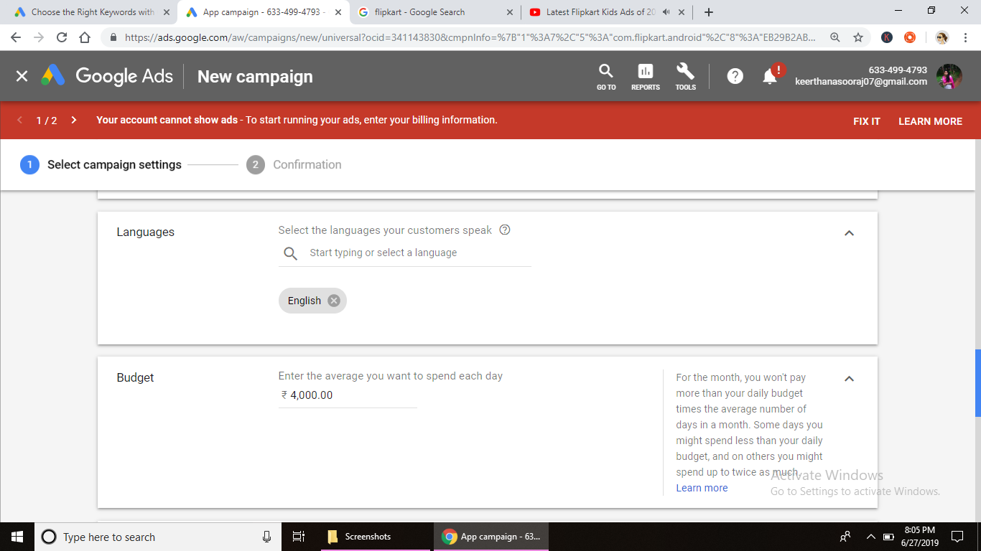

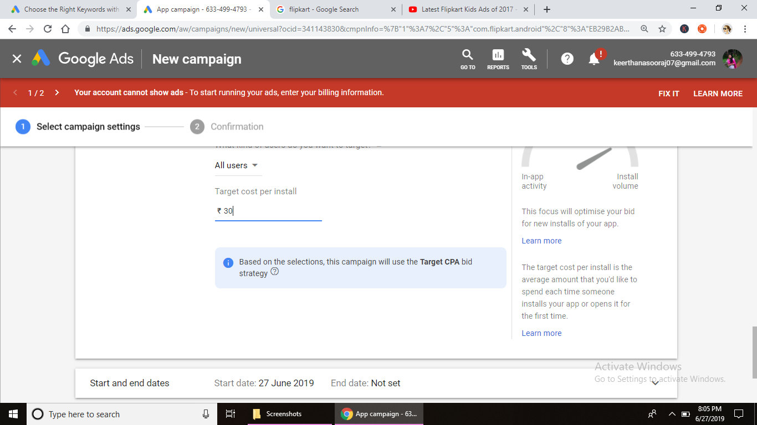

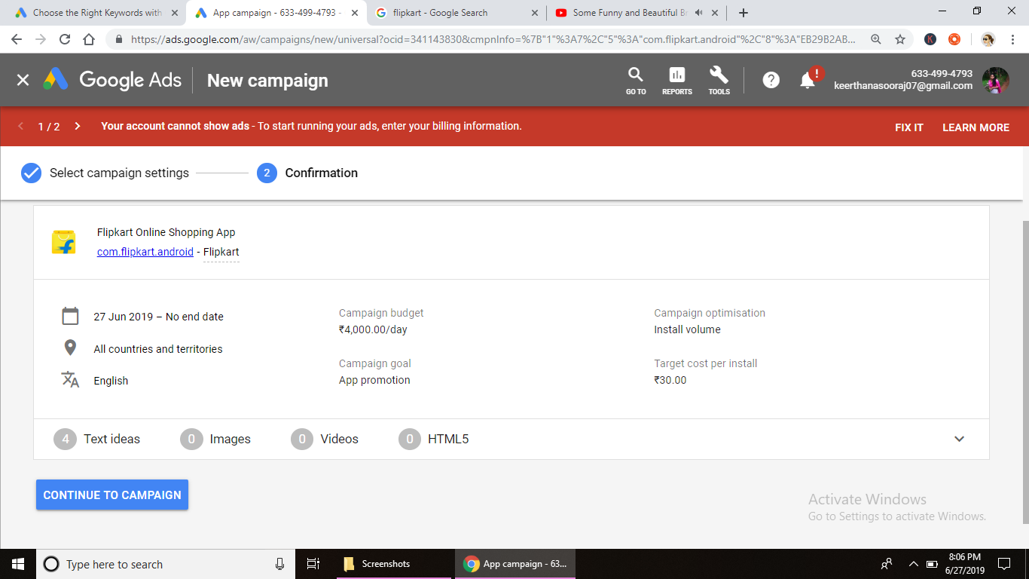

ASSIGNMENT 17

Create app promotion on

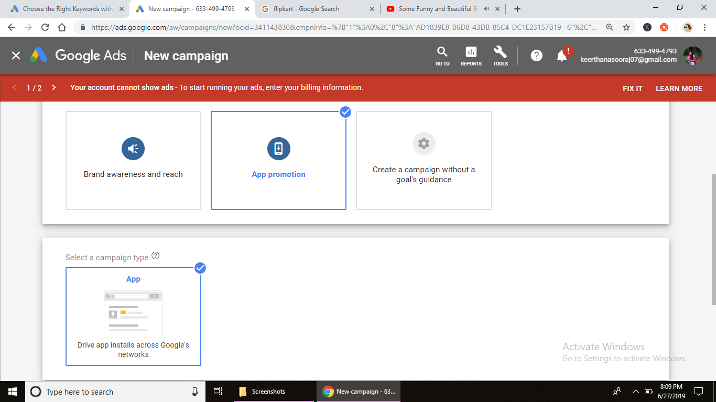

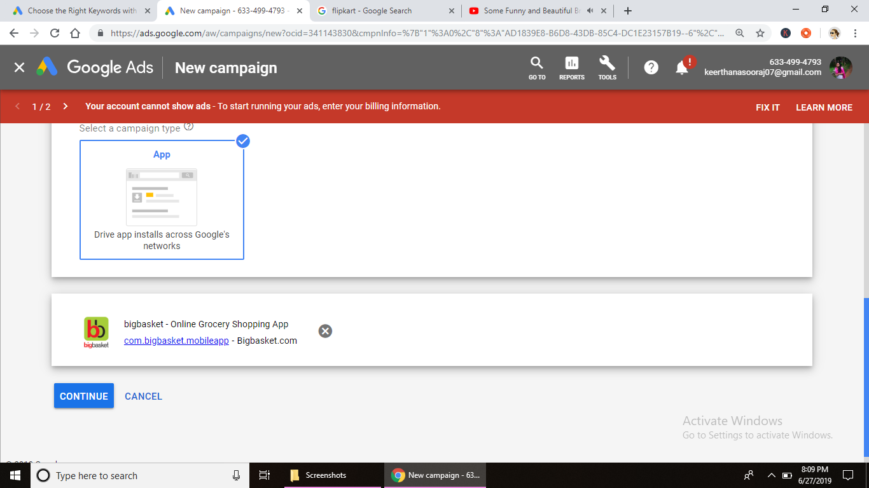

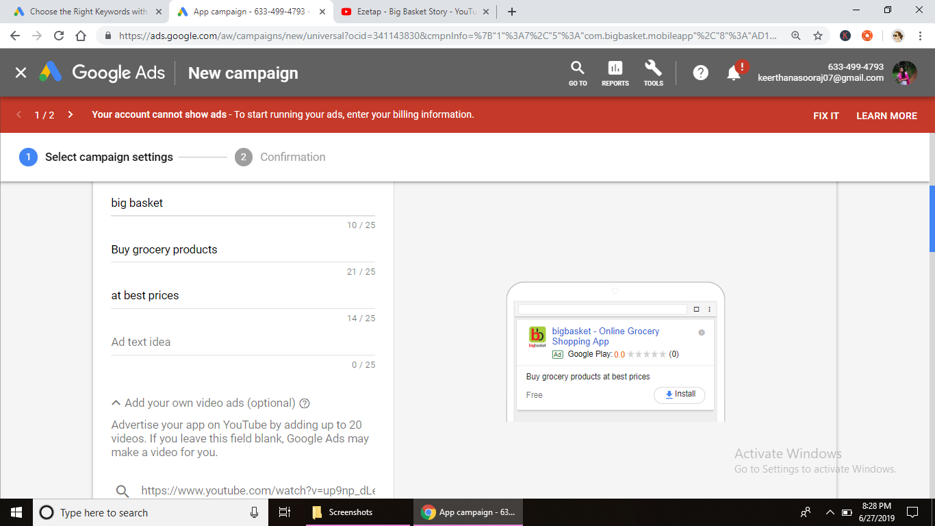

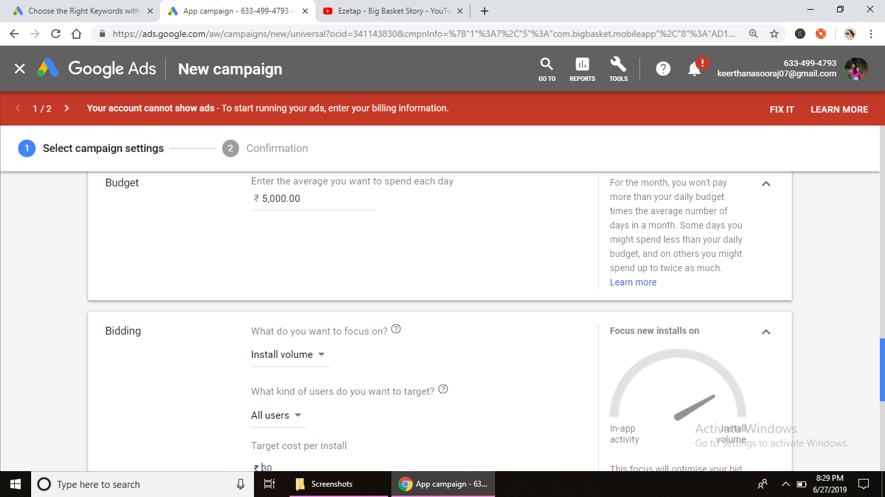

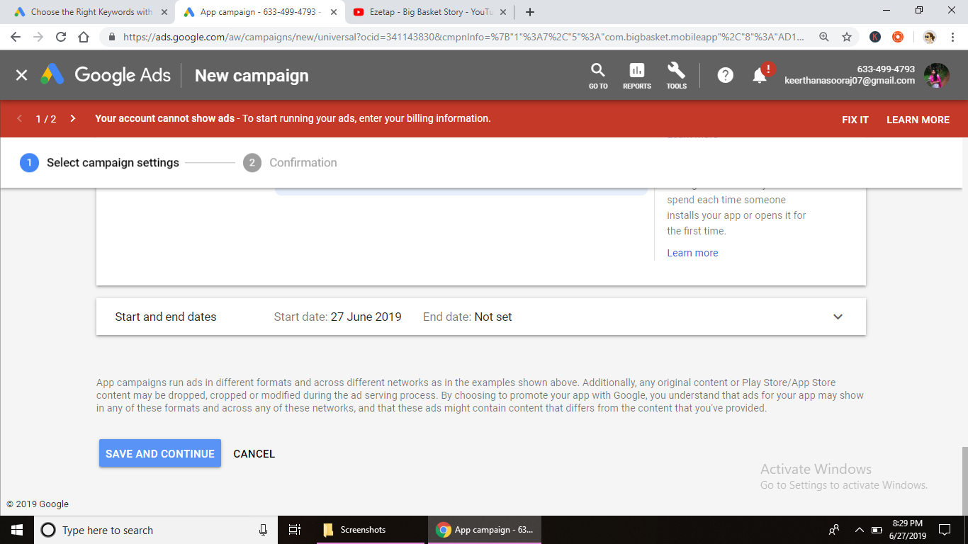

**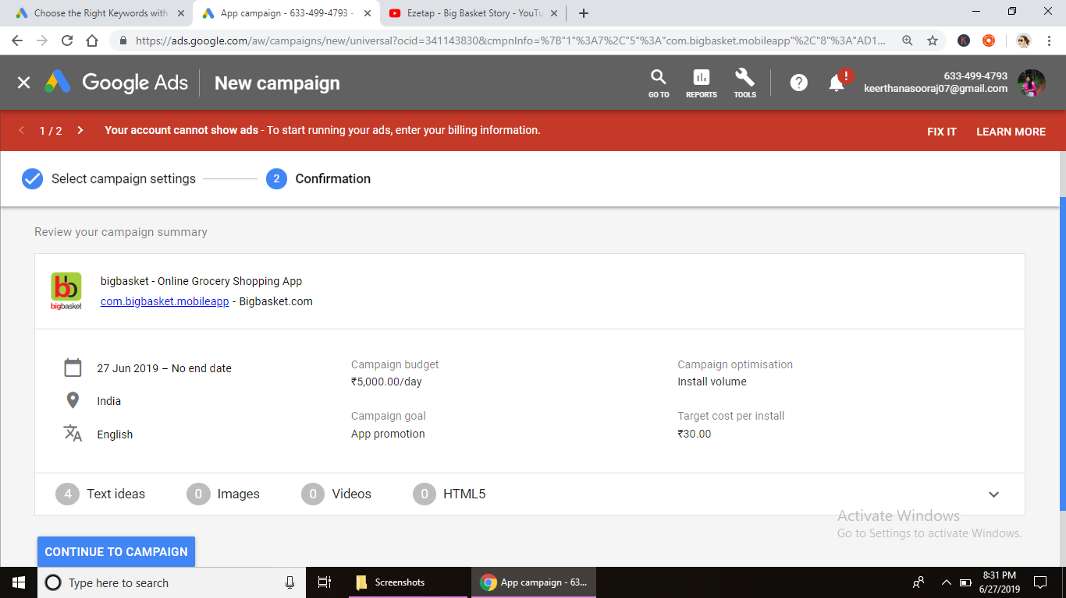**

**Assignment 18**

**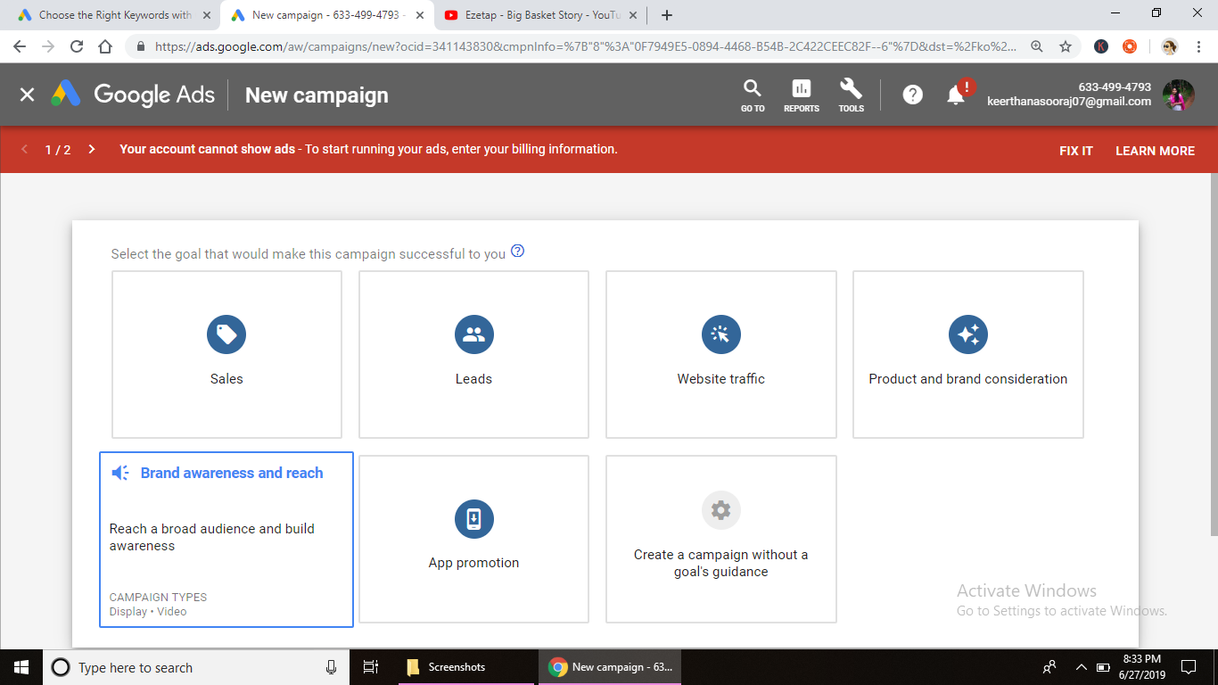**

**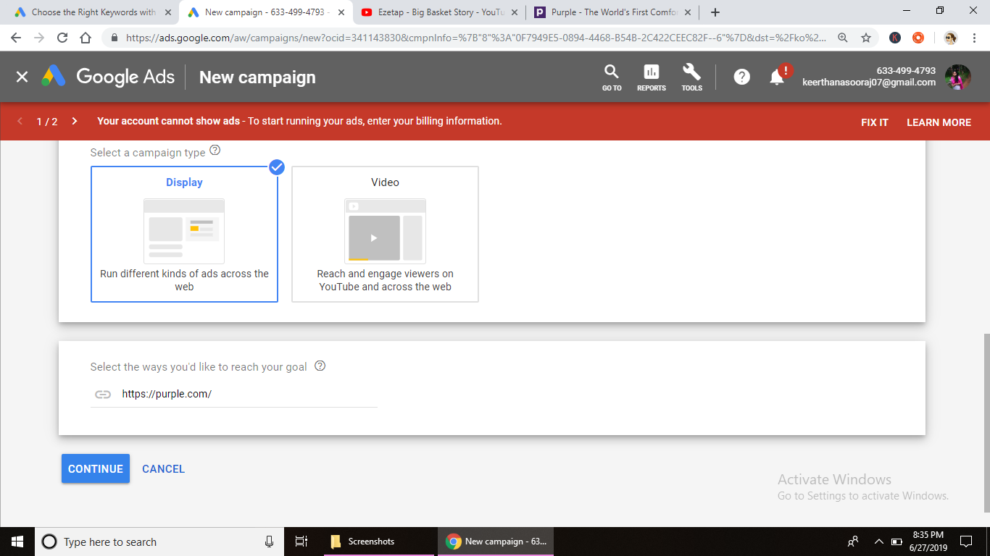**

**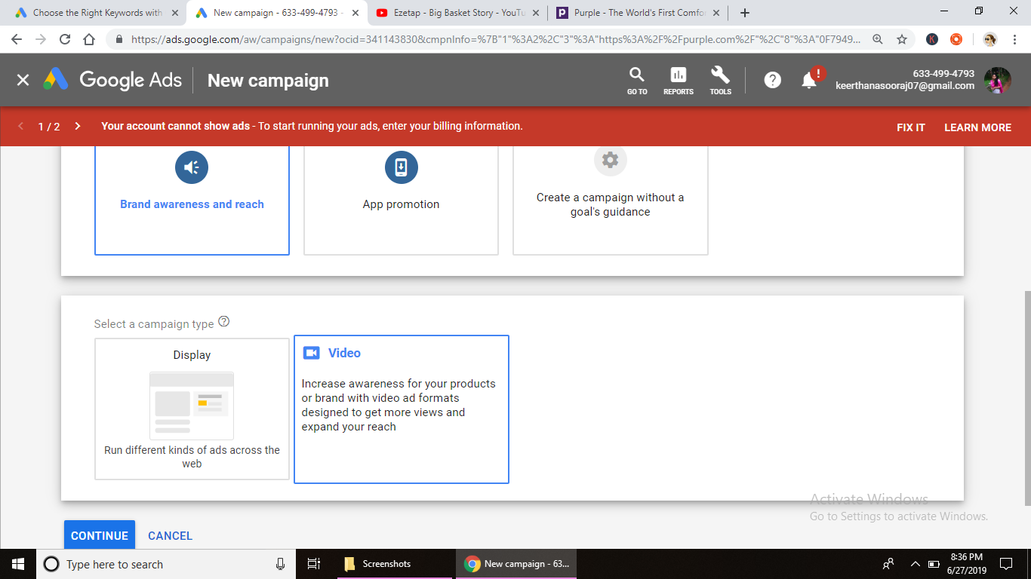**

**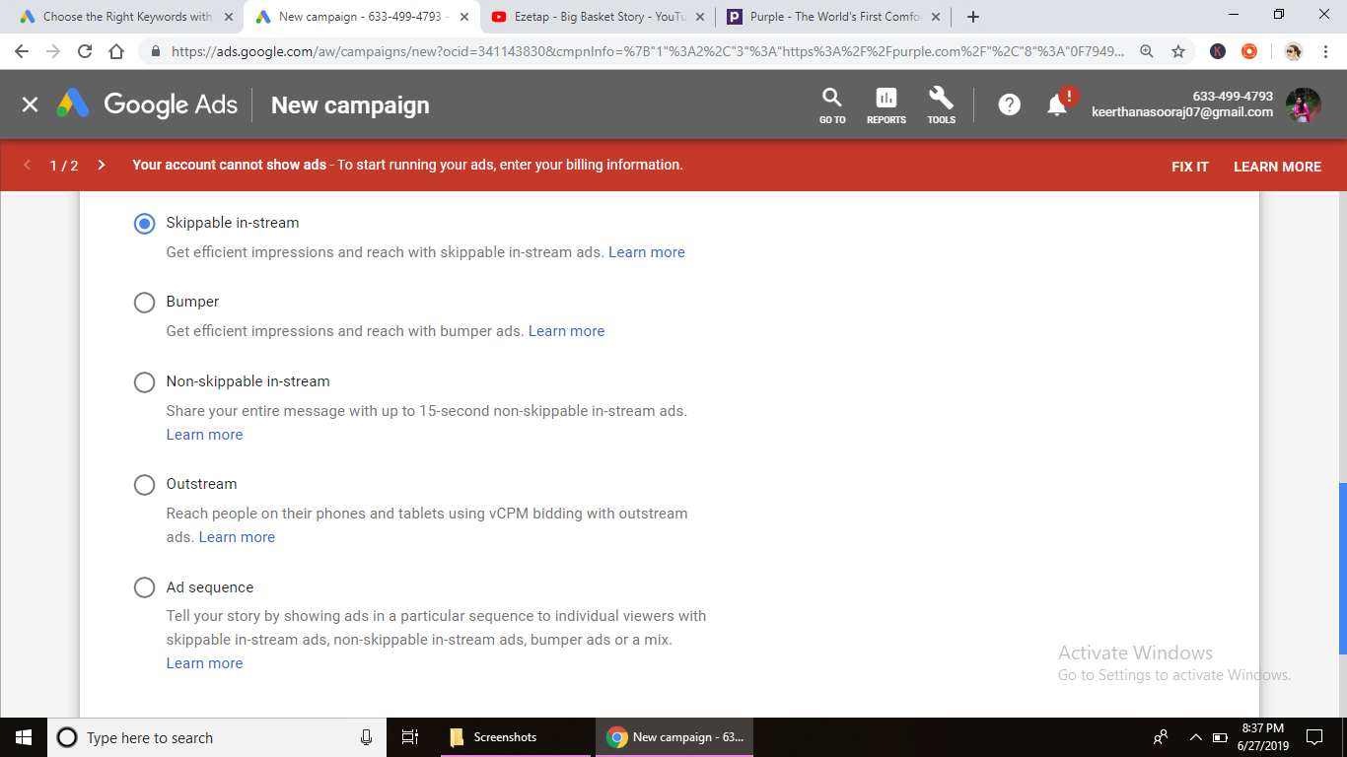**

**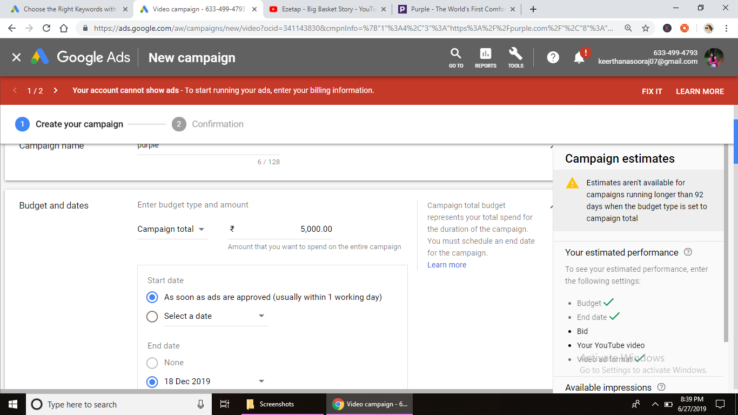**

**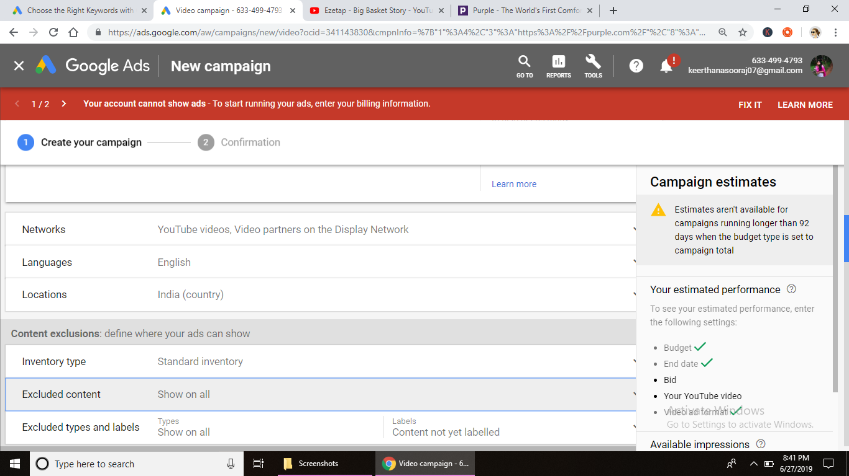**

**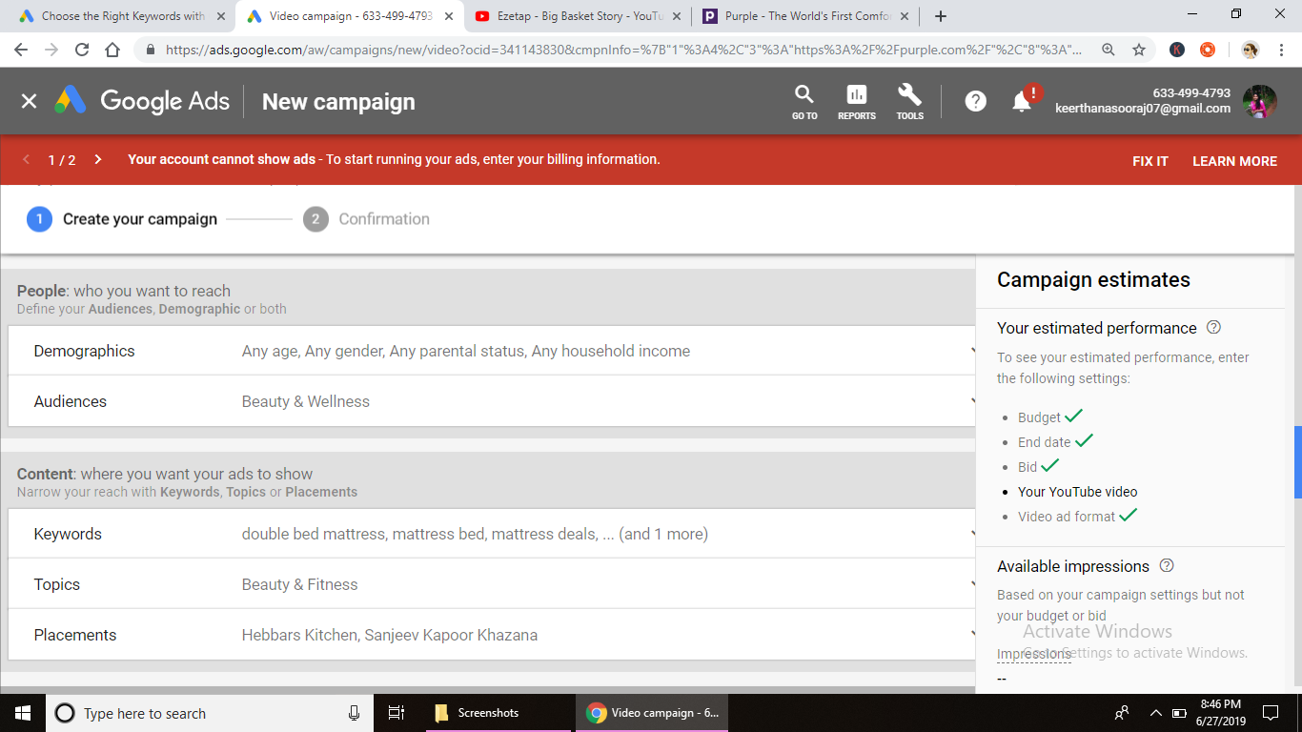**

**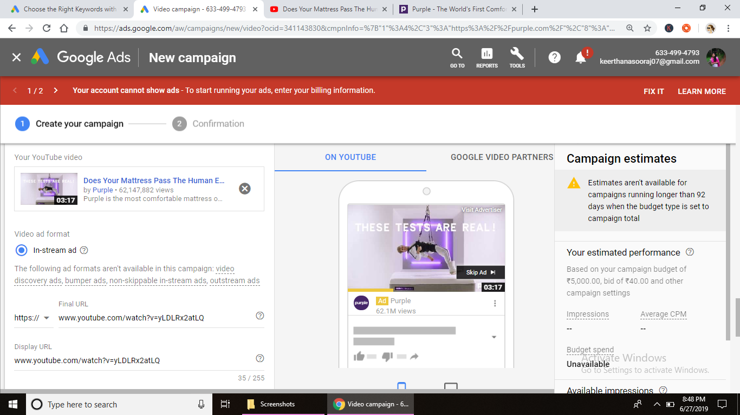**

**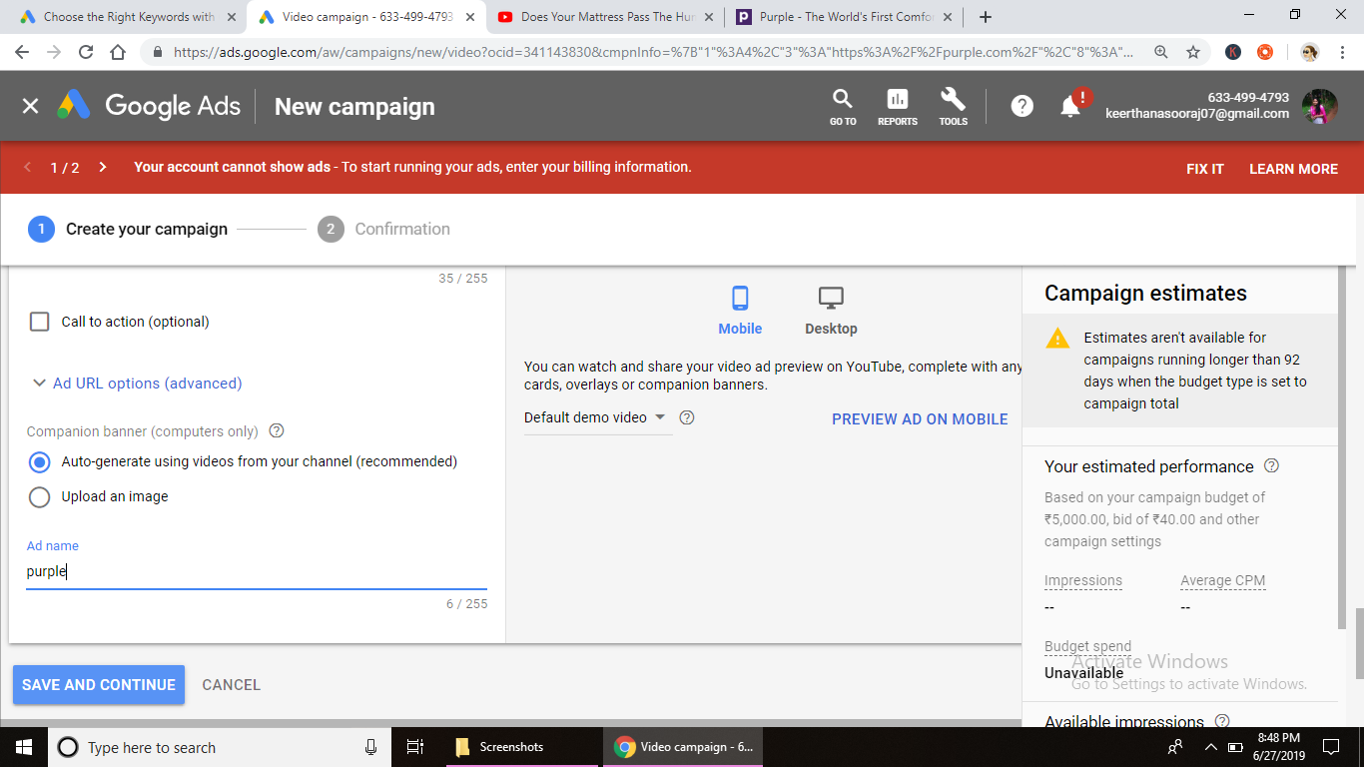**

**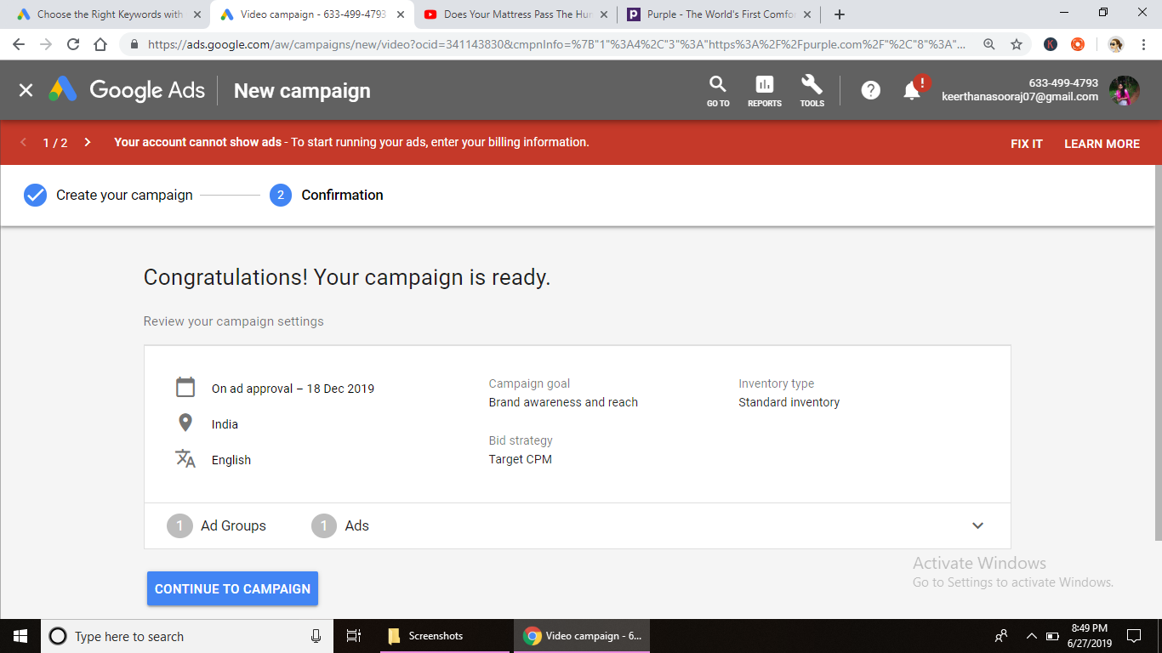**

**Assignment – 19 DATE: 2/7/19**

**Assignment Name: shopping ads**

**Faculty- NIKAHATH**

**Q1. -**

**A1.**

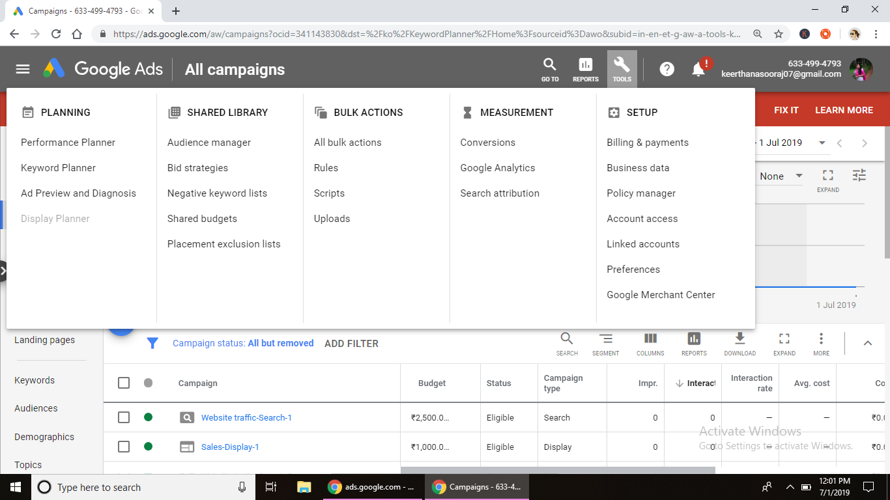

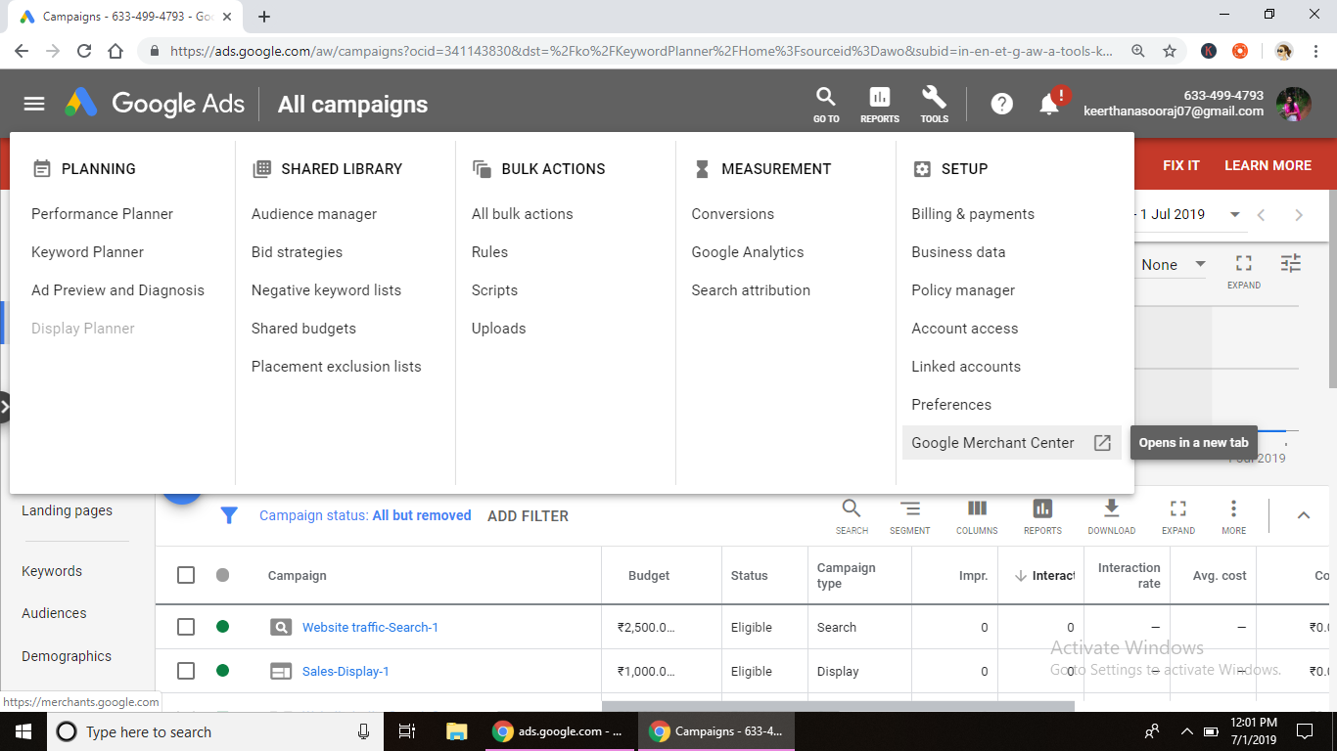

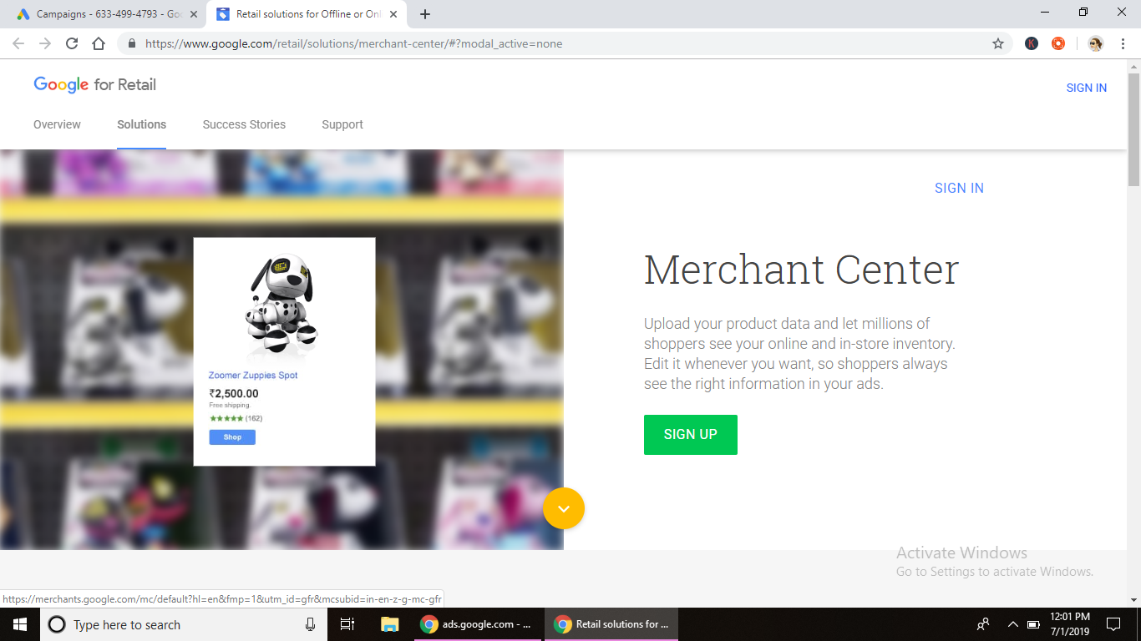

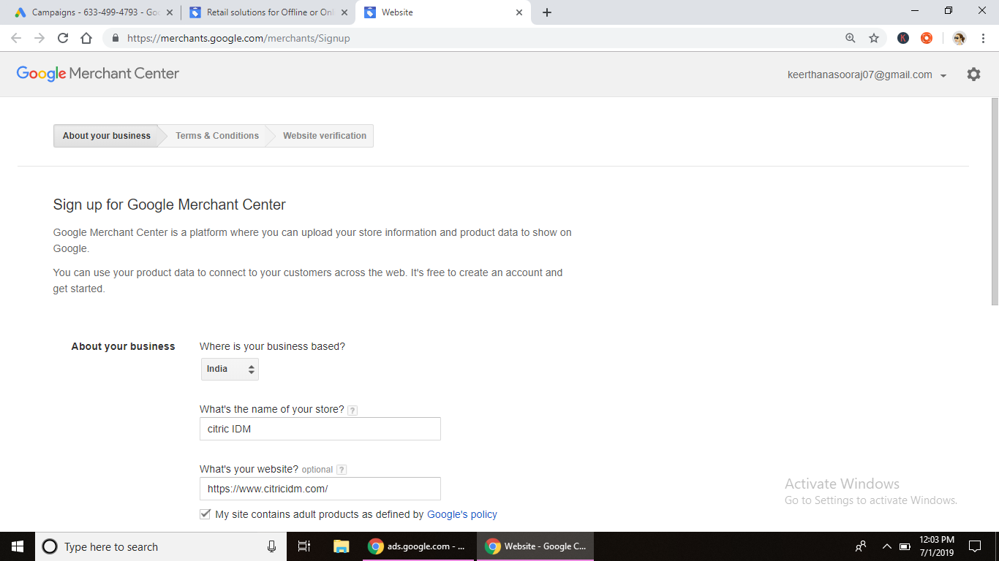

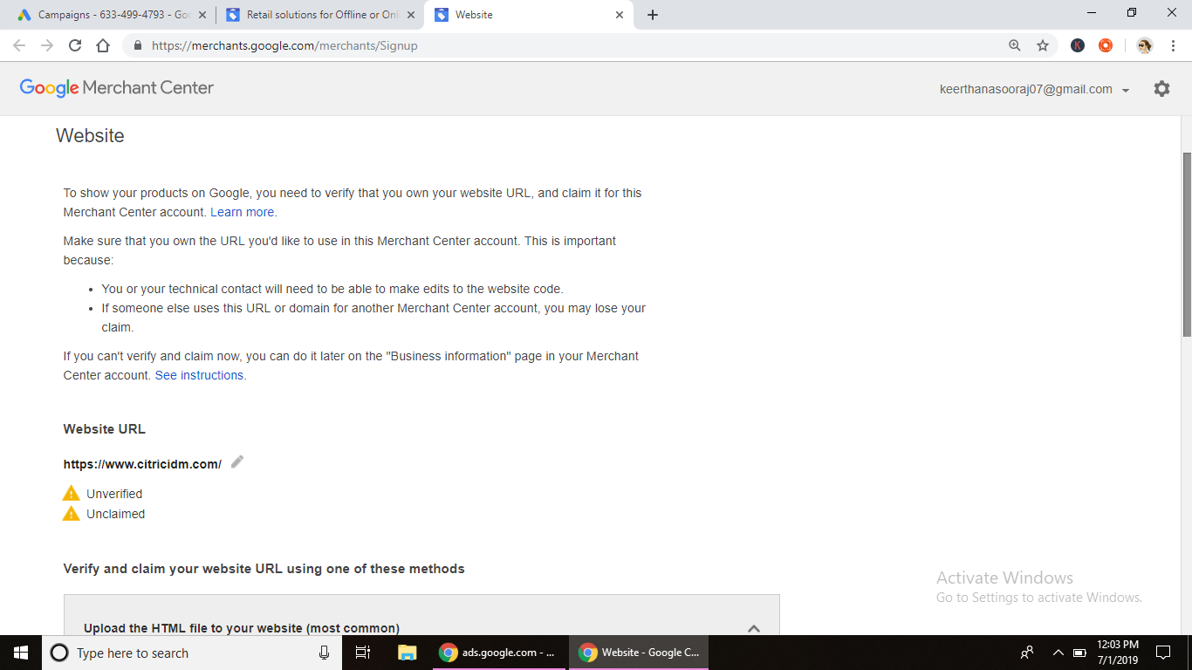

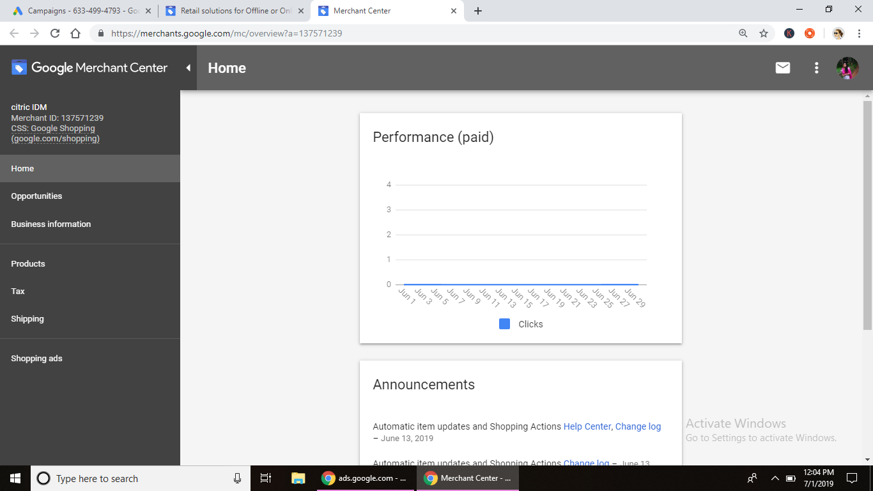

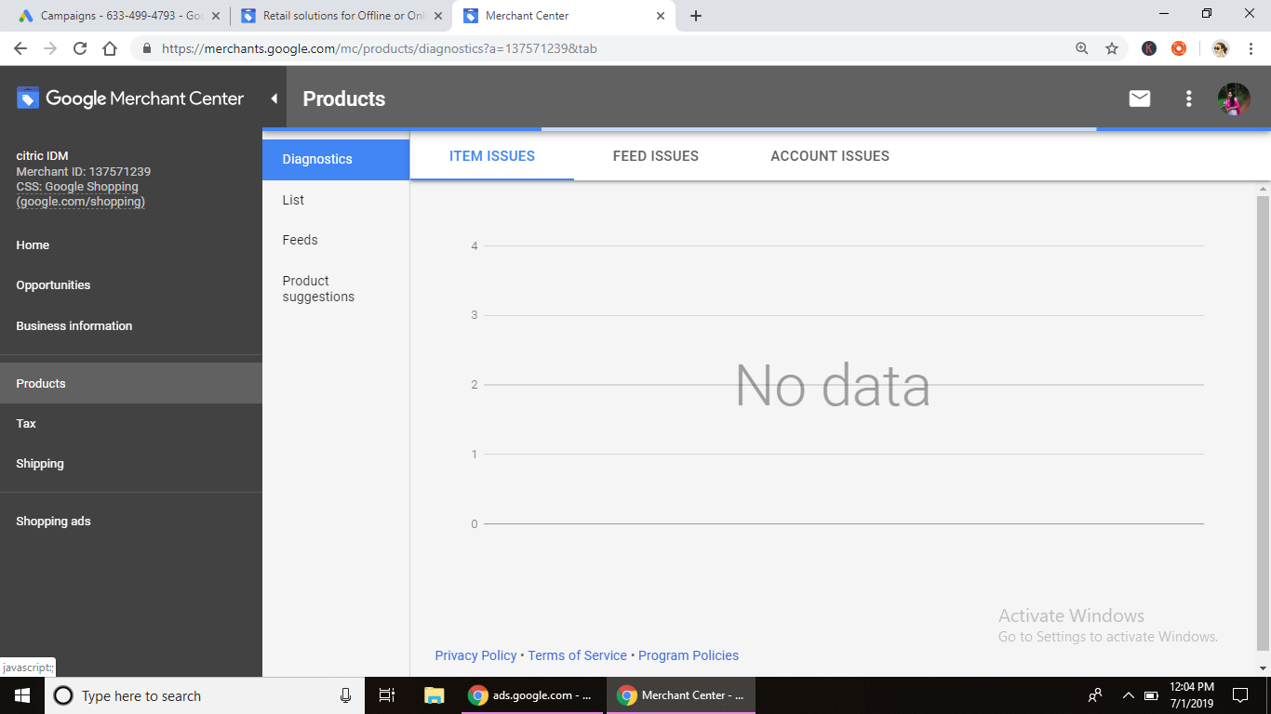

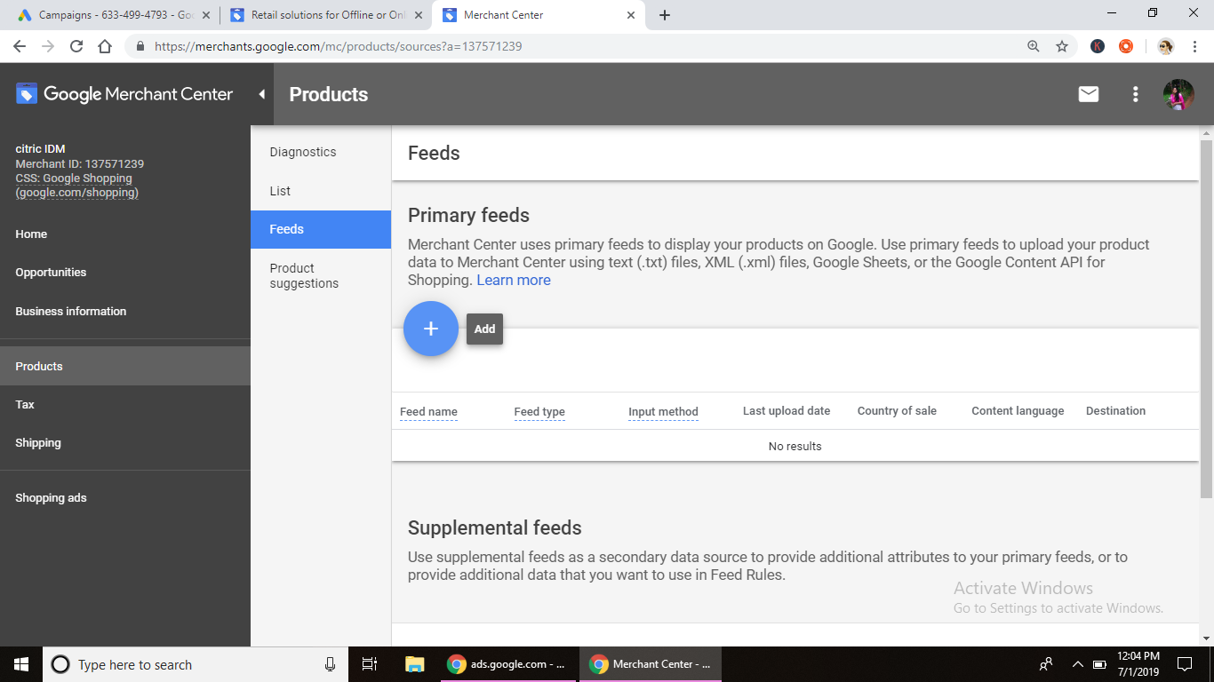

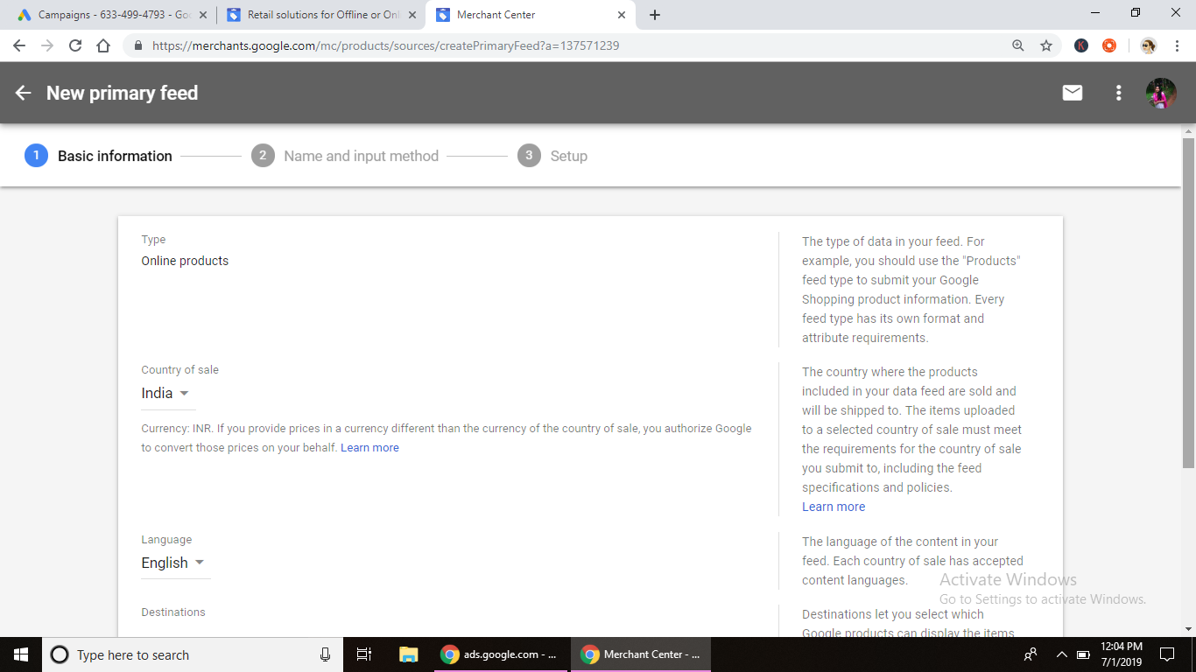

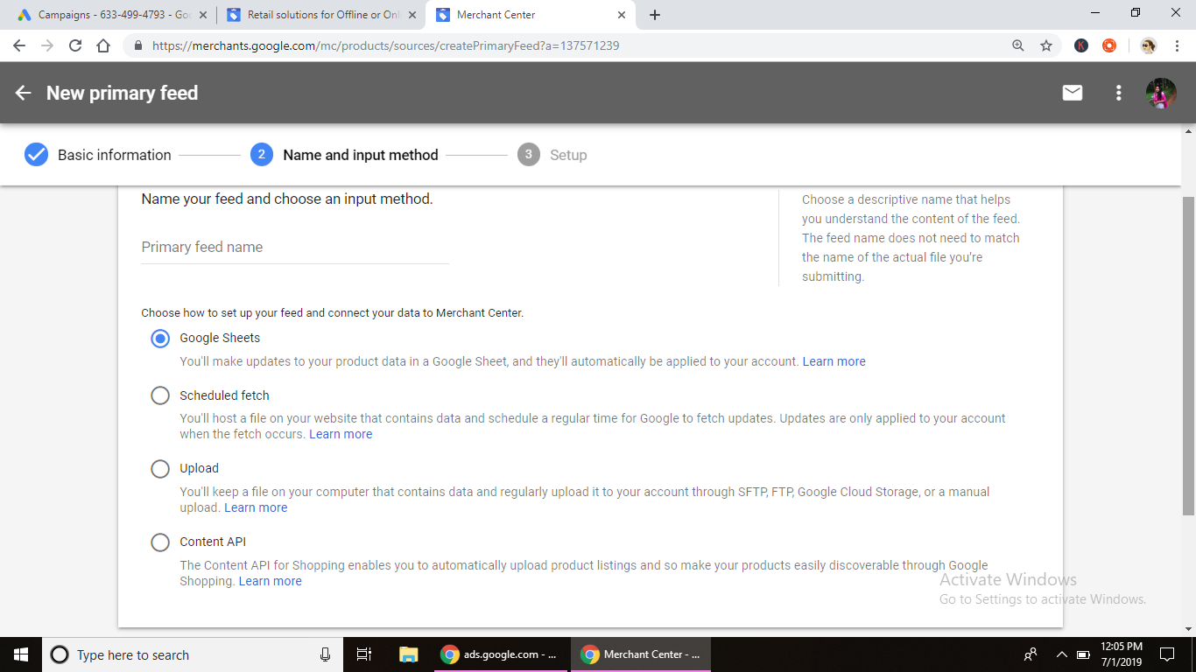

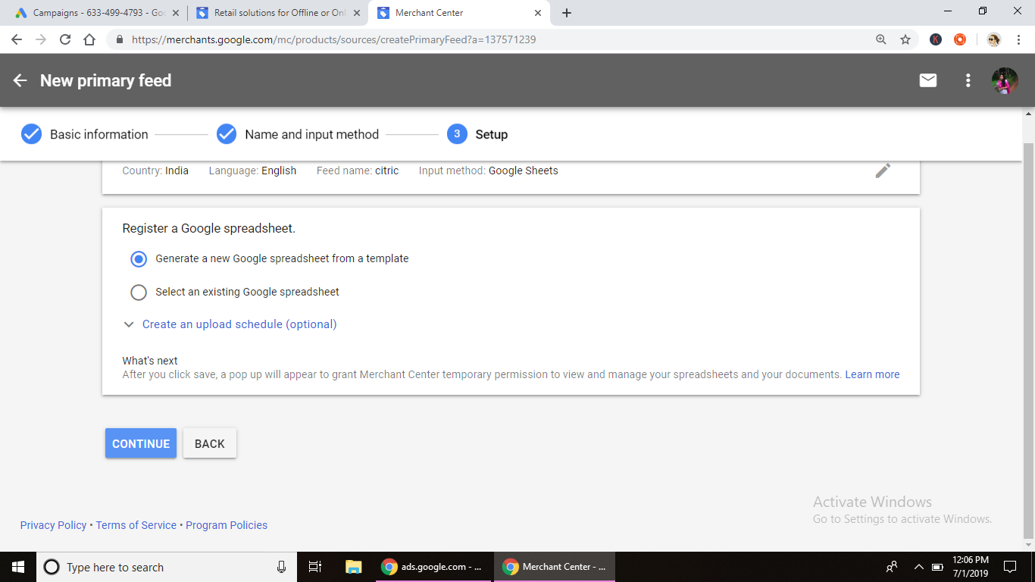

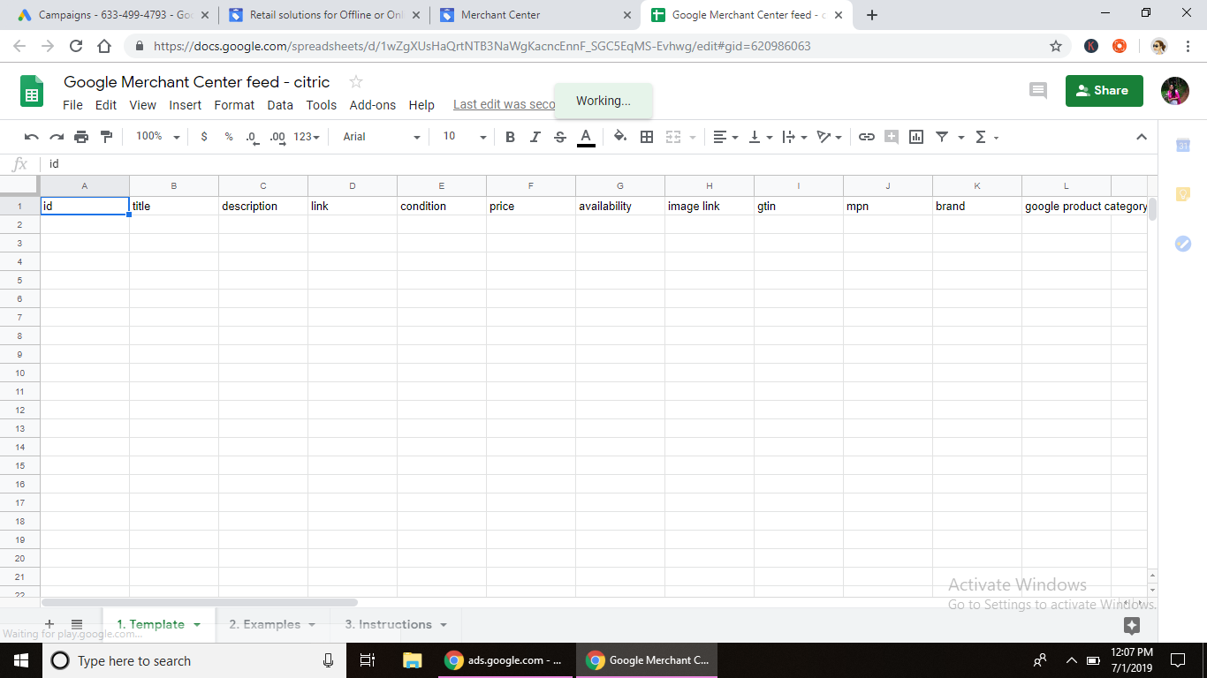

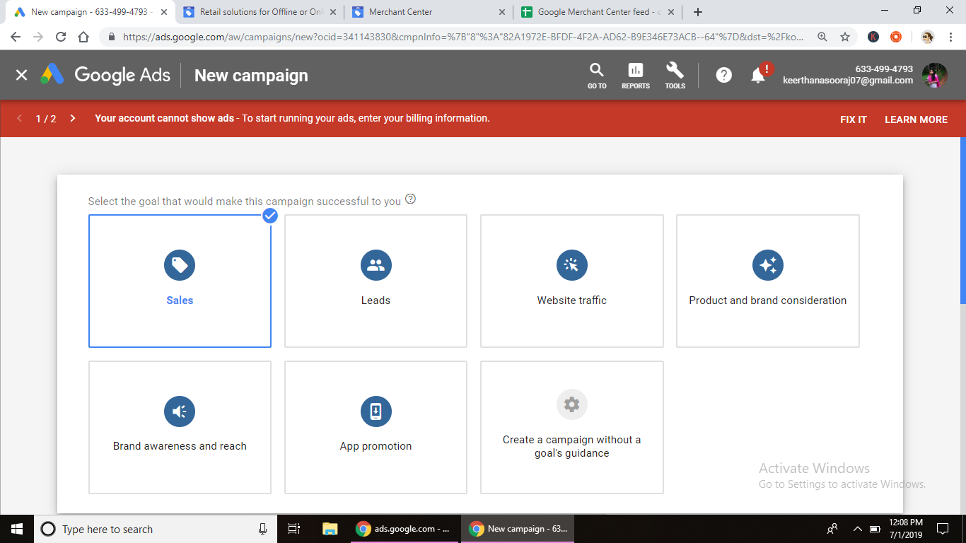

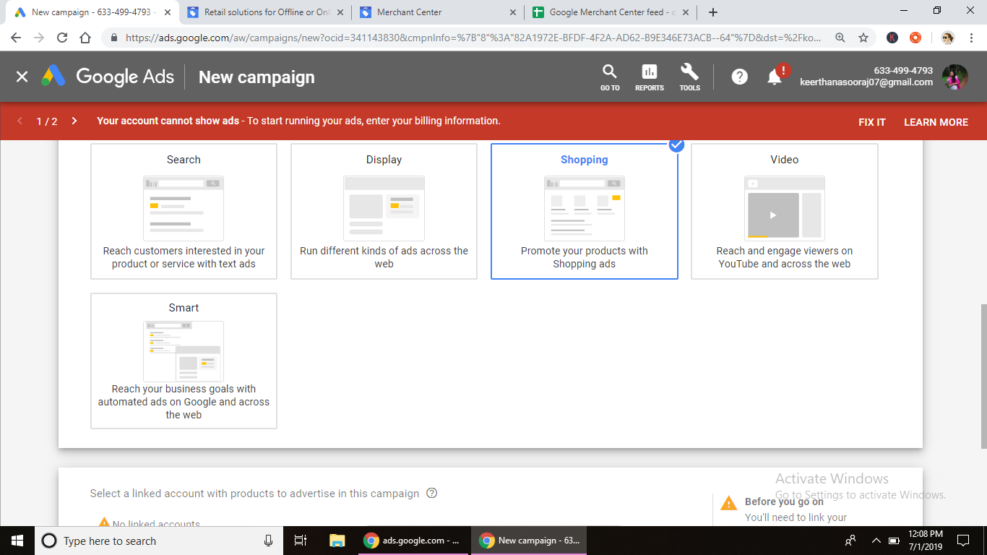

**Assignment – 21 DATE: 8/7/19**

**Assignment Name: SEM FINAL DOCUMENTATION**

**Faculty- NIKAHATH**

**Q1. -**

**A1.**

**SEM**

Search Engine Marketing is a process in which you market your business or product by using the available paid advertisements of various search engines. You can bid on the keywords that you want your ads to get displayed in the search engines. Search Engine Marketing is also known as paid search or pay per click (PPC). Search Engine Marketing, more commonly referred to as **SEM**, is one of **the** most **important** marketing channels to generate web traffic. ... But marketers have since made **the** distinction between SEO and **SEM**. **SEM** now most commonly refers to paid advertising within search engines.

Benefits of SEM :

* Increase brand awareness and brand equity of product.
* Increase Visibility - Increase in web site traffic.
* Advertise to an audience that's already interested in you.
* Increase in targeted leads.
* Target your ads to users based on languages and locations.
* Competition advantage - Marketers can enable users to select their product over their competitors.
* Greater ROI — compared to other advertising media, paid search strategies are more efficient.

**GOOGLE ADS OR PPC ADS**

**Pay Per Click Management (PPC) - The Fastest Way To Get Qualified Leads**

Paid search is a viable Internet marketing strategy offering business a great flexibility and control in their advertising campaigns. It can be implemented as a temporary, seasonal or long-term strategy and monthly budgets can be closely monitored and controlled. It is about ensuring that through your Search Engine Marketing efforts you will deliver to the right person, the right message and the right experience at the right time.

The Google Ad words program is currently the largest paid search network and provides advertisers the opportunity to display their advertisements in the sponsored listing of the Google search engine and other Web sites. The Yahoo Sponsored Search program offers many of the same features as Google's AdWords program.

**TYPES OF ADS:**

SEARCH ADS

DISPLAY ADS

VIDEO ADS

SHOPPING ADS

UNIVERSAL APP CAMPAIGN

STRUCTURE OF ADS:

Campaigns consist of ad groups, and ad groups have ads. These ads are triggered and

Displayed on Google when a user makes a search. When you create a campaign you are

Creating these ads that show up on Google and bring your business, customers and sales.

Ad Groups:

Within a campaign you can create various ad groups. Each ad group will contain a number of

Ads for the same product (or category or sub-category). You can write different ads to target

Different users with relevant content that will address their requirement and appeal to

Them.

Ad Copy

Ad copy is a term that refers to the main text of a clickable advertisement, whether it is a

Contextual or a pay per click ad. The text of the ad copy is generally the second and third

Lines of an ad displayed on a search engine results page or any other web page, and is

Between the title and the display URL.

Keywords:

Keywords are the words that Google uses to trigger your company’s ads. Ads get triggered

When a user searches for something on Google. The keywords you use should be similar

(And possibly the same) to what the user is searching. They should be relevant to your

Products, services and business. You pay for every keyword (when a user clicks on the ad),

So you should choose them with care.

Keywords are specific to an ad group. Different ads in an ad group will use the same

Keywords. Different ad groups will have different keywords. Therefore, to divide the

Campaigns logically into ad groups (not simply ads) is important.

The Keyword Planner Tool in your Google Ad words account helps you choose keywords

Effectively.

Ads:

Ads can contain text, images, videos and links (on a display network). In the Google Search

Network they can only contain text and links. When a user clicks on them, she is directed to

A landing page of a website where further call to action (according to the goal of your

Website) takes place.

Campaign Structuring and Implementation:

The campaign structure will depend upon your business structure and goals. It is always

Good to create the structure to resemble closely to your website structure or in the way you

Are running your marketing activities, as it becomes easy to track and analyse.

You could create campaigns based on:

• Target audience.

• a business goal you want to achieve.

• Location and region.

• The products and services you offer.

**CTR :**

**Click-through rate (CTR)** is an incredibly important concept in search engine marketing. The simplest definition is that click-through rate is the percentage of people who click on your ad after seeing your ad. (In mathematical terms: CTR = Clicks/Impressions.)

With both AdWords and organic SEO, your success can be improved in only three ways: (1) getting more people to see your ad or snippet; (2) getting more people to click on your ad or snippet; or (3) getting more people to become a customer (i.e., convert) on your landing page. In other words, search engine marketing is a “constrained system.”  And one of those constraints is the CTR.

With AdWords, your CTR is one of the key components of your quality score.  In SEO, your CTR is going to determine whether you maintain your ranking.

CTR FROM DIFFERENT ADS:

VIDEO ADS = 1-1.5%

DISPLAY ADS = CTR/0.5-1%

SHOPPING ADS= 1.5-2%

**SEARCH ADS:**

Google search ads are online ads that appear alongside the search engine result page when users search a keyword query on Google. These ads are PPC, or pay-per-click ads, in which advertisers pay for each ad click. Google’s PPC search ads are managed by Google’s AdWords advertising platform, which allows advertisers to bid on keywords, craft ad text, set budgets, and more. To advertise on Google AdWords, you'll need to [create a Google AdWords Account](https://accounts.google.com/ServiceLogin?service=adwords&hl=en-US&ltmpl=signup&passive=false&ifr=false&alwf=true&continue=https://adwords.google.com/um/SignupToken&app=Signup&sacu=1&sourceid=awtest&subid=ww-en-et-awhp2-1d2b3c4a5a6b7a).

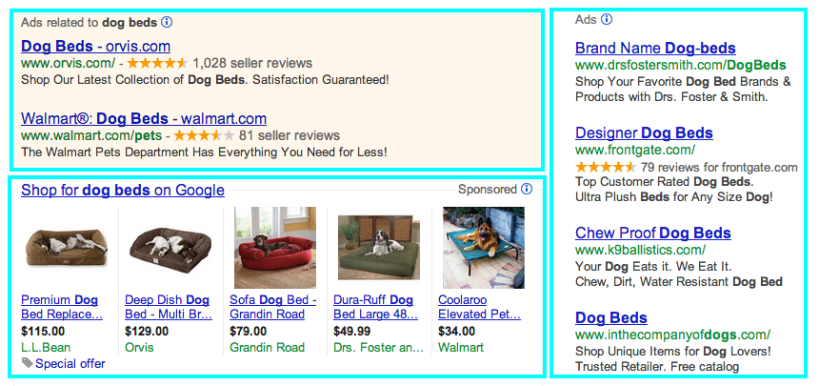

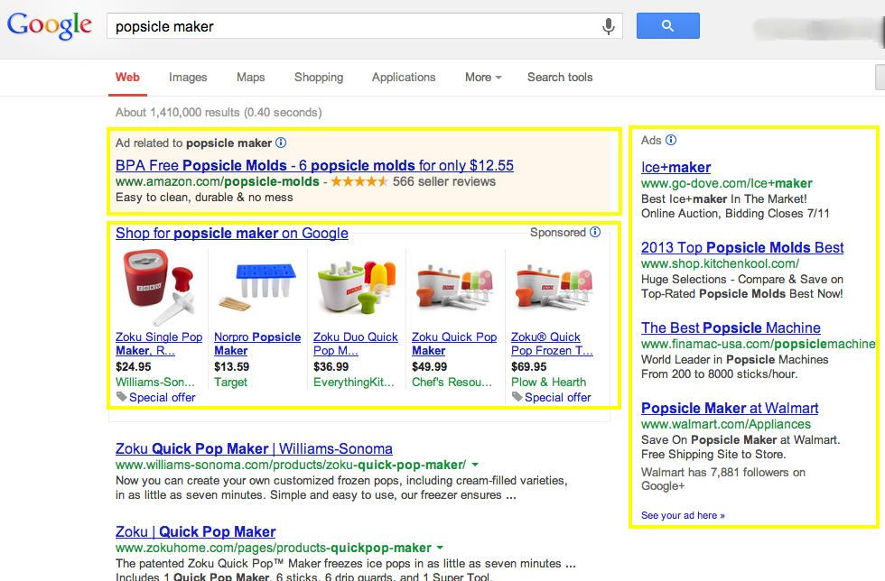

Important factors in search ads

* Targeting – For instance, your ads will be shown in the geography that you choose (you can go as specific as the ZIP code)
* Search term and keyword – What is being searched for by the user + the keyword that you optimize the ad for.
* Ad copy relevance – Ads that appear for a specific search term should be relevant. A search for colleges should not throw results for travel packages.
* Landing page experience – How relevant is the landing page to what the searcher wanted? Did he get what he was looking for?
* Conversion rate – This is again controlled by relevance, landing page quality, and experience.
* Bids – If 2 advertisers have perfect ads and landing pages, the higher bid will get preference over the lower one.
* Quality score: Quality score again depends on all of the other factors mentioned above. So, it’s more like a cycle than everything else. Everything is interrelated.

**STEPS TO CREATE SEARCH ADS:**

**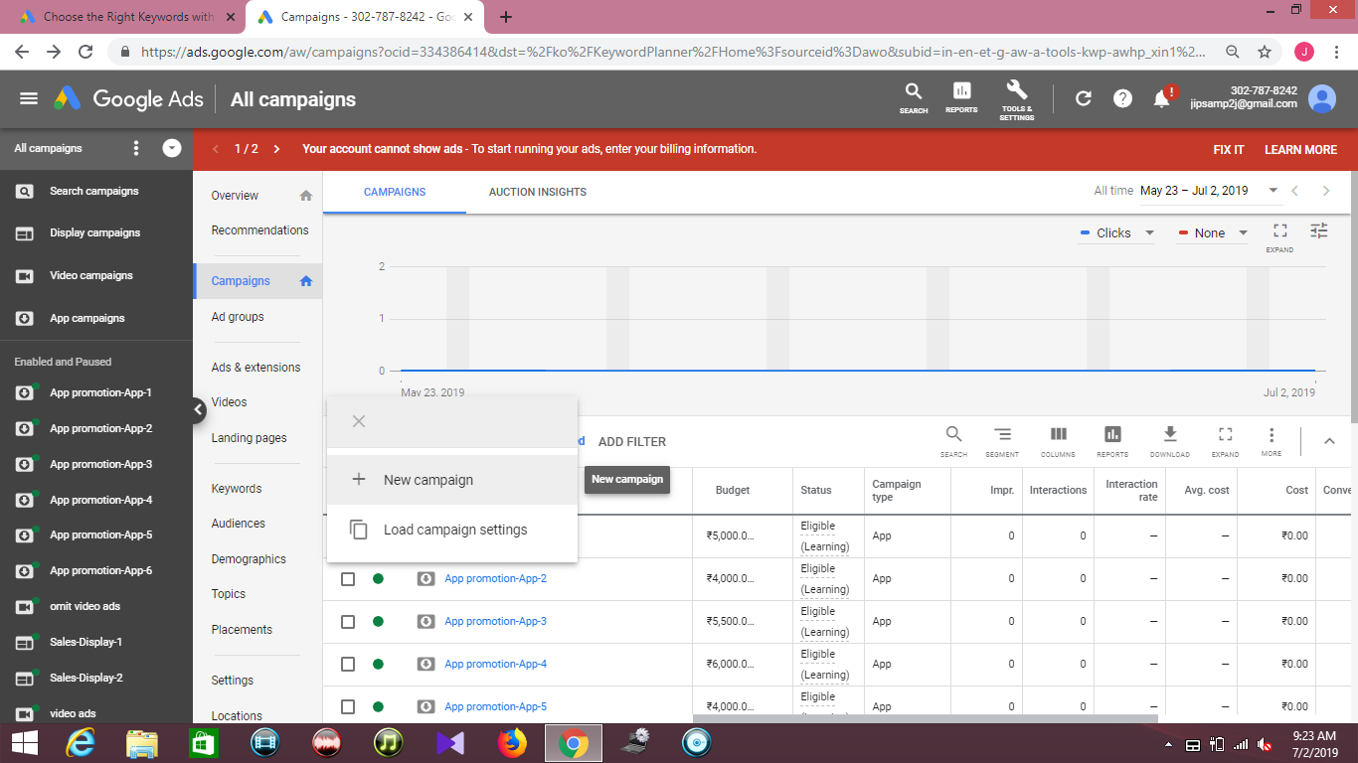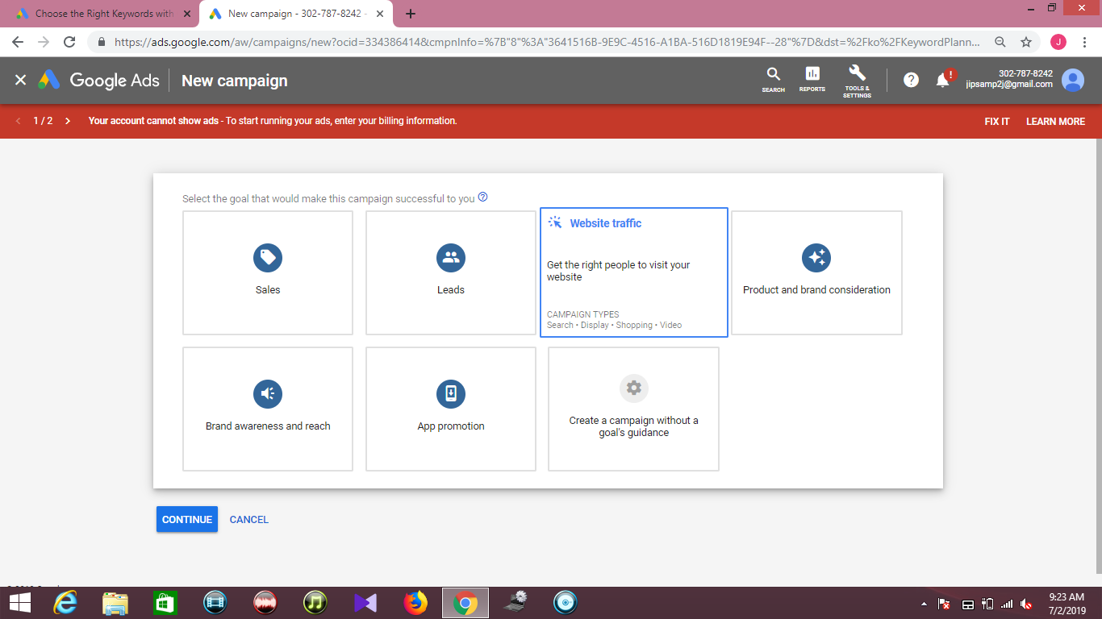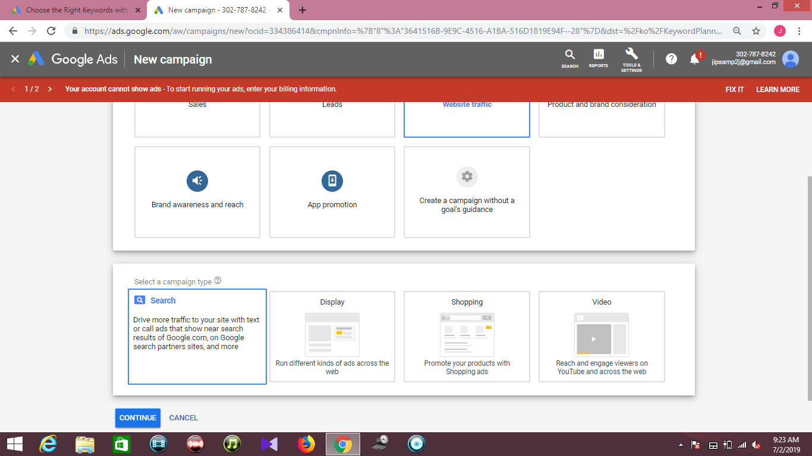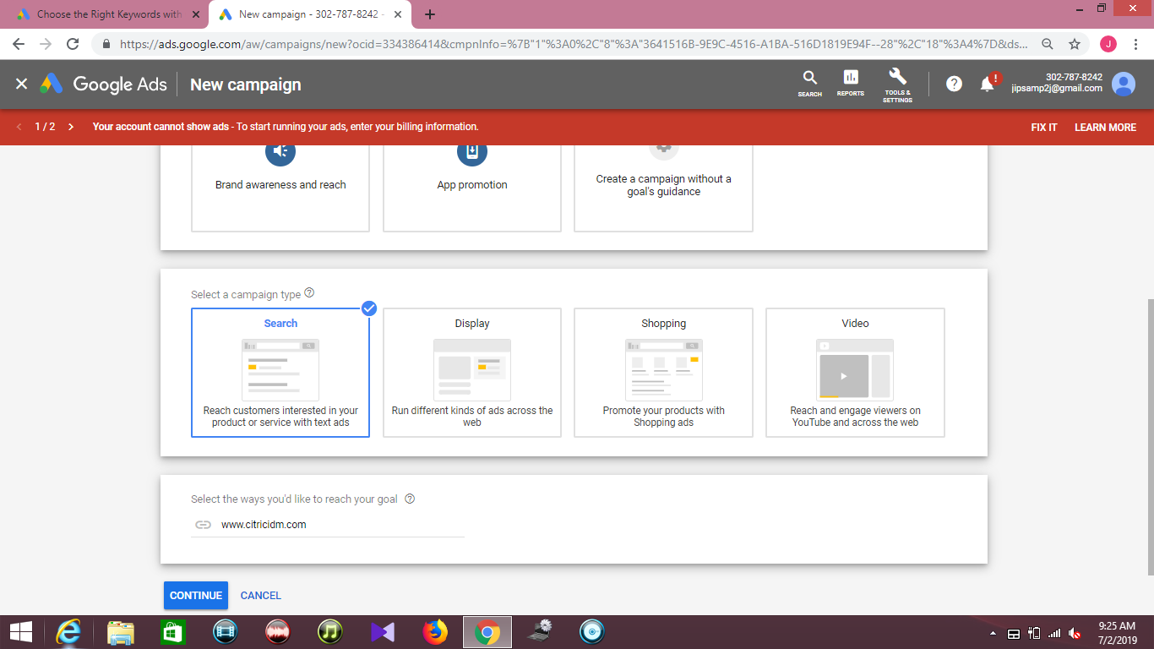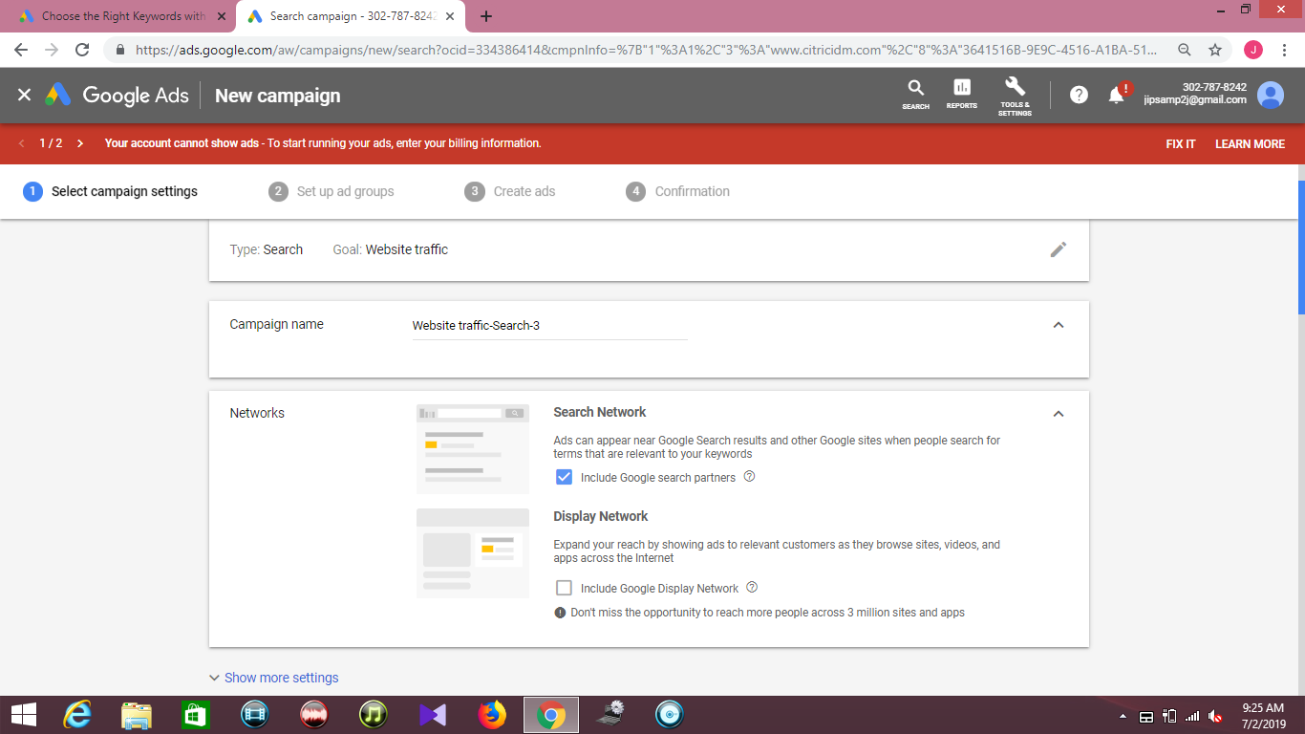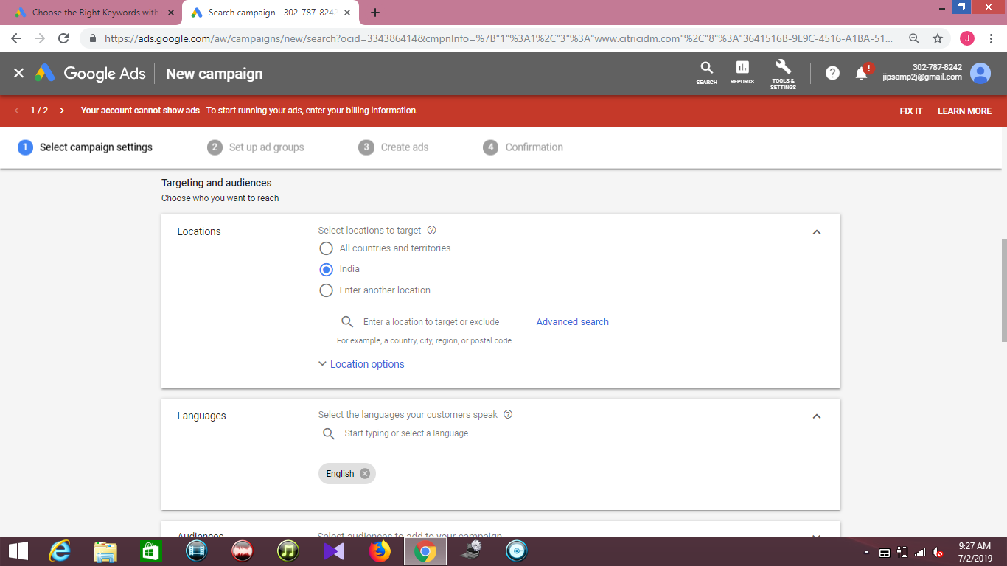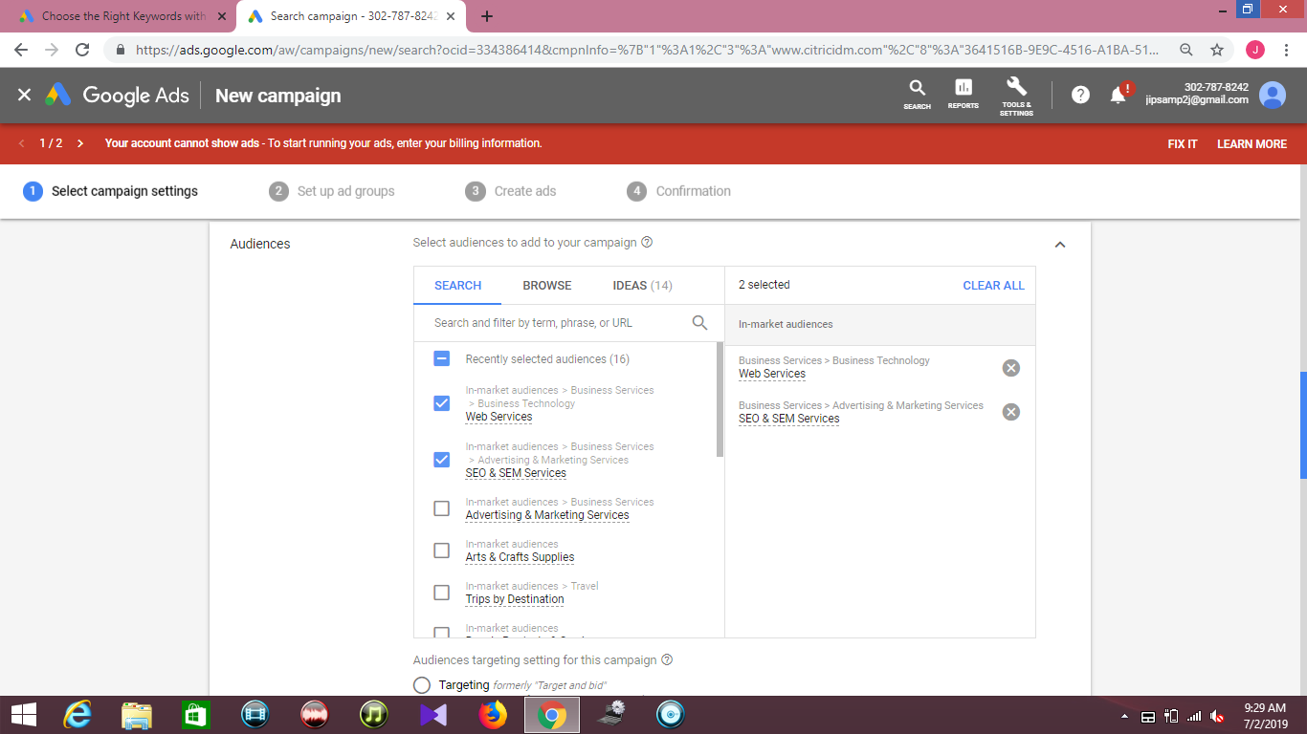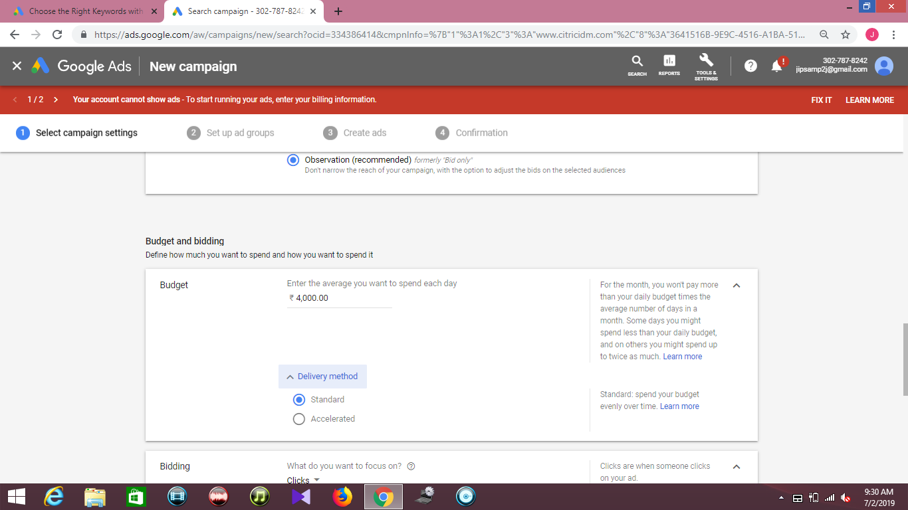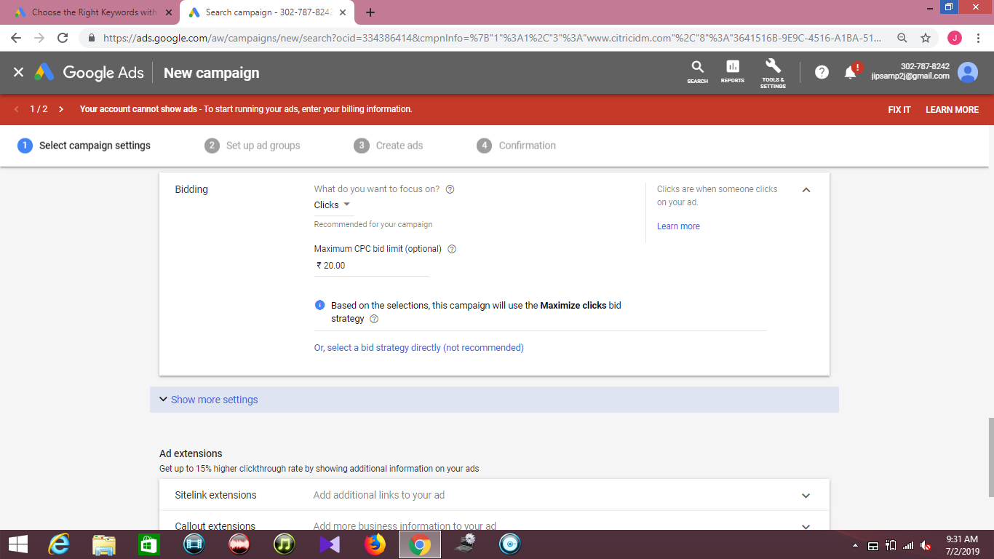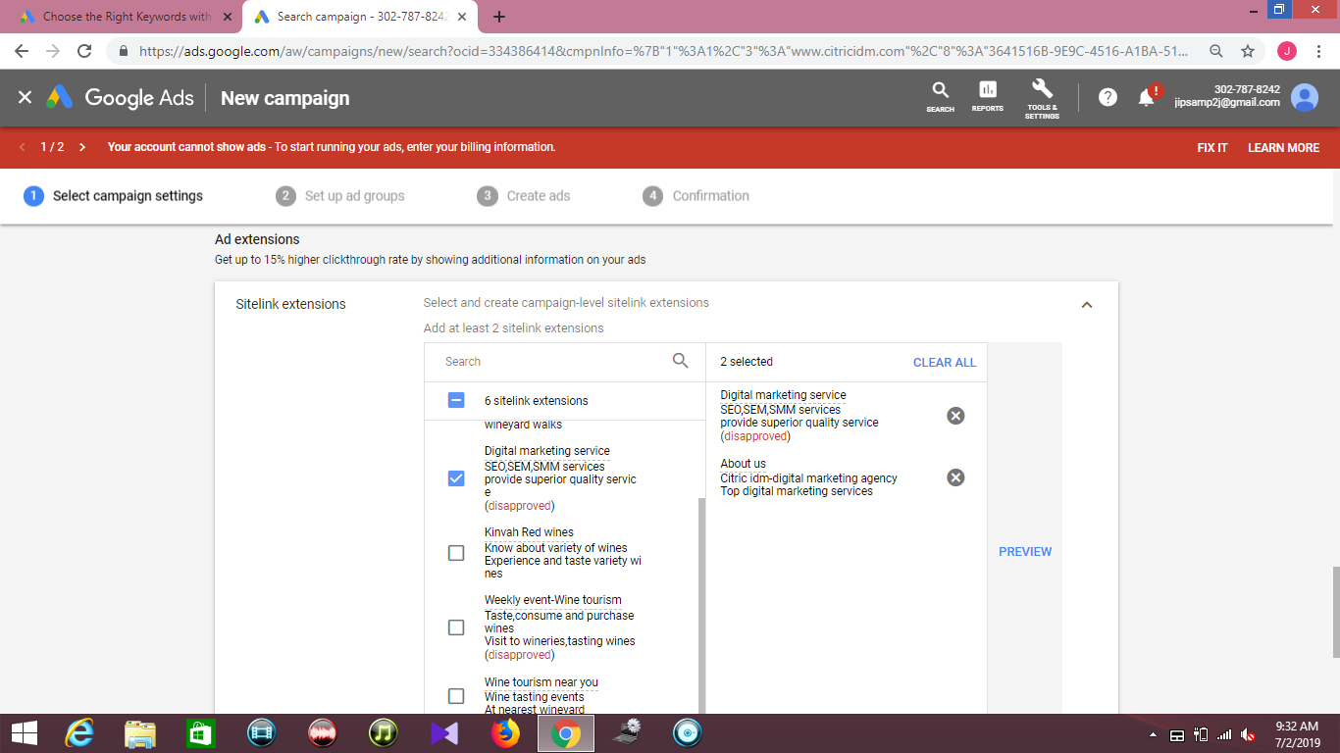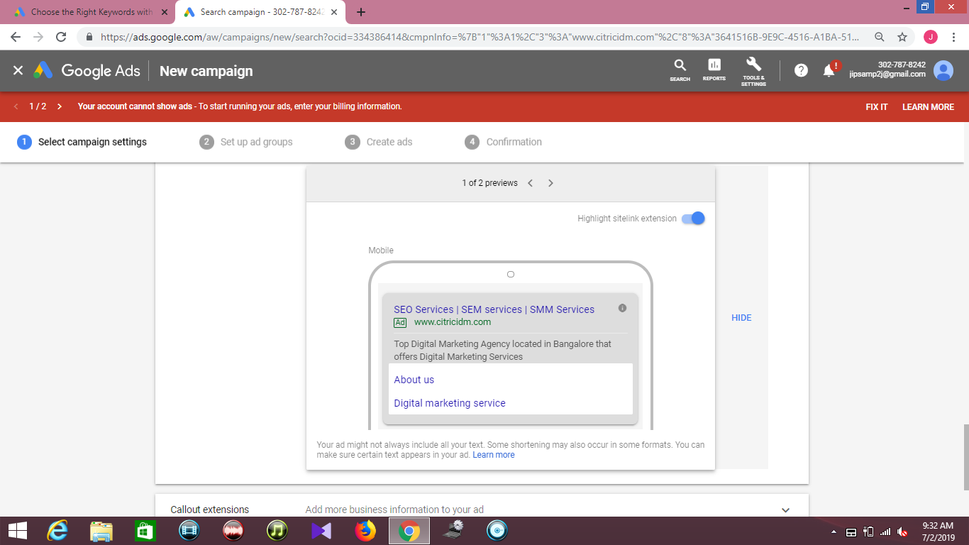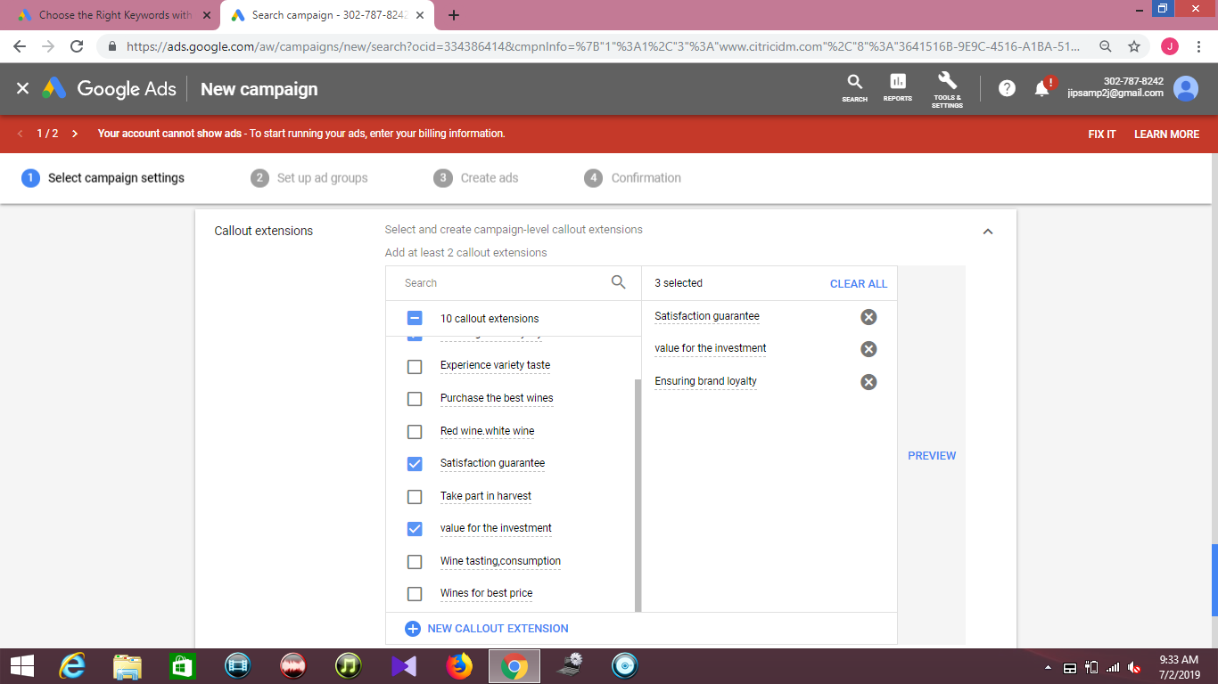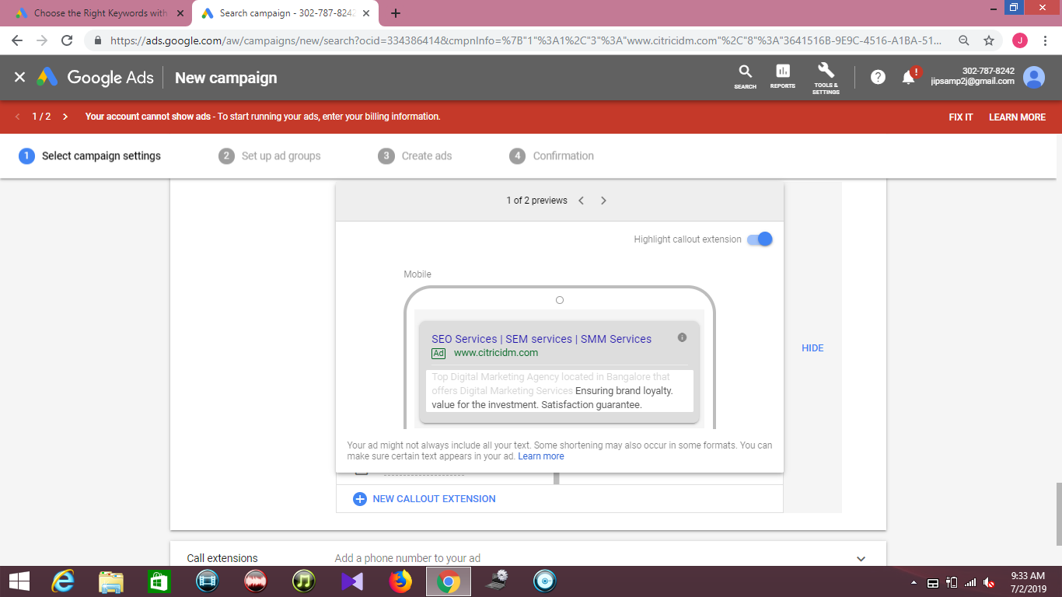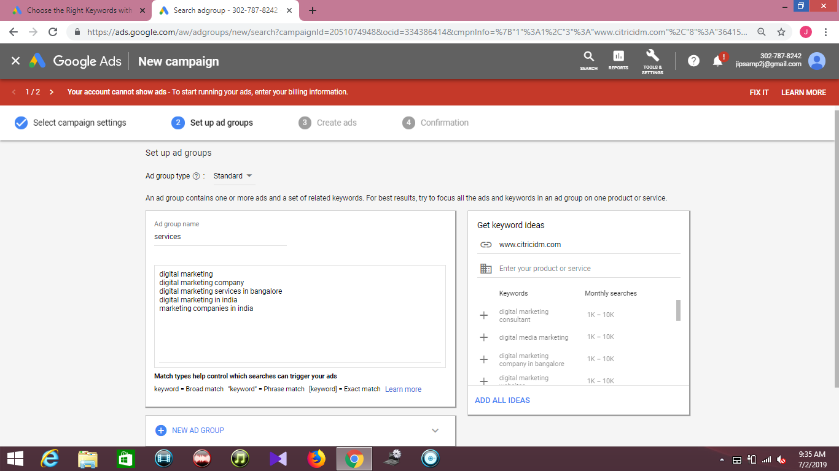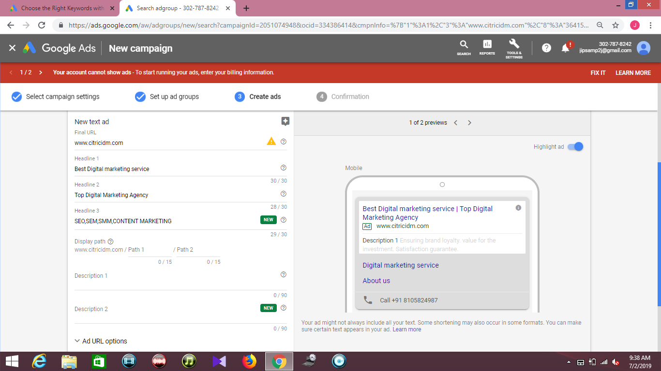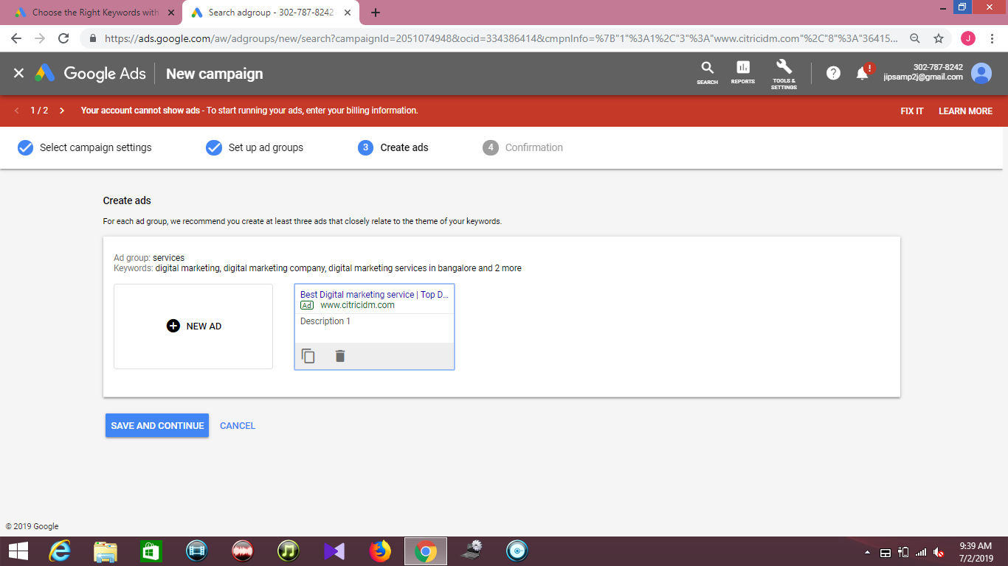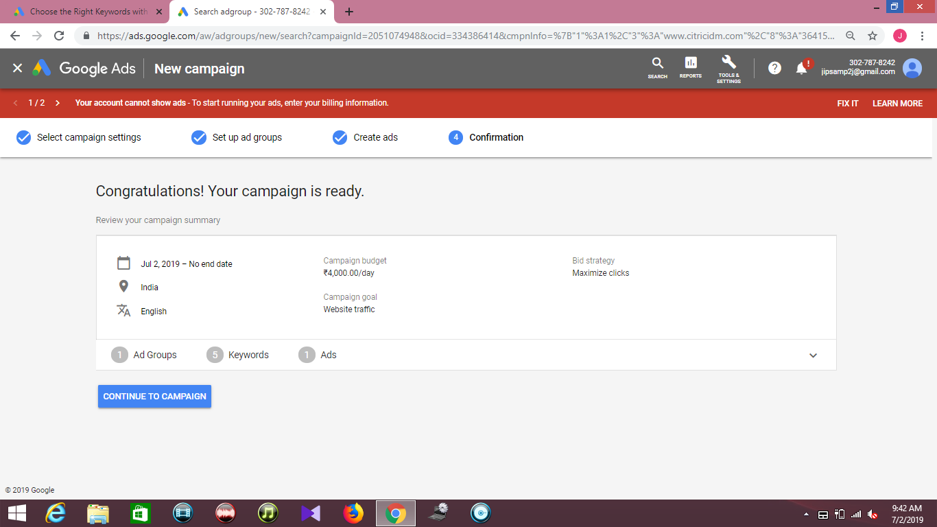Dynamic Search Ads**

Dynamic Search Ads are the easiest way to find customers searching on Google for precisely what you offer. Ideal for advertisers with a well-developed website or a large inventory, Dynamic Search Ads use your website to target your ads and can help fill in the gaps of your keywords-based campaigns. Without Dynamic Search Ads, even well-managed Google Ads accounts with many keywords can miss relevant searches, experience delays getting ads written for new products, or get out of sync with what's actually available on advertisers’ websites.

Dynamic Search Ads use Google's organic web crawling technology to automatically target relevant search queries based on a retailer's website content. Dynamic Search Ads are useful for campaigns because they: Help fill in the gaps in keyword campaigns for a better return on investment (ROI) through incremental traffic.

**How they show**

When someone searches on Google with terms closely related to the titles and frequently used phrases on your website, Google Ads will use these titles and phrases to select a landing page and generate a clear, relevant headline for your ad.

Example:

You own an international hotel chain. Someone searching on Google for “luxury hotel New York” sees your ad with the headline “Luxury hotel - NYC,” clicks your ad, and then lands on the site of your top New York location.

**Adword Extensions**

Extensions expand your ad with additional information—giving people more reasons to choose your business. They typically increase an ad's click-through-rate by several percentage points. Extension formats include call buttons, location information, links to specific parts of your website, additional text, and more.

### How they work

### **To maximize the performance of your text ads, Google Ads selects which extensions to show in response to each individual search on Google. For that reason, it’s a good idea to use all the extensions relevant to your business goals.**

### **By adding more content to your ad, extensions give your ad greater visibility and prominence on the search results page. That means you tend to get more value from your ad. Extensions often increase your total number of clicks, and can give people additional, interactive ways of reaching you—as with maps or calls.**

**Types of Adword Extensions**

**1. Sitelink extensions**

To add more links to your ads, create sitelink extensions. Sitelinks can take people to specific pages on your site—your store hours, a specific product, or more. When someone clicks or taps on your links, they skip right to what they want to know or buy.

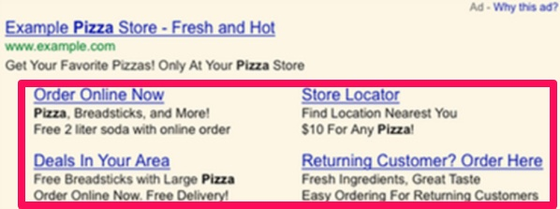

**2. Callout Extensions**

Callout extensions are small snippets of text that appear with your search ads and highlight additional features or benefits of your products/services. Up to 4 callouts can appear with your ad and each can be up to 25 characters long.

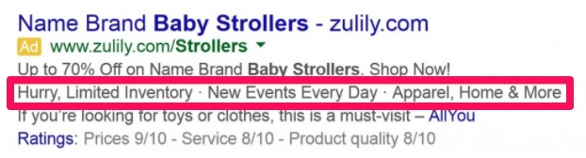

**3. Call Extensions**

Call extensions are a type of ad extension, an ad feature that allows advertisers to include additional information about their businesses andoffering to their text ads. In the case of call extensions, this additional information is your business phone number.

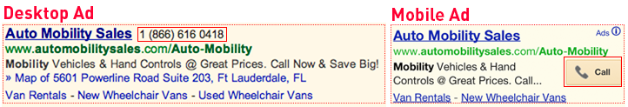

**4. Location Extension**

Location extensions can help people find your locations by showing your ads with your address, a map to your location, or the distance to your business. People can then click or tap your extension to get further details about your location on your location page, which includes the most relevant business information all in one place. Location extensions may also include a phone number or call button so that users can easily call your business.

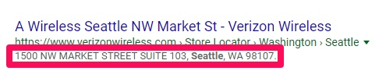

**Ads Budget**

Google Ads lets you set an average daily budget for your campaigns, with the flexibility to change it at any time. Your daily budget is the average amount you'd like to spend each day over the course of the month. Those days are balanced by days when your spend is below your daily budget.

**Formula to calculate ads budget for search ads**

**1. Impressions=Sum of average monthly searches**

**2. CPC=Sum of high bid/Total number of keywords**

Number of clicks is calculated by the formula for CTR

**3. CTR=Clicks/Impressions\*100**

**4. Total Budget=CPC\*Clicks**

**5. CPA (Conversions)**

**Clicks\*3/100 (**Assuming 3% Conversion, Acquisition, Leads**)**

**Total Budget/Number of Conversions**

**2) Display Network (Display Ads)**

Known for displaying image ads, the Display Network (DN) contains over a million websites to show ads on (managed placements). The features are slightly different for the DN and start with “Marketing objectives” or “Nomarketing objective.” If you select “Marketing objectives,” you’ll be able to build your campaign based on awareness (impressions), influence (visits, engagement), or actions (buy, call, visit a location). As you select from one of these three boxes you will change the features on the page that relate best to building that type of campaign.

When should you use the Display Network?

* For building brand awareness
* If you have certain website you want to advertise on
* To create remarketing campaigns
* If you want to display ads on YouTube

**Steps to create Display Ads**

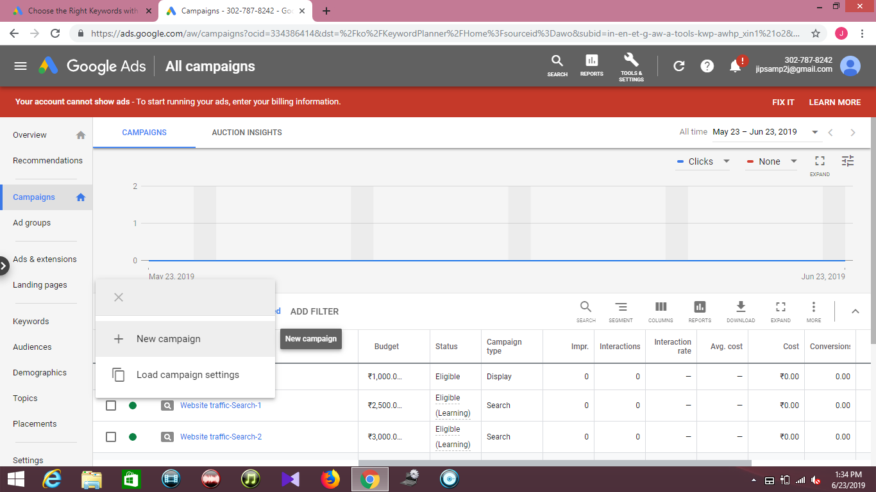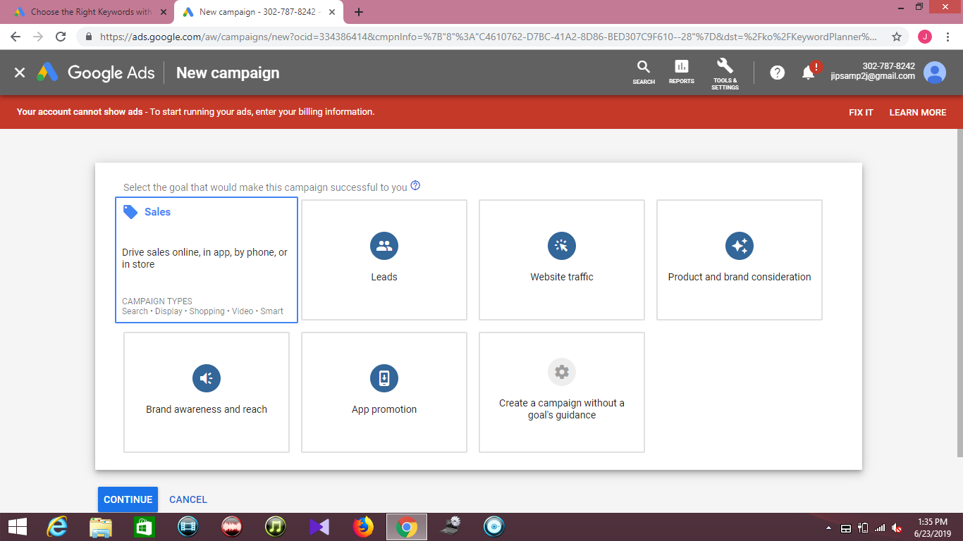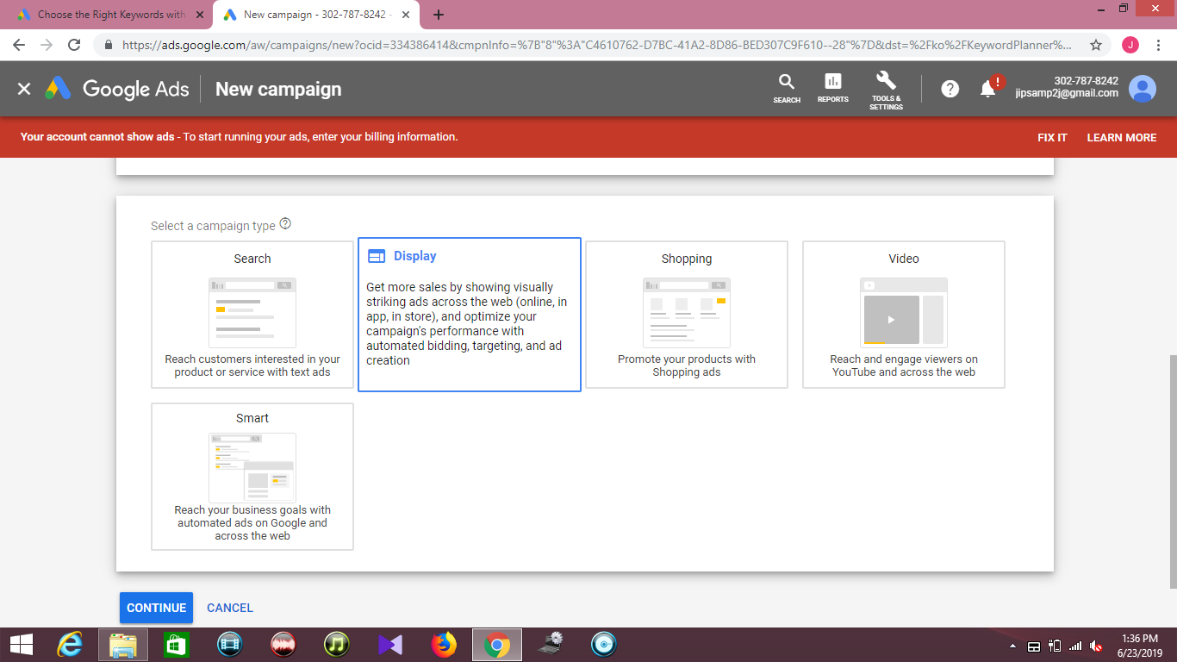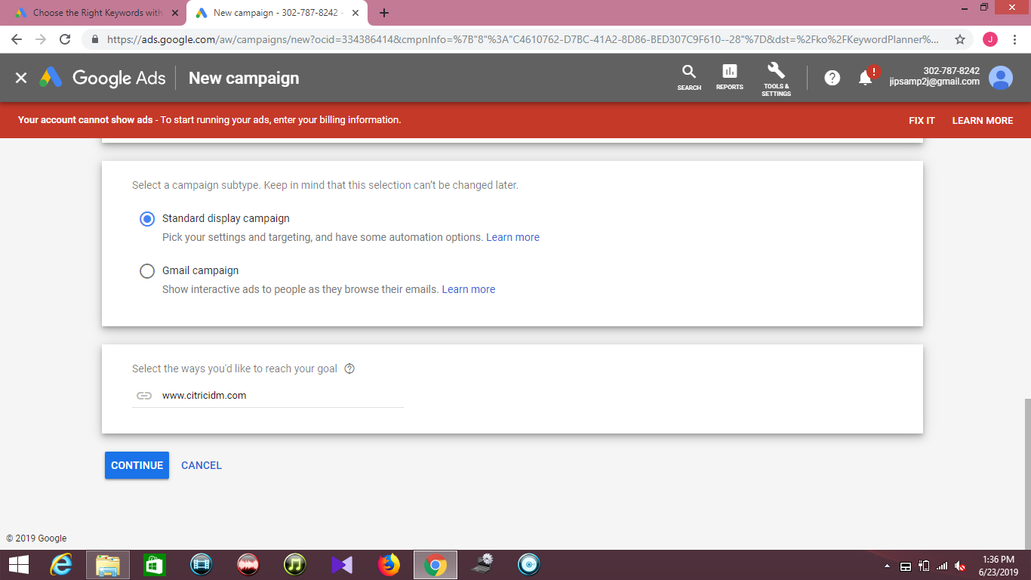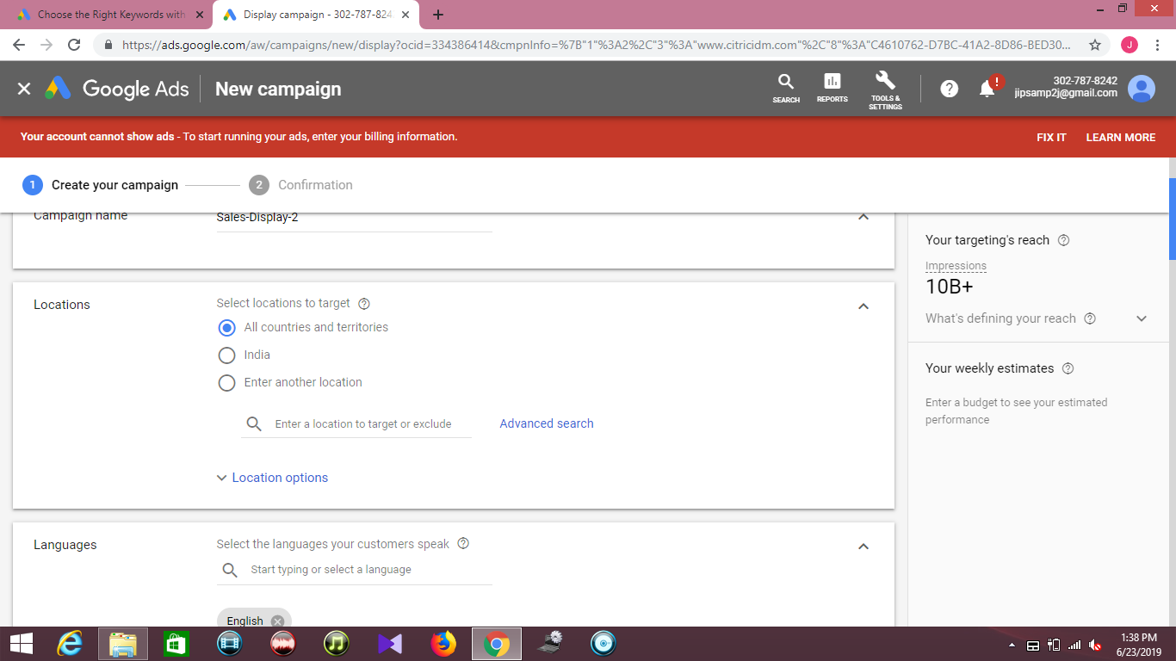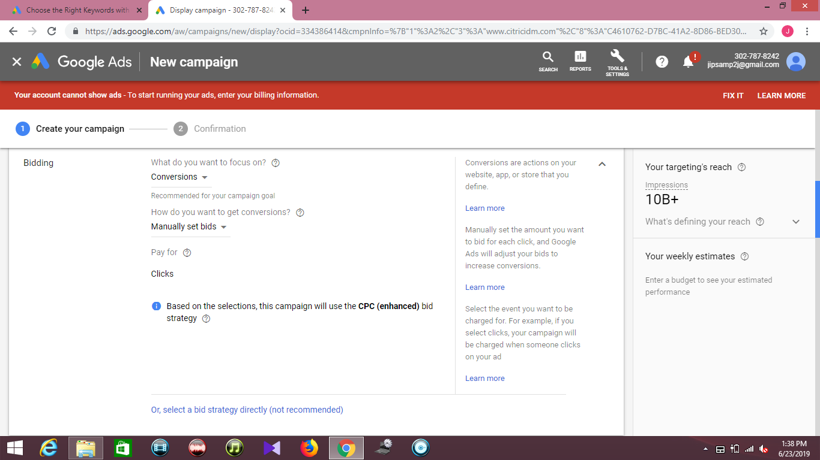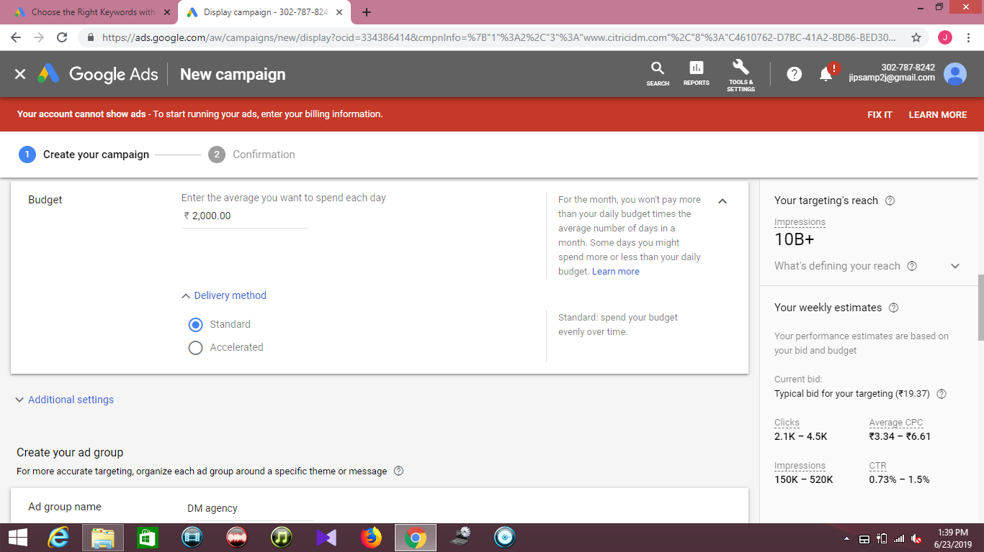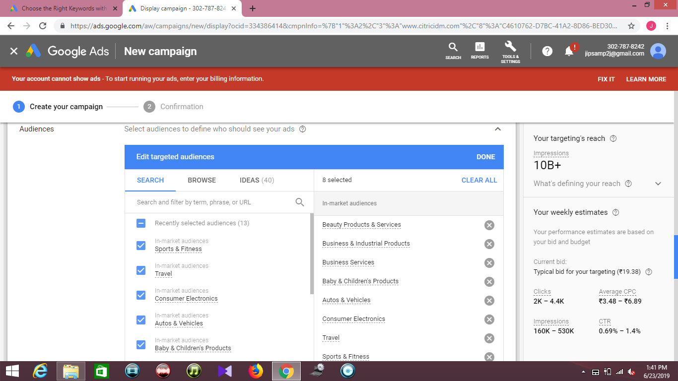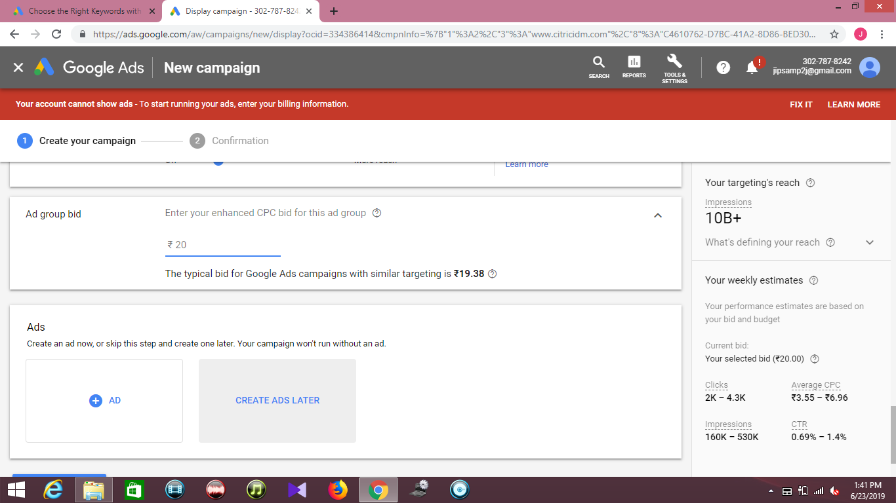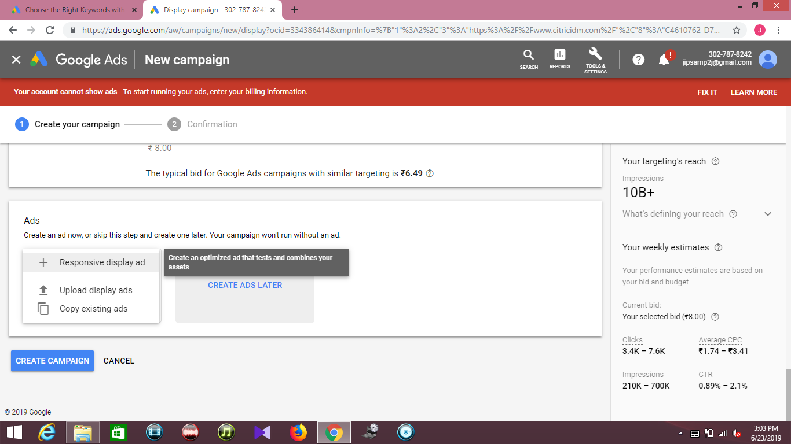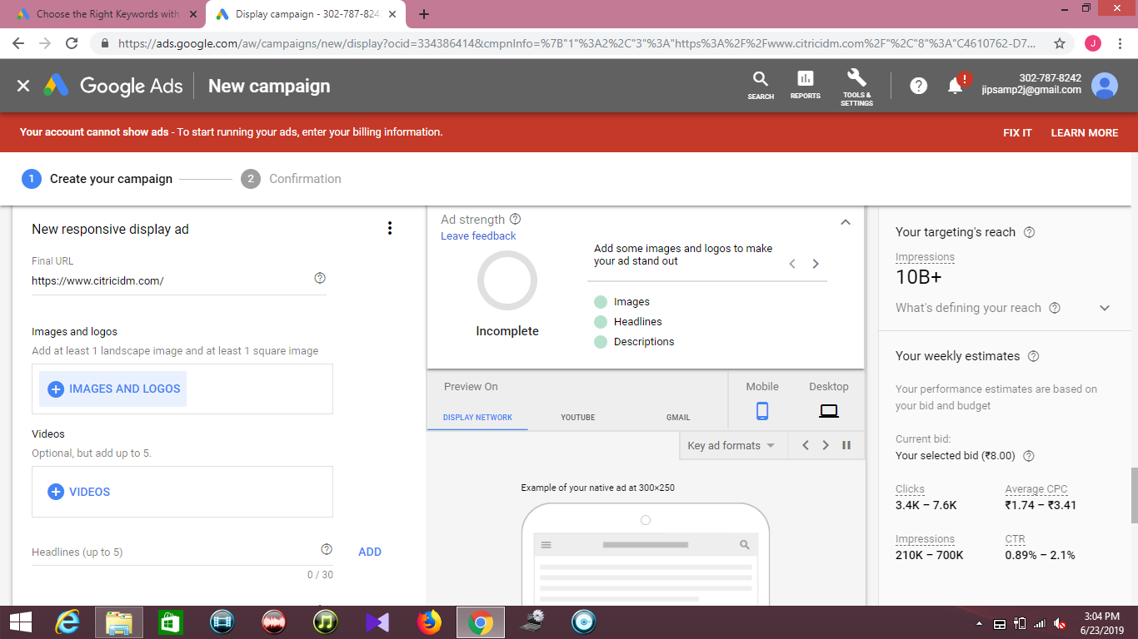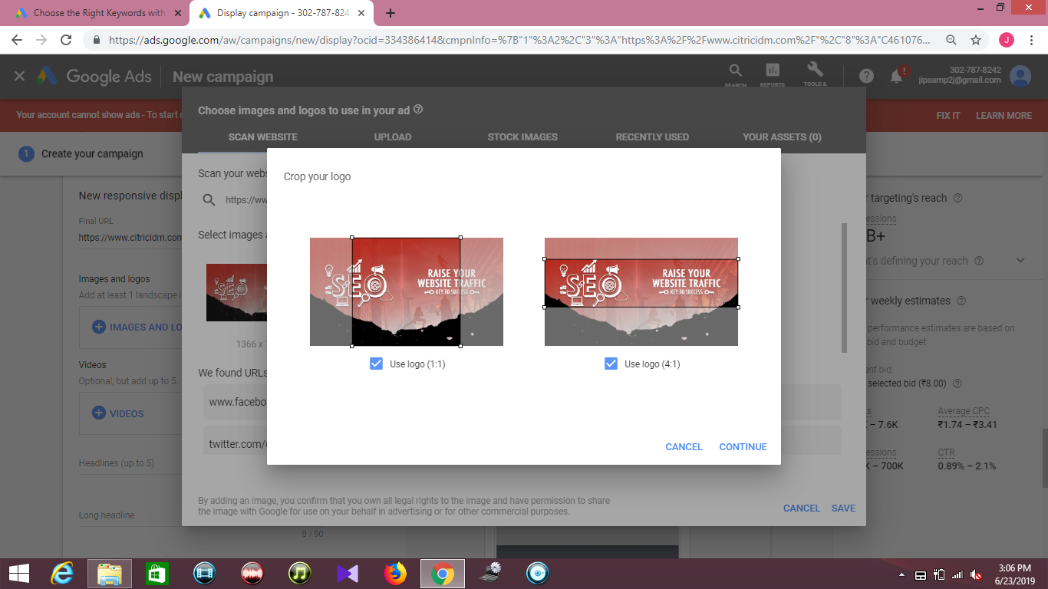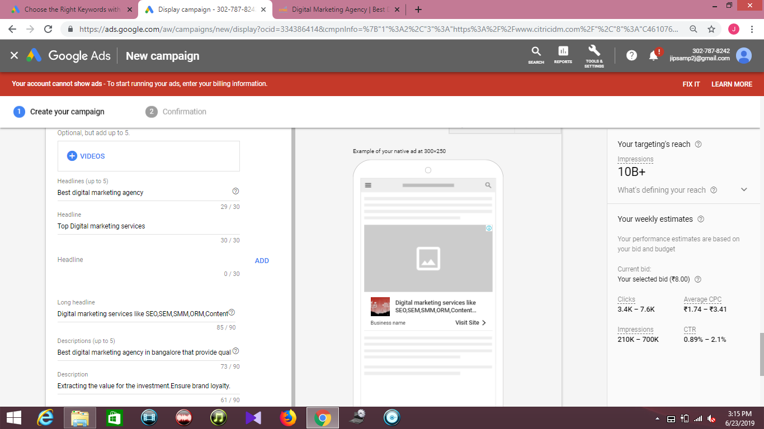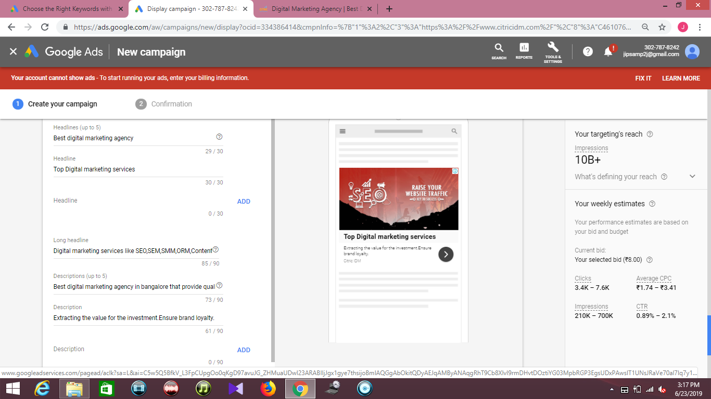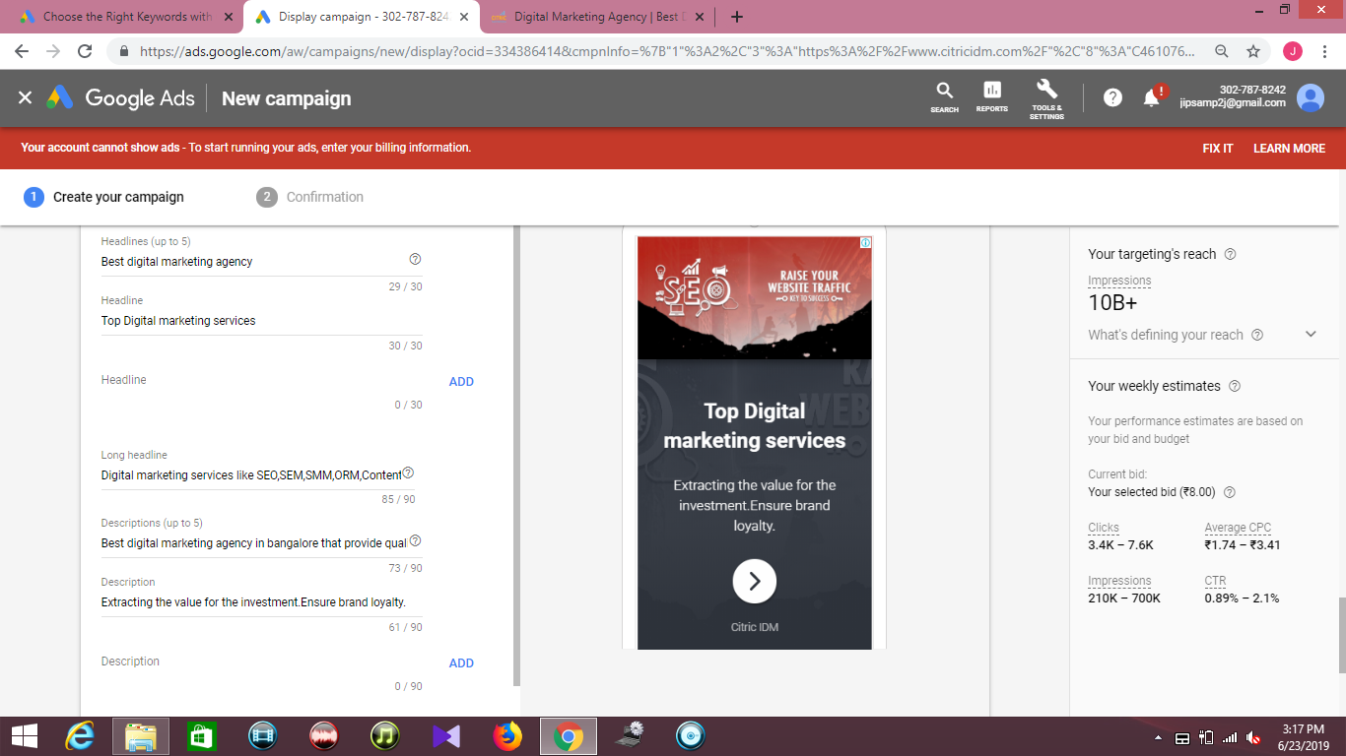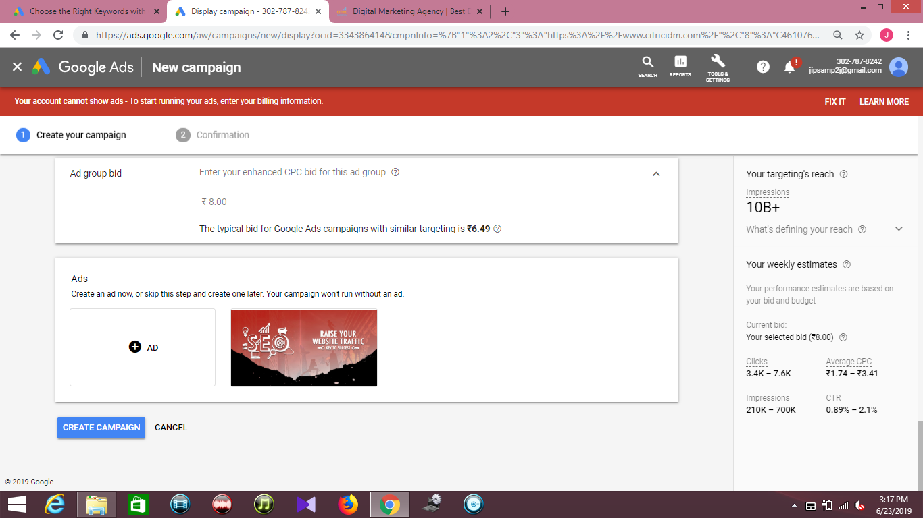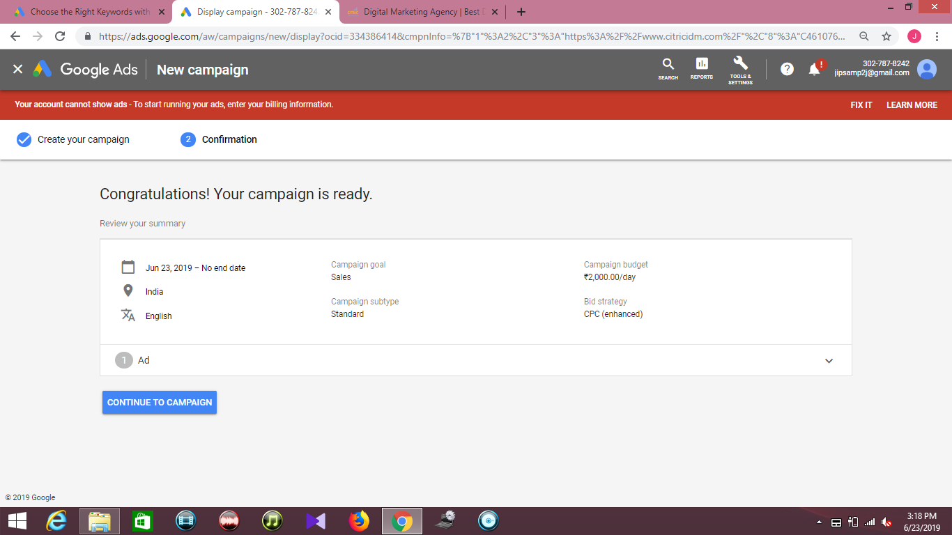**Types of Display Ads**

**1. Responsive Display Ads**

Responsive display ads are replacing responsive ads as the default ad type for the Display Network. They can be used in standard Display campaigns as well as Smart Display campaigns. To create a responsive display ad, upload your assets (images, headlines, logos, videos, and descriptions), and Google will automatically generate ads to be shown on the Google Display Network.

**2. Upload Display Ads**

The Google Display Network contains more than 2 million websites, videos, and apps, and is designed to help you find the right audience. Possible to create and upload your own image ads for a Display Network campaign without description.

**3. Copy Existing Ads**

Instead of creating new ads, keywords, ad groups and campaigns each time you want to improve your account, you can save time and work by copying your existing ads, ad groups, keywords, and campaigns. For example, you could copy an existing campaign to use it as a template for a new campaign or you could copy a keyword list from one ad group to another so that you have a head start on building your new ad group’s keyword list.

**Mention Google Partners**

Google Partners is a marketing program for advertising agencies or third-parties that manage Google Ads accounts on behalf of other brands or businesses. When you sign up for Partners, you'll get access to a range of benefits, including special events and trainings, industry research, and more.

**3) Video (YouTube) ads**

Advertise on YouTube with Video campaigns on Google Adwords. You can choose ad formats that serve with an option to skip the ad after five secondsor as a six second buffer between videos. Campaign features allow you to extend ads with shopping campaigns and with mobile app installs. Campaign setting are straight forward here, but there are a few options to select to get started.

When should you use Video campaigns?

* For creating placing your commercial video content on YouTube
* If you have video content you want to promote

# Video ad formats(Types)

In Google Ads, you can create compelling video campaigns with a range of video ad formats to engage customers in different ways on YouTube and across video partner sites. Available video ad formats include: skippable in-stream ads, non-skippable in-stream ads,  video discovery ads, Outstream ads, and bumper ads.

While video ad content must be hosted on YouTube, video ads can appear on YouTube and on video partner sites and apps across the Google Display Network, [including on tablets and mobile devices](https://support.google.com/google-ads/answer/9128498) (depending on your format and settings).

**Instream Video Ads**

**1. Bumper or Skip Ads**

A bumper ad is a skippable video ad format created to extend the reach of a campaign. It appears before the video the user has chosen to view. Sold on a CPM basis, Bumper ads perform well on mobile devices. Maximum video length is 6 seconds. Like non-skippable ads, bumpers are paid for on a CPM basis.

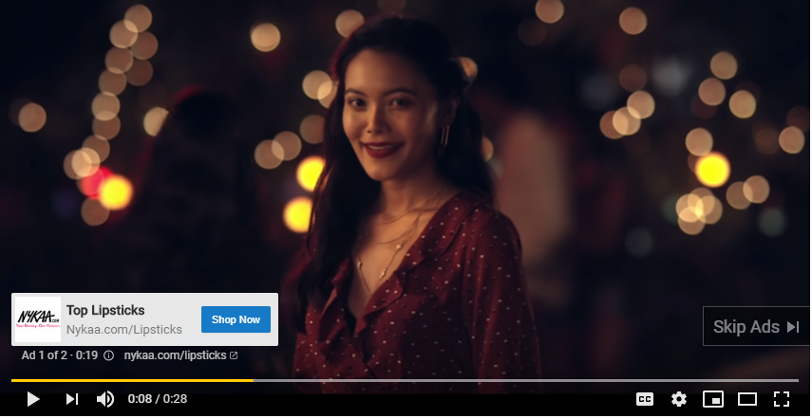

**2. In Display Ads**

An in-display ad is a YouTube video ad format that appears in side YouTube video with small text description.

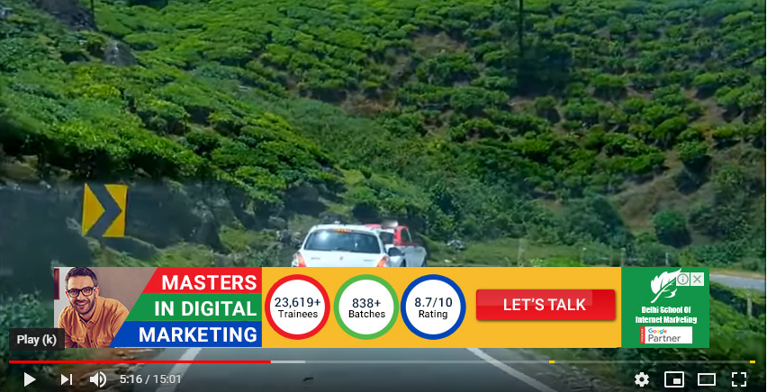

**3. Master Head**

A YouTube Masthead is a digital billboard placed on YouTube’s homepage for 24 hours, reaching roughly 60 million people (YouTube receives 1.8 billion users/month).

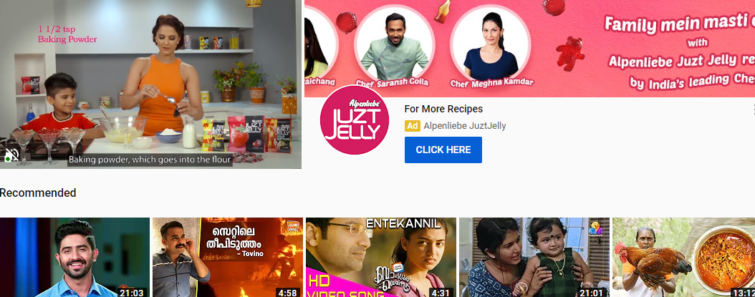

**4. In-search or True view**

In-search/True view ads appear in YouTube search results when the viewer's search is related to the ad's keywords. Sponsors pay for ads that the viewer begins to watch.

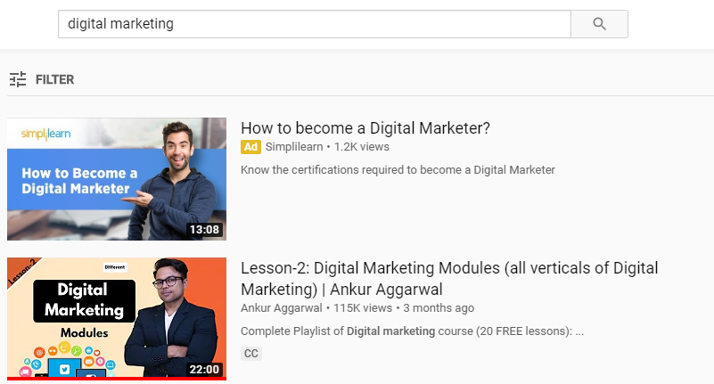

**5. Non skippable ads**

The non-skippable video ad is an ad format that may appear pre-, mid-, or post-roll while viewing content which cannot be skipped.

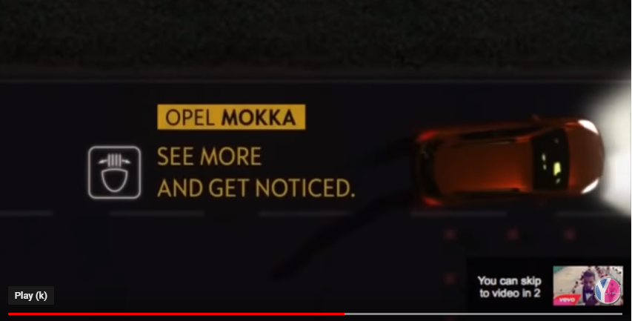

**6. Roll-over ads**

Roll-over ad refers to ad that plays in the middle of content, rather than before or after the publisher's video content. It is simply the ads played in between the videos.

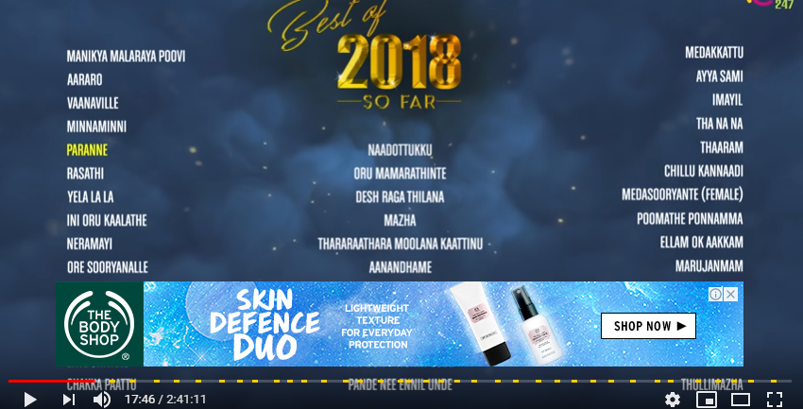

**OutStream Ads**

Outstream video ads are very high-quality video ads served outside of a video player or third party websites, between paragraphs of text, typically without sound. They are designed to be 100% viewable, magically deploying and playing when the unit is onscreen. The format is seamlessly integrated within desktop and mobile and is non-intrusive to the user experience. This ensures high CPM's and higher earnings for you.

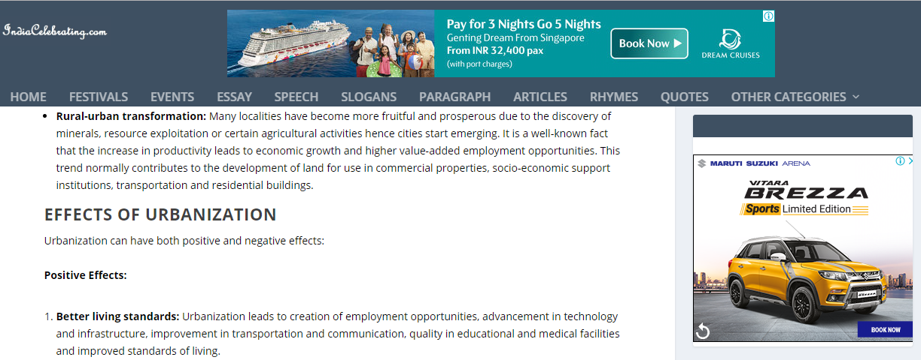

**Steps to create Video ads**

**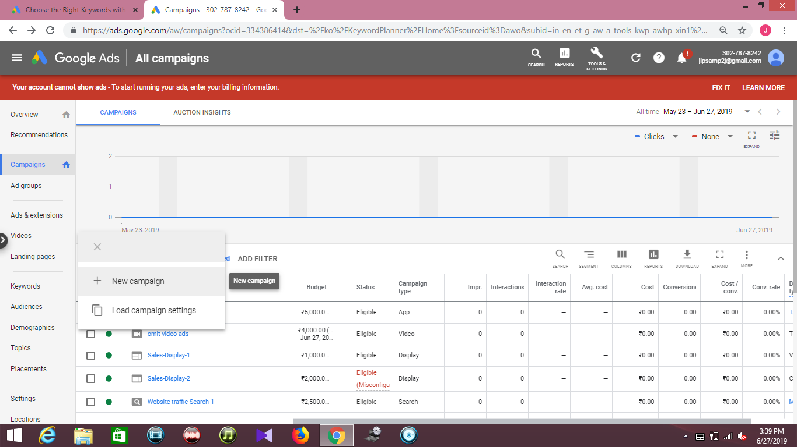**

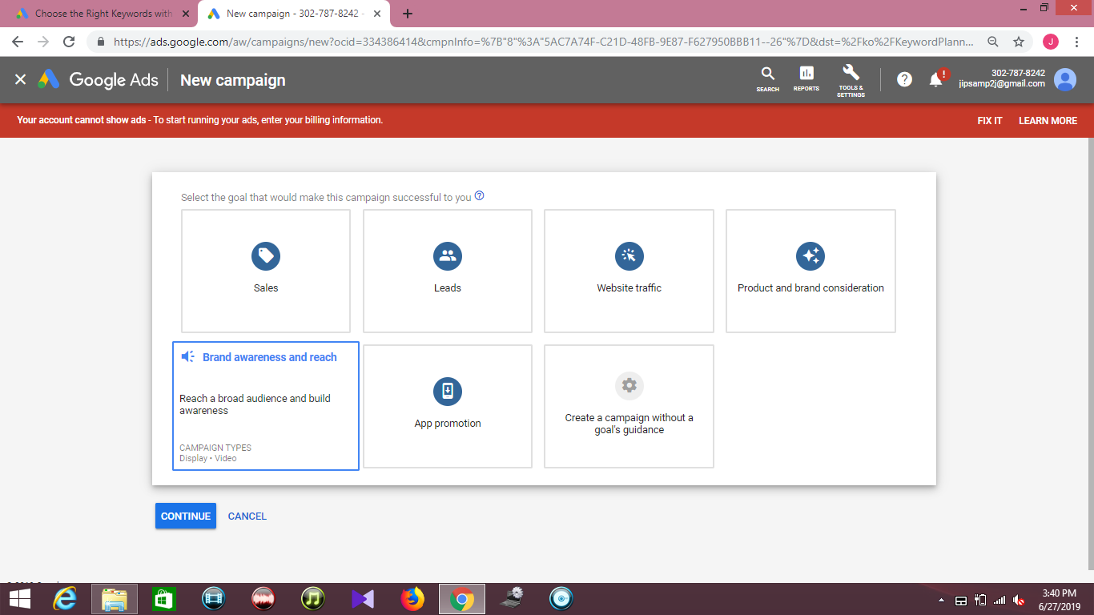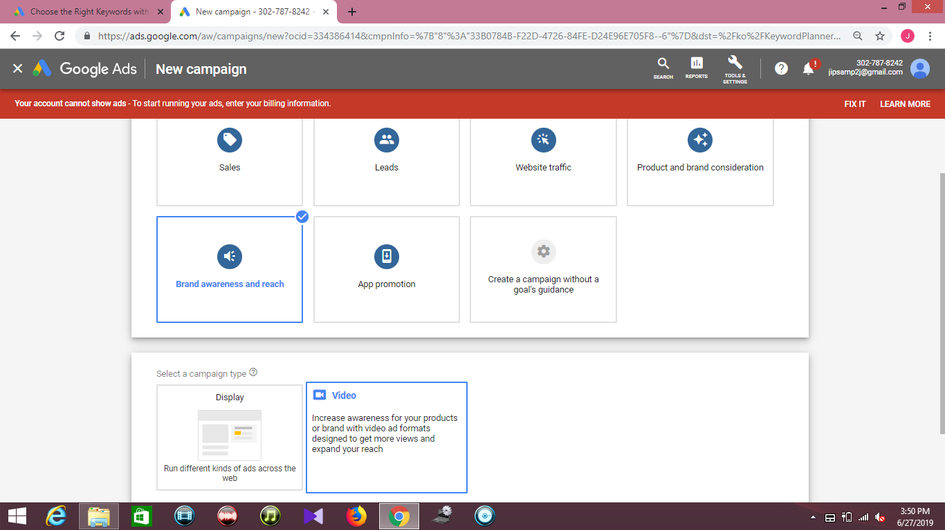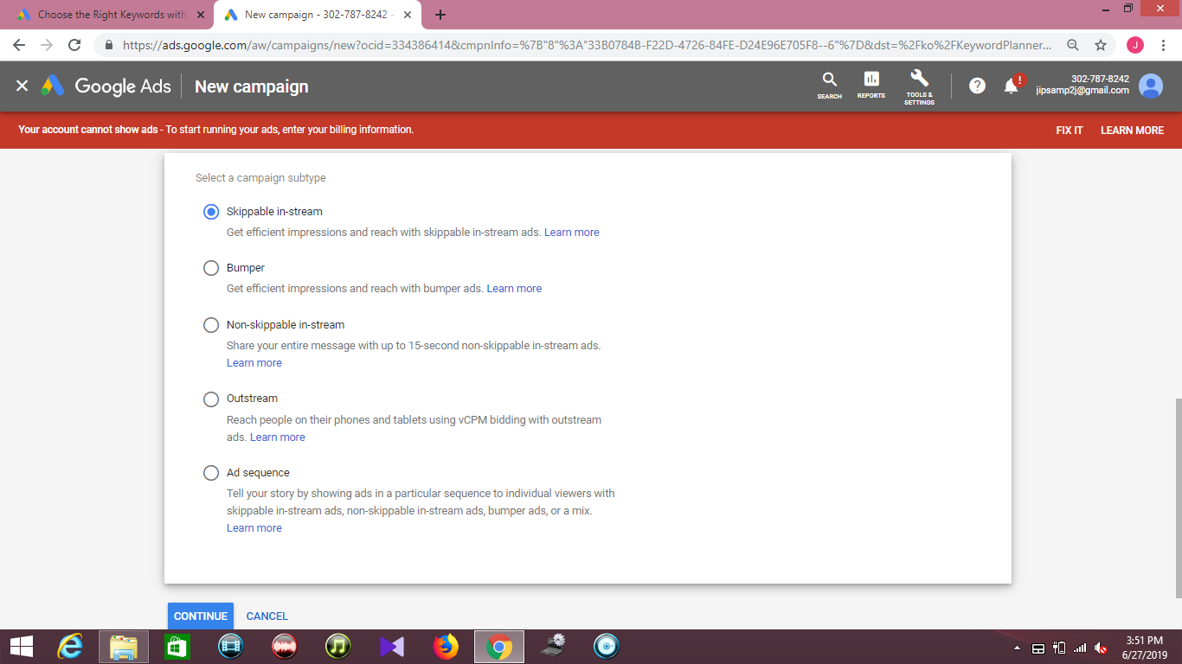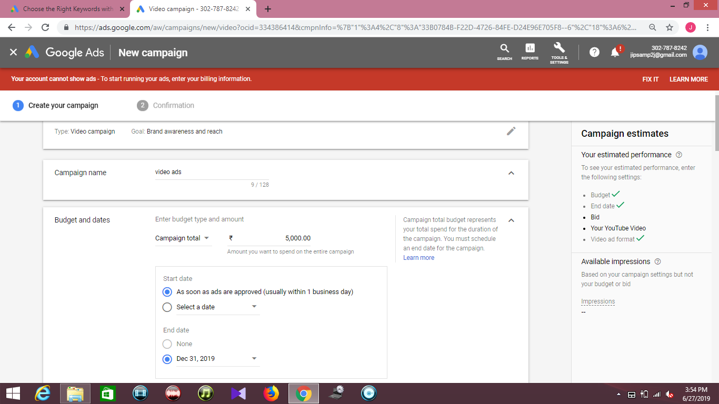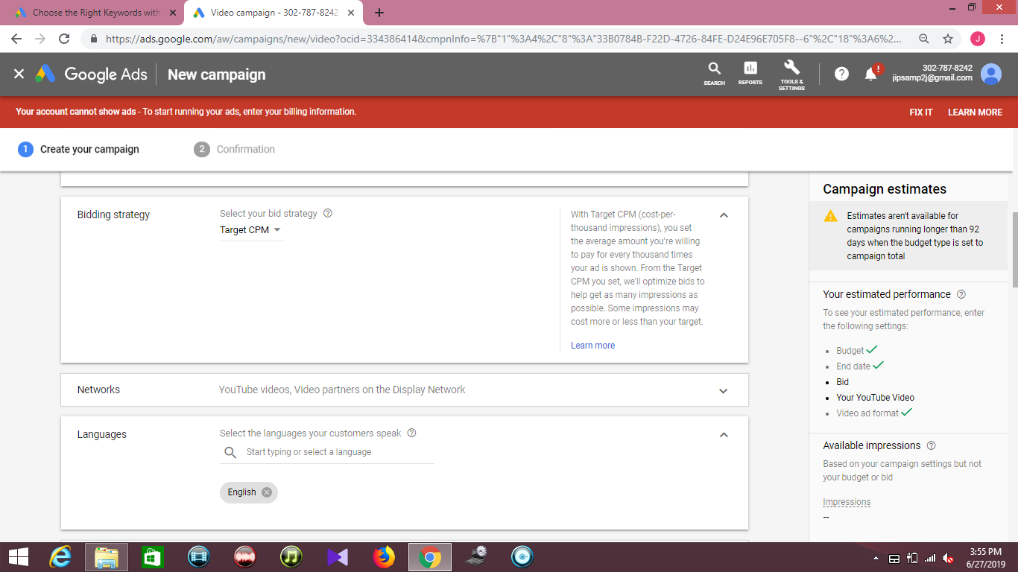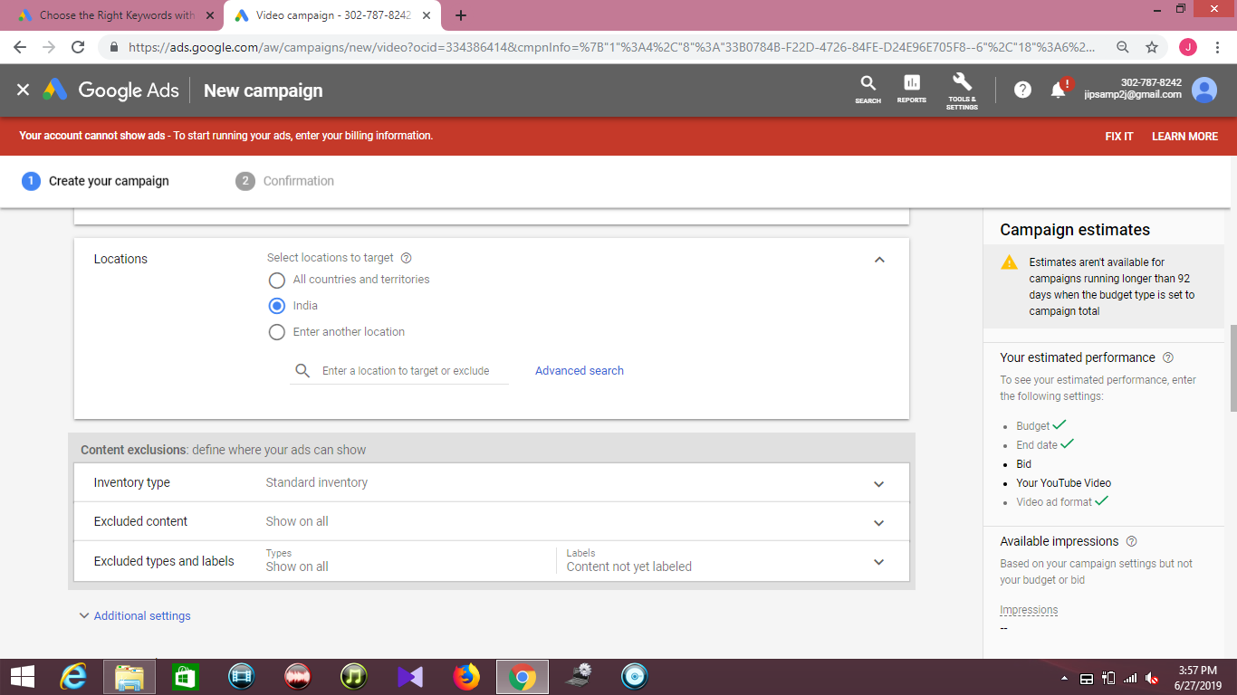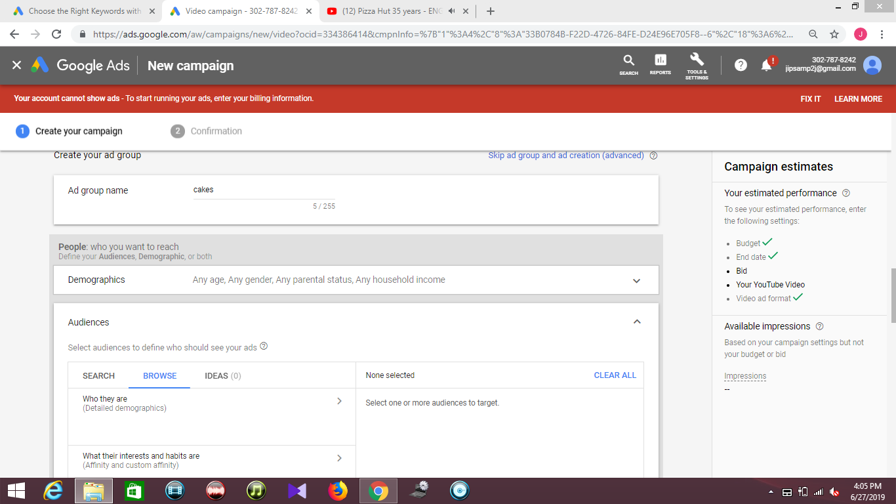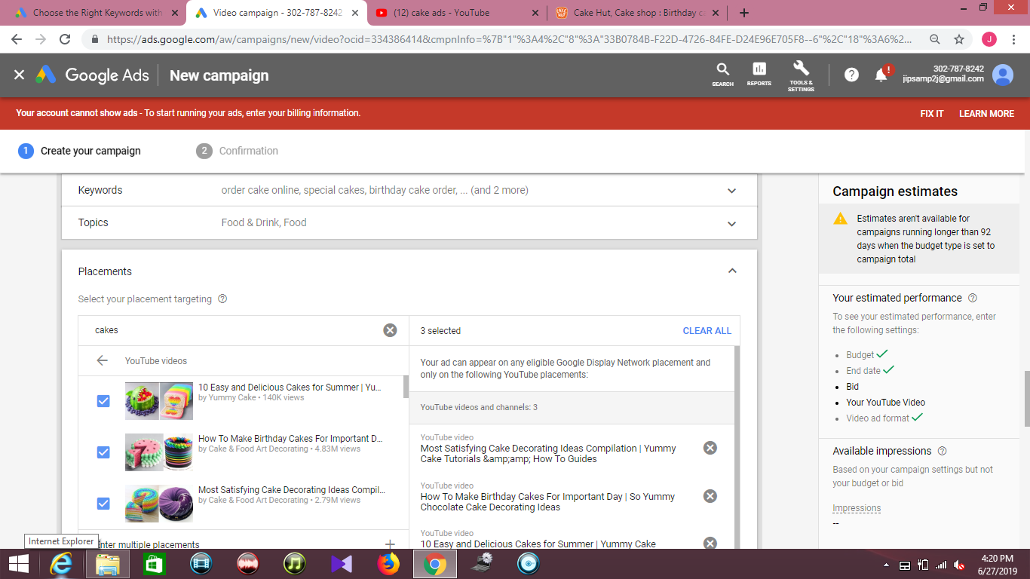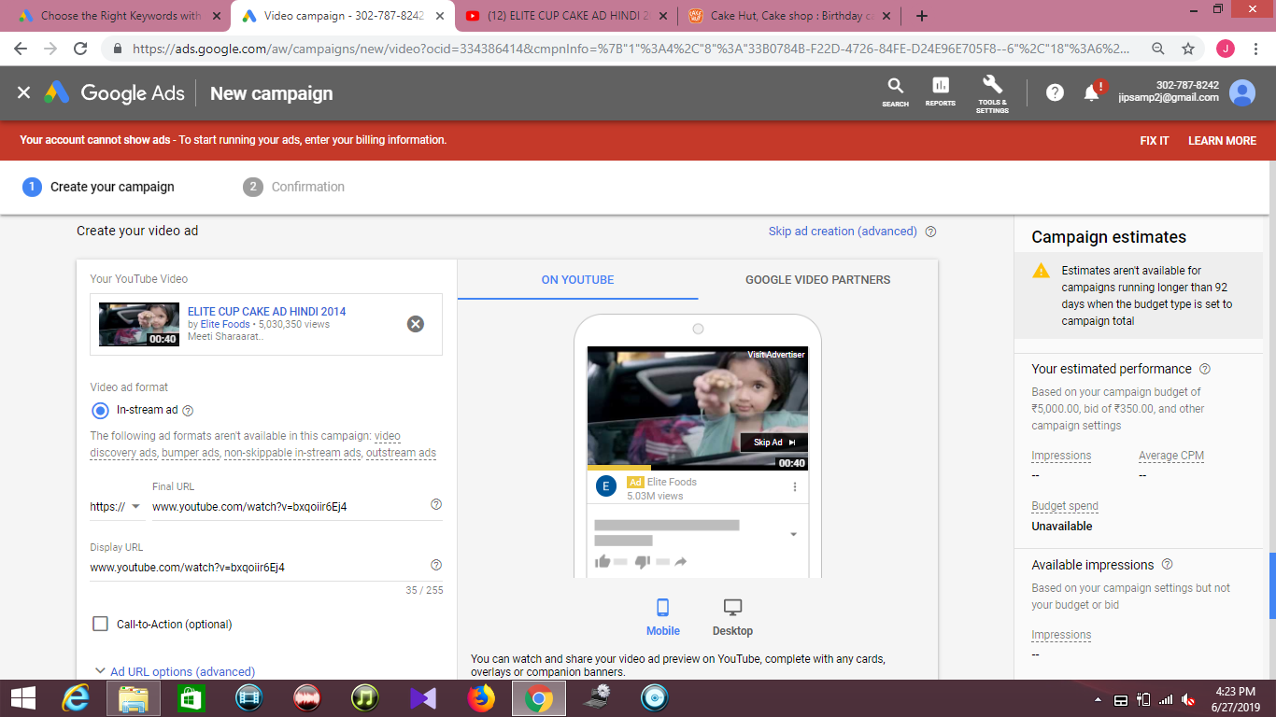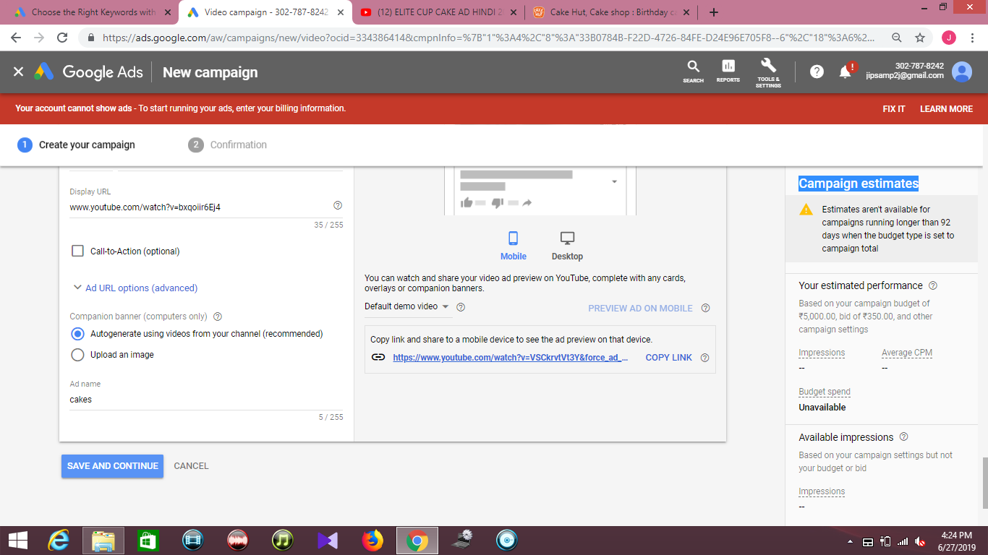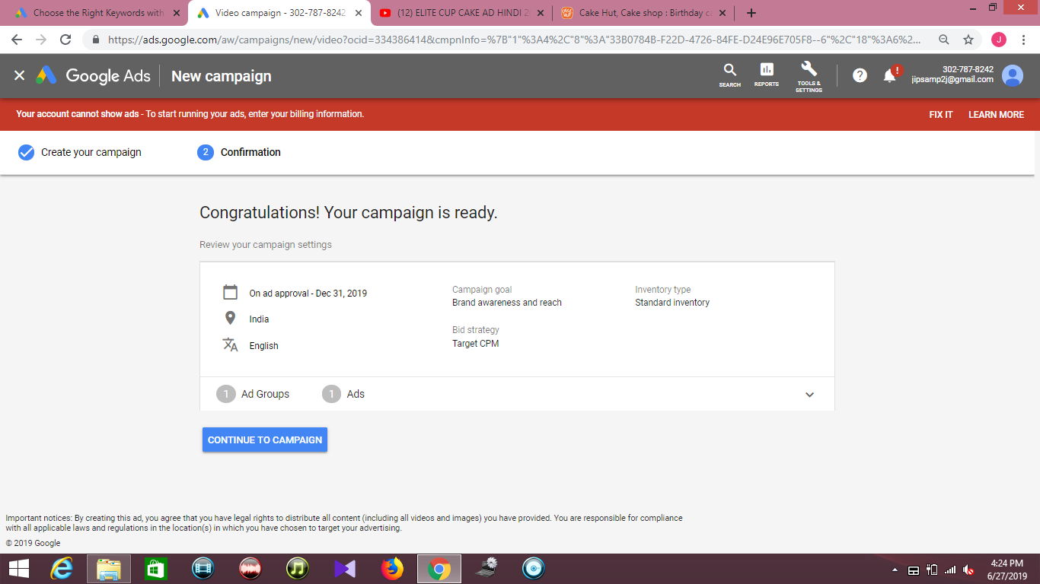**4) Universal App Campaign**

Universal app campaign (UAC) is a campaign that allows you to easily promote your Android or iOS apps across Google's top properties including Search, Play, YouTube, and the Google Display Network. This guide shows how to create one, set targeting, and run reports.

Universal App Campaigns (UAC) are an automated ad type in Google Ads that help advertisers generate more app installs and/or drive in-app conversions. They do this by using machine learning to identify your best performing ads and show them to the most relevant users.

When should you use Universal App Campaign?

* If you have a new or existing app
* If you want to drive in app sales

**Where can Universal App Campaigns run**

While before the introduction of Universal App Campaigns you had to run separates ads on AdMob, YouTube, and Google Ads to target each of Google’s properties, this is no longer necessary. With UAC ads, you’ll now show up in the following places:

* Google Search
* Google Play
* YouTube
* Google Display Network

**Why app Campaigns known as Machine Learning ads**

Universal App Campaigns (UAC) are an automated ad type in Google Ads that help advertisers generate more app installs and/or drive in-app conversions. They do this by using machine learning to identify your best performing ads and show them to the most relevant users.

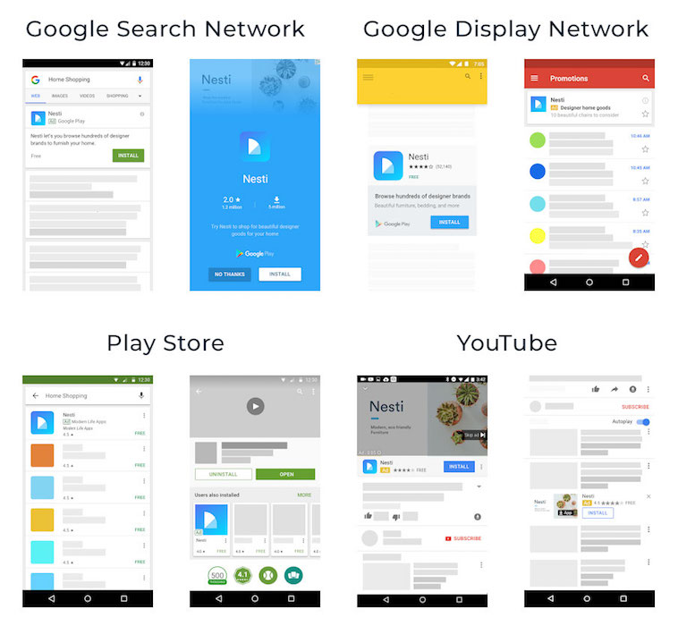

**How do Universal App Campaigns work**

Advertisers don’t need to create ads for each different ad placement. Instead, Google will create ads for you from the text and digital assets you set. Google also manages bidding and targeting to maximize campaign results for your set goal and budget.

**What still needs to be done manually:**

* A daily budget
* A target cost-per-install (CPI) or cost-per-action (CPA)
* Target location
* Target languages
* Up to four different lines of text of a maximum of 25 characters in length
* A campaign start date (end date is optional)

The biggest consideration when building your UAC ad is the campaign objective. You have two options:

* **Install Volume (CPI)**
* **In-App Actions (CPA)**

Both goals optimize ads according to your set bid. Install volume ads use a cost-per-install (CPI) pricing model, while in-app actions use cost-per-action (CPA).

**1. Create app promotion on Youtube**

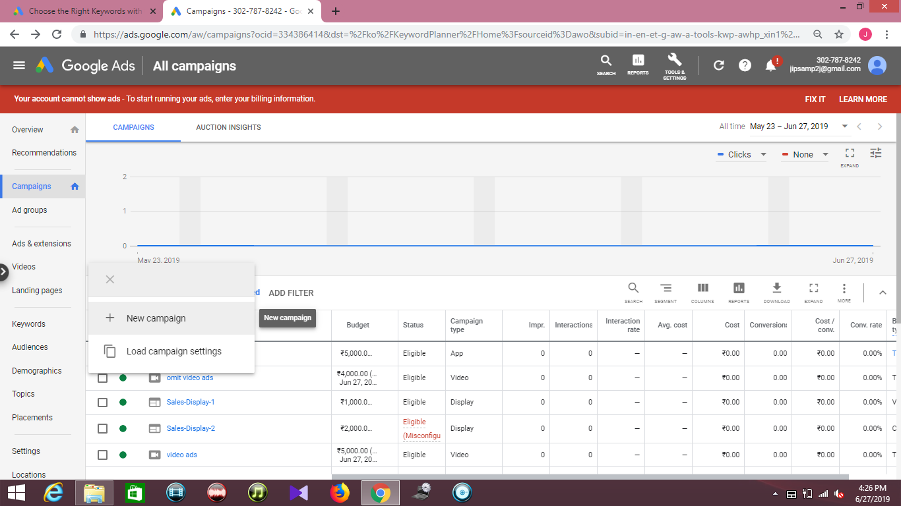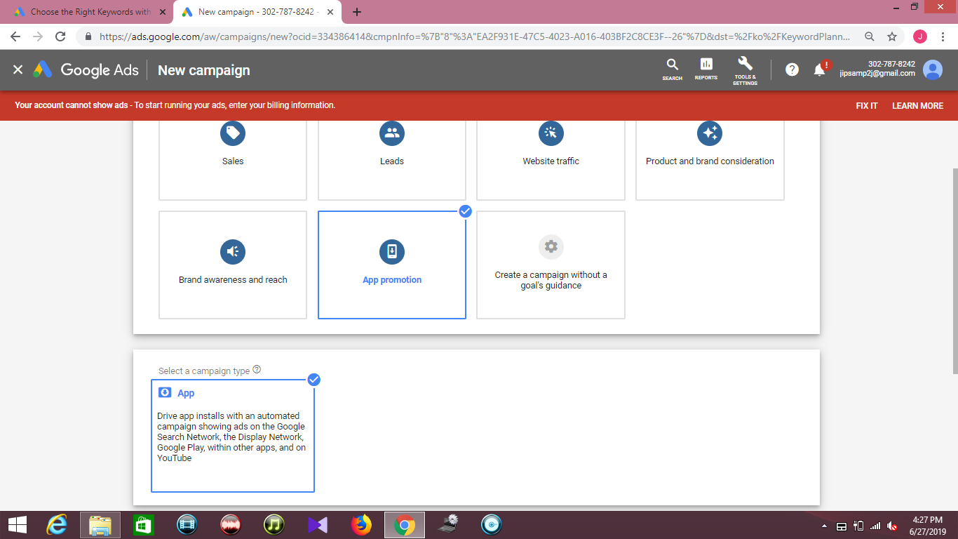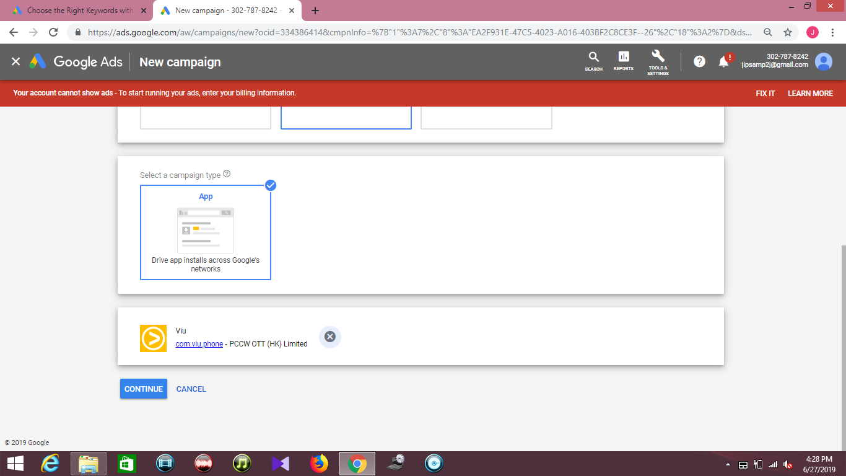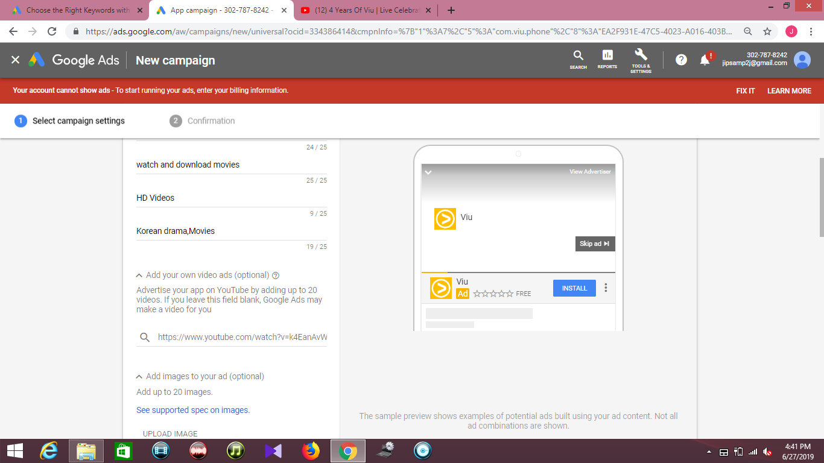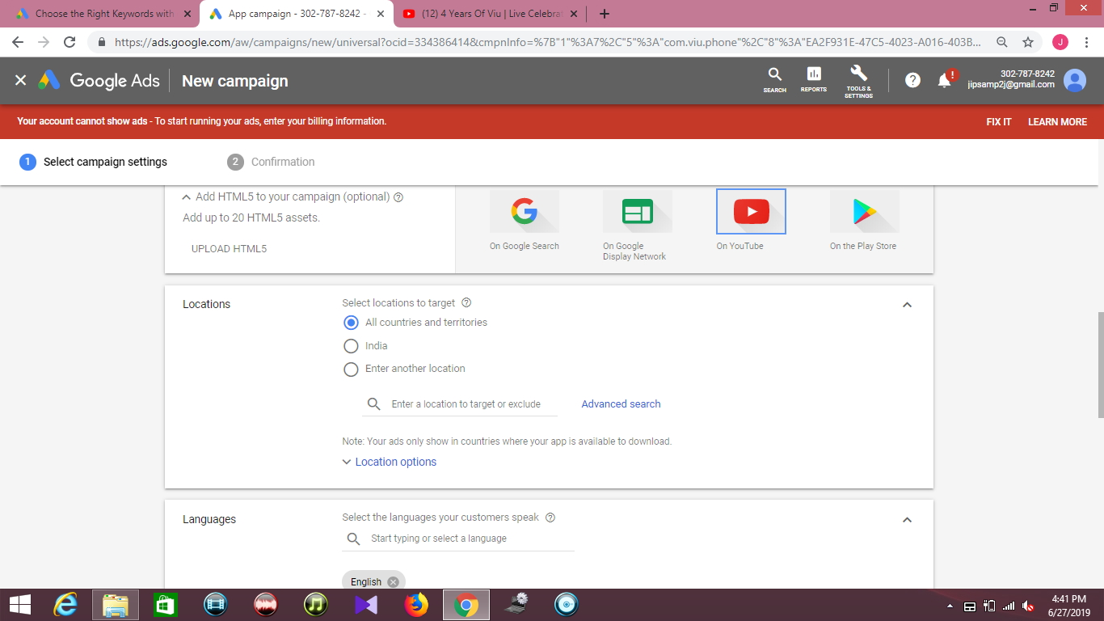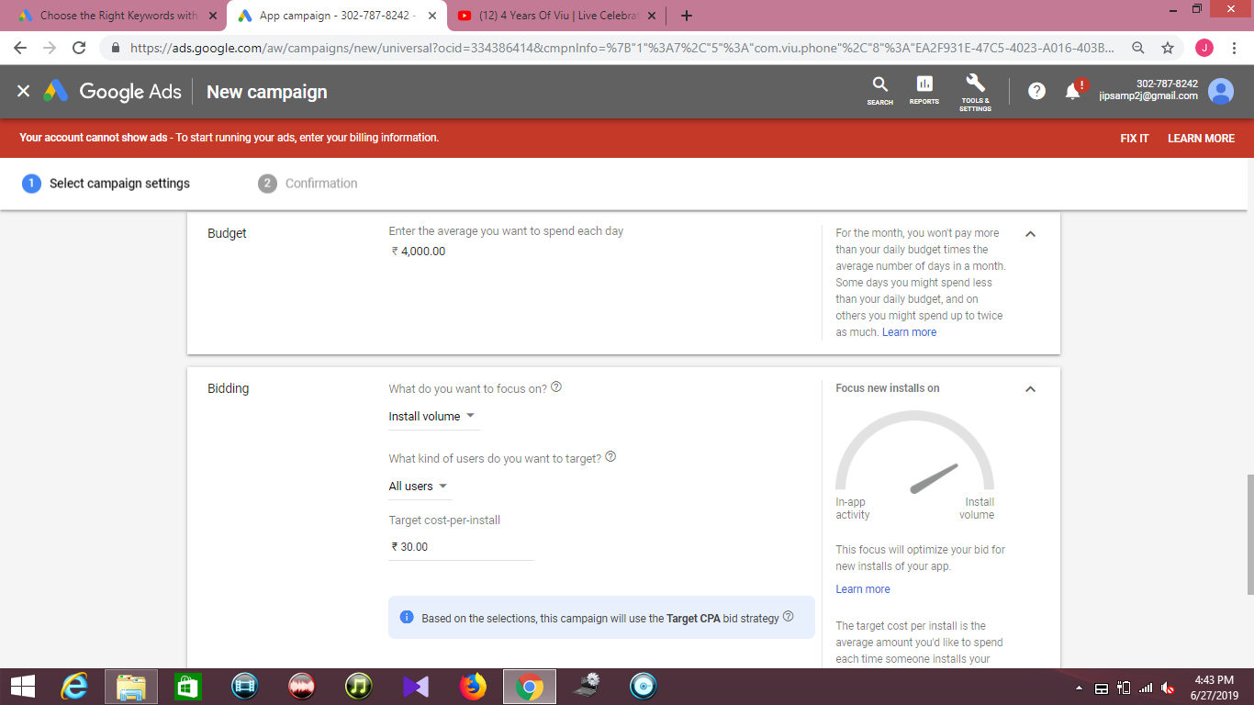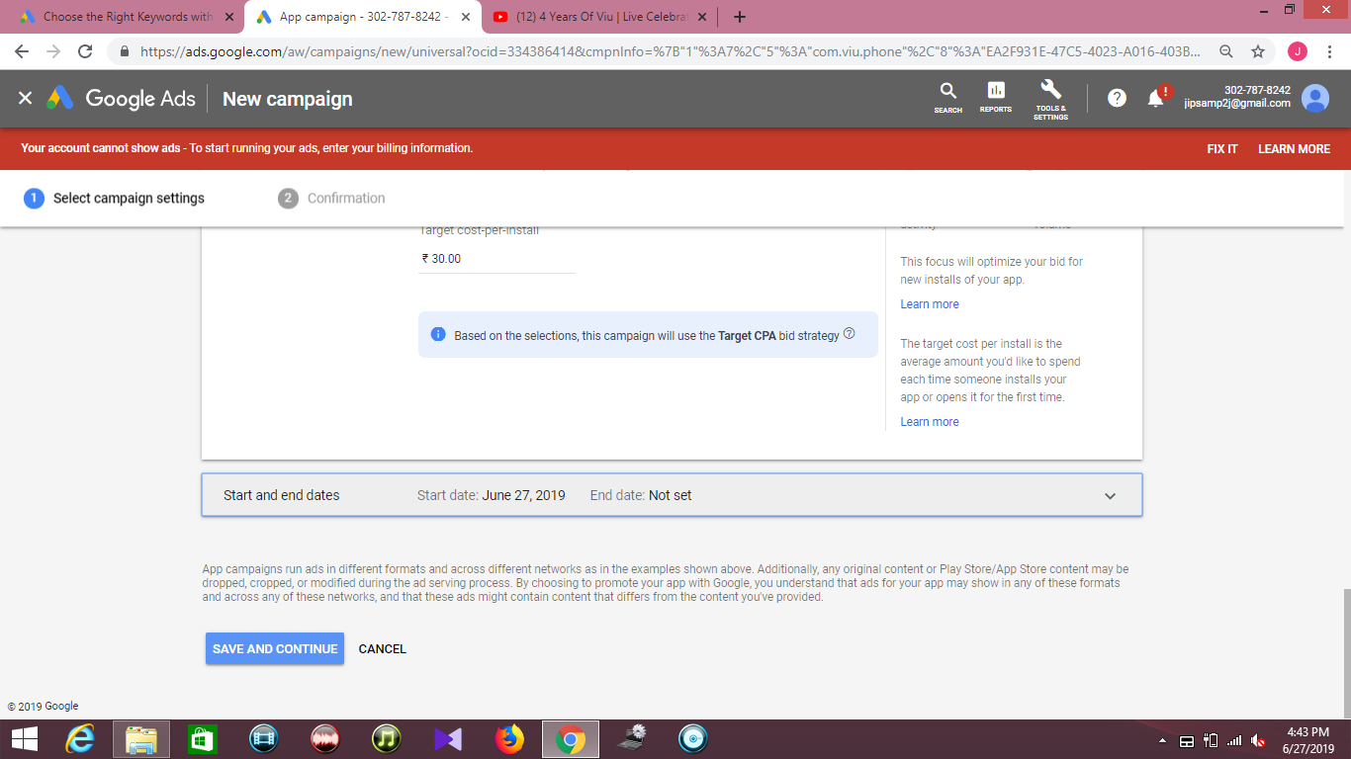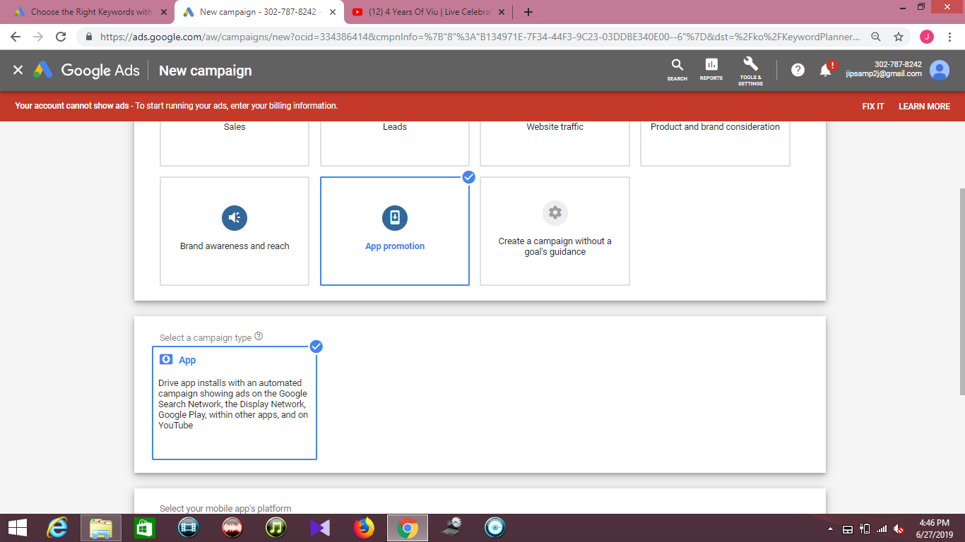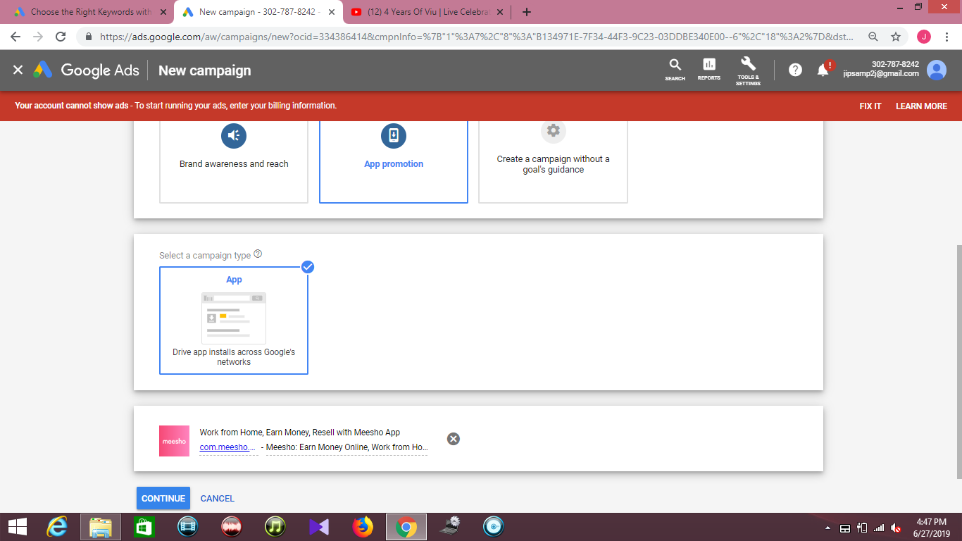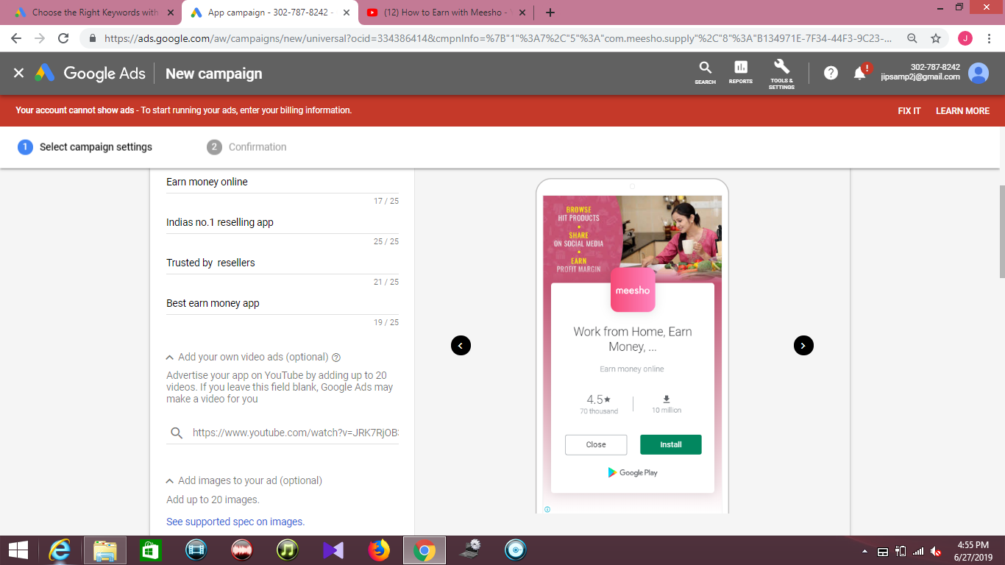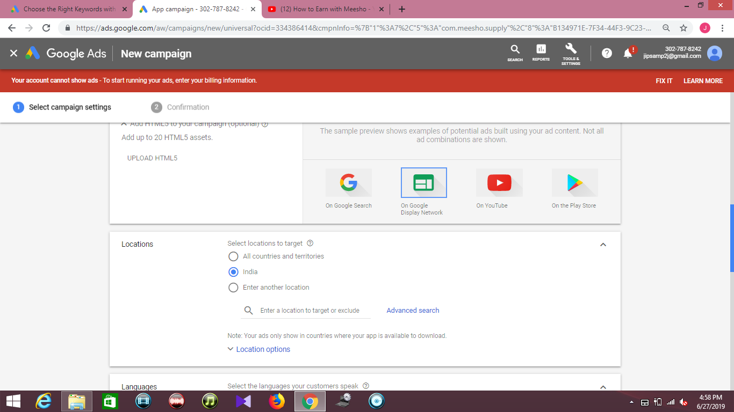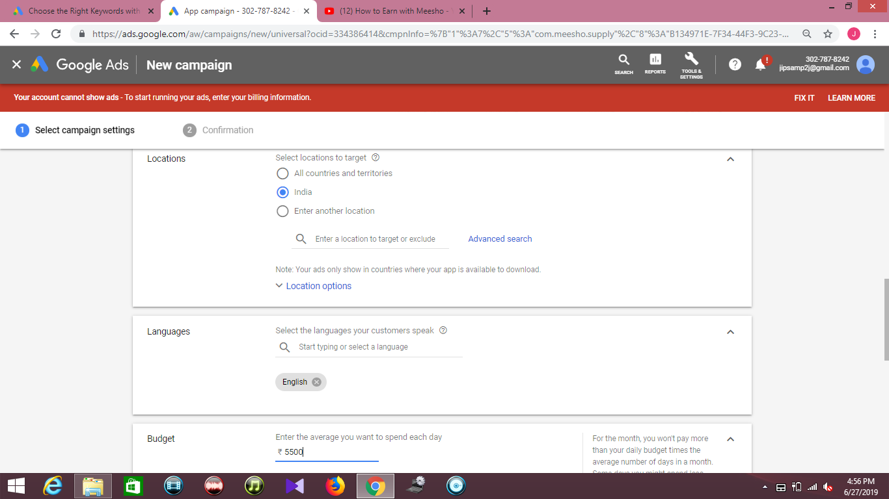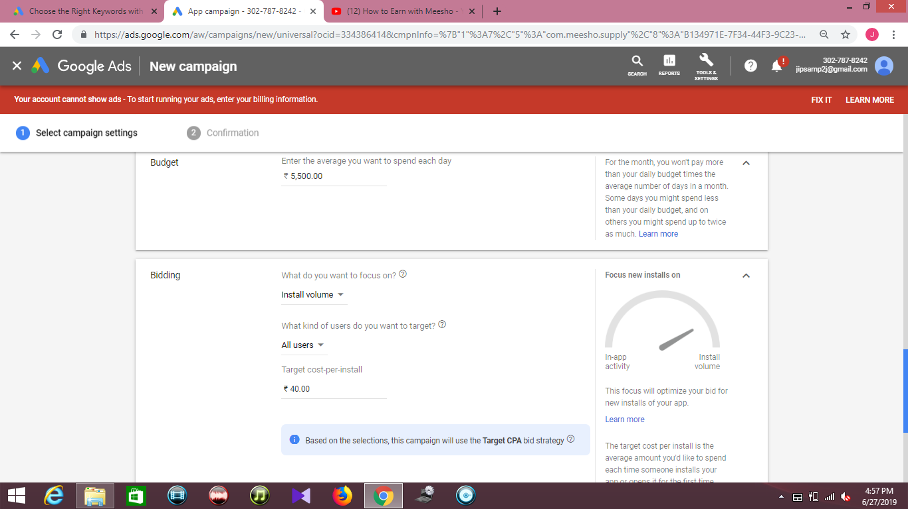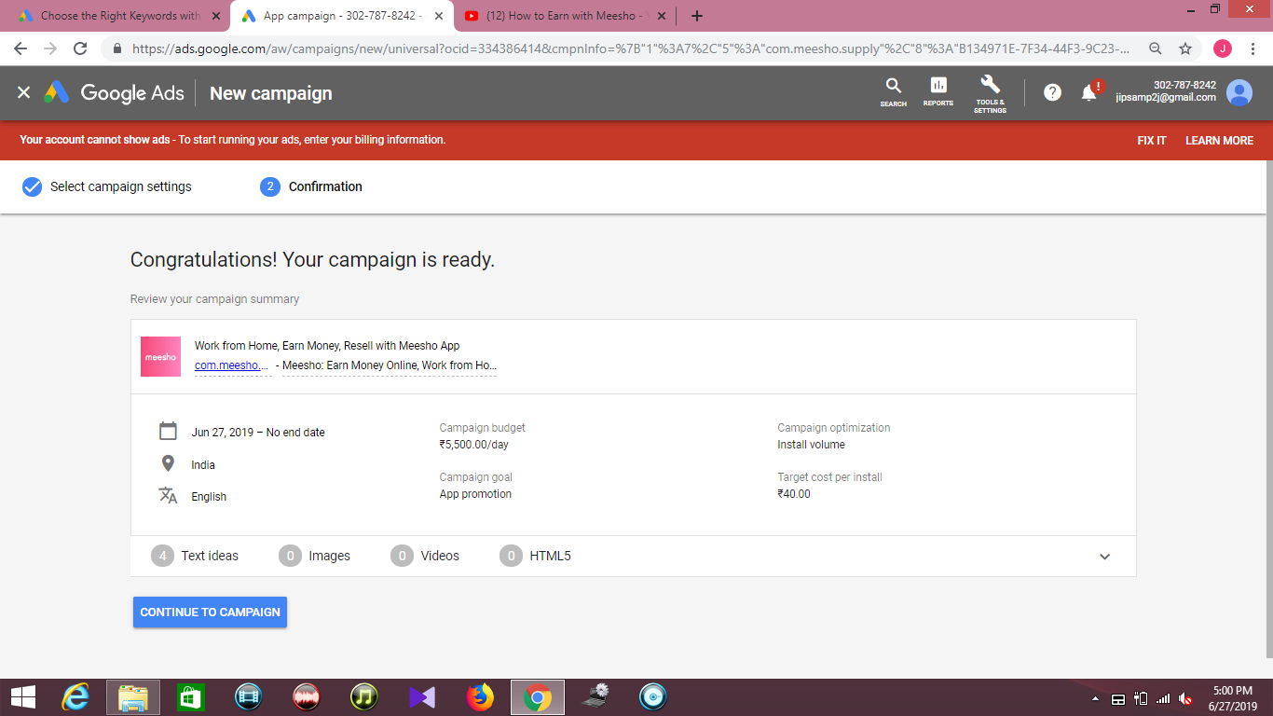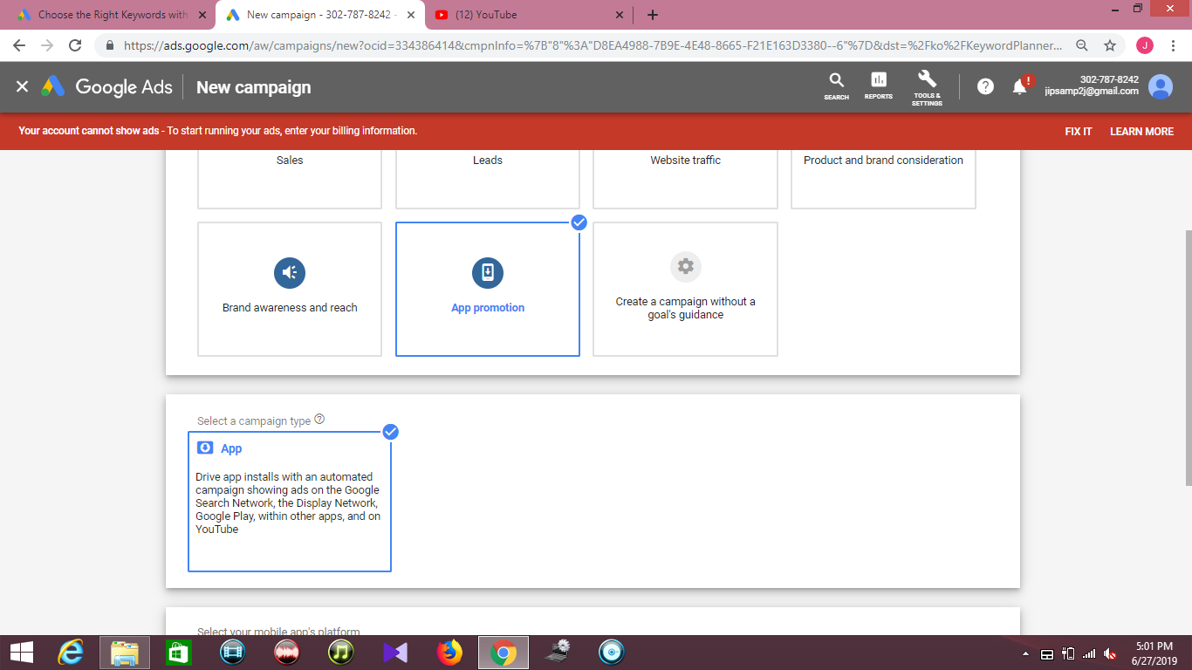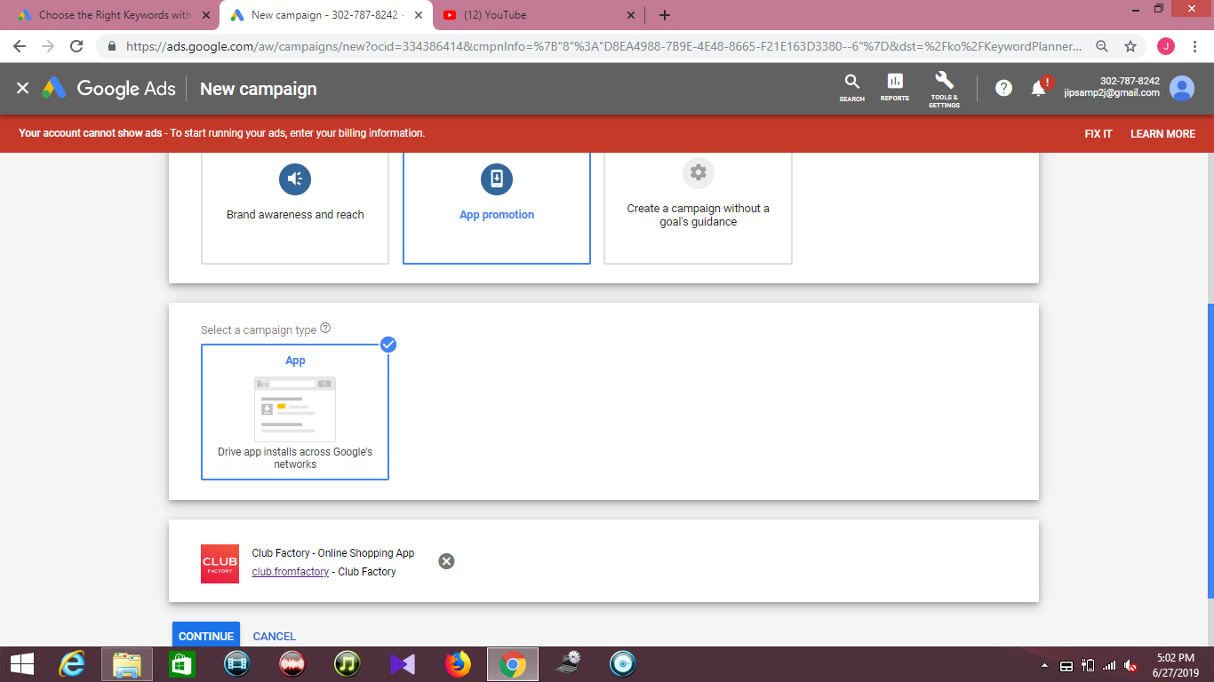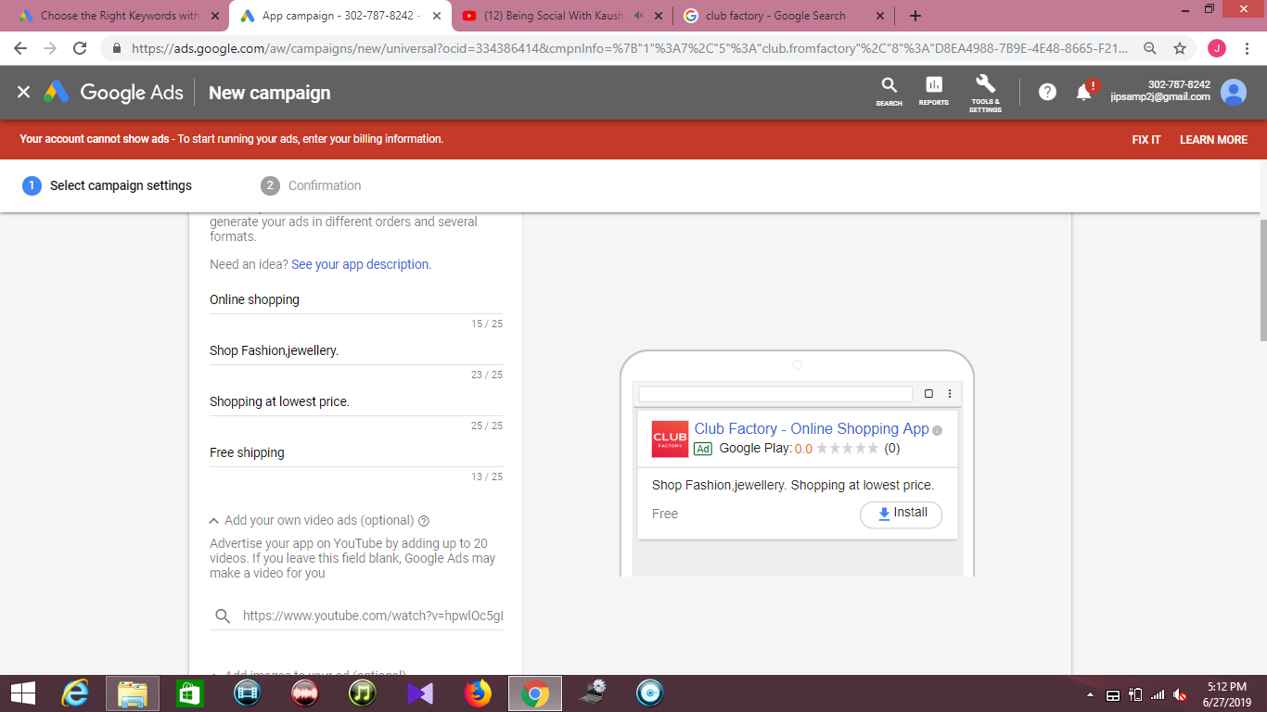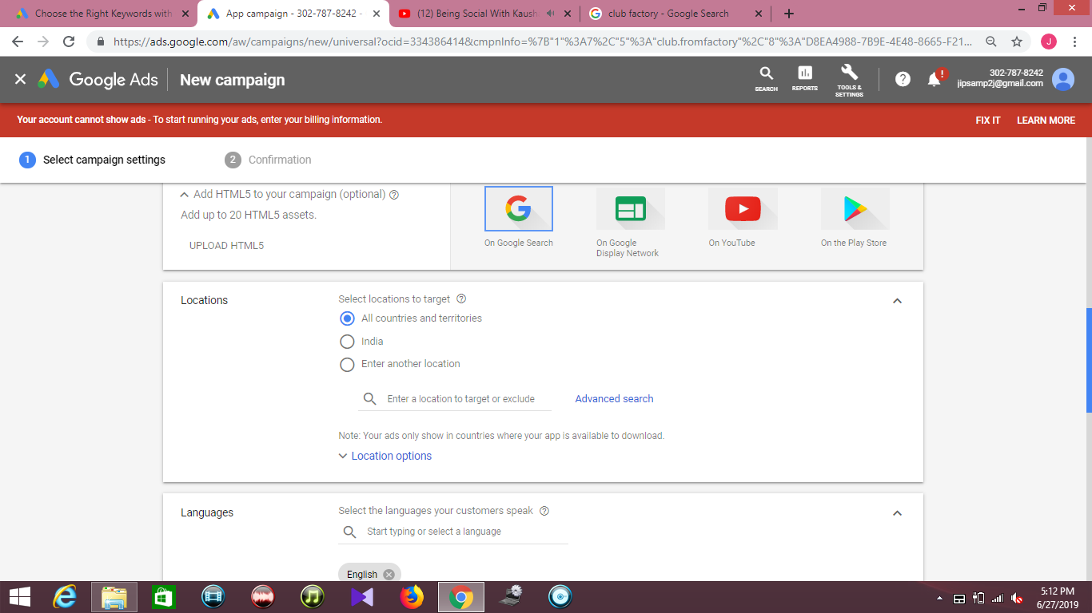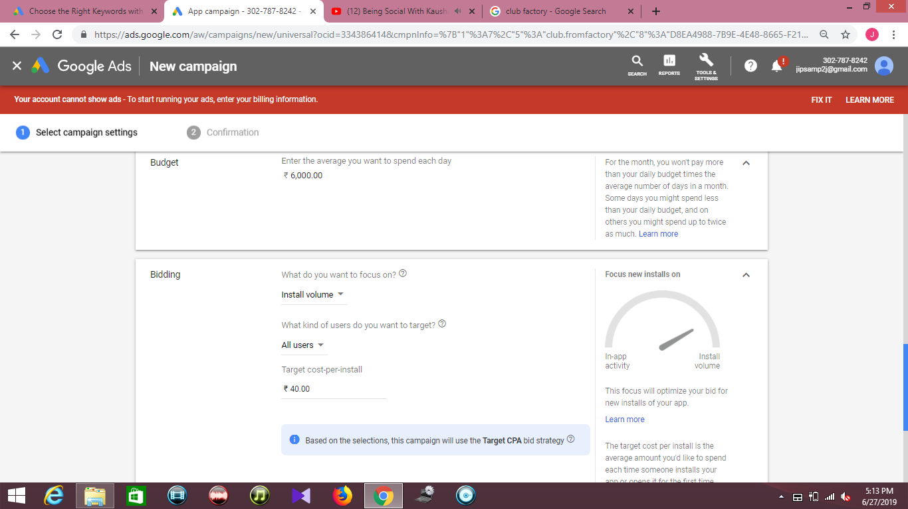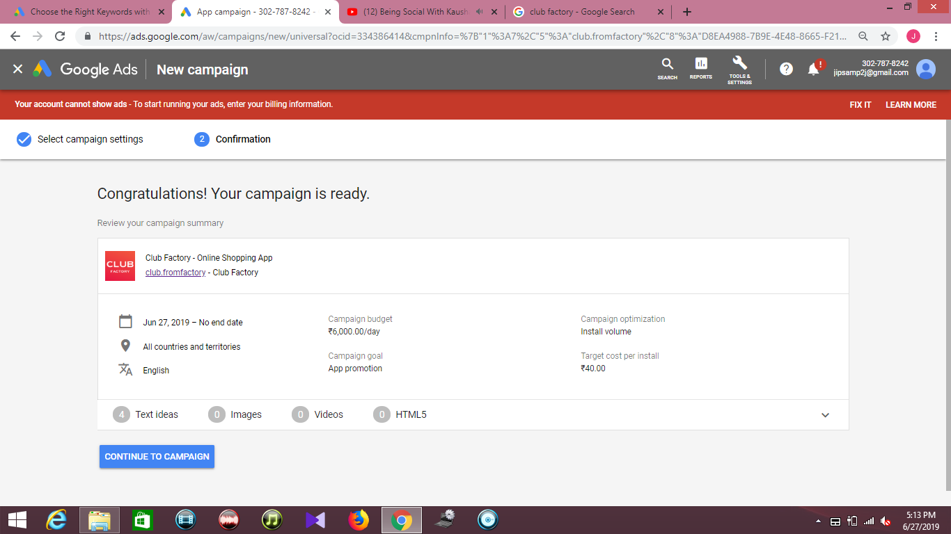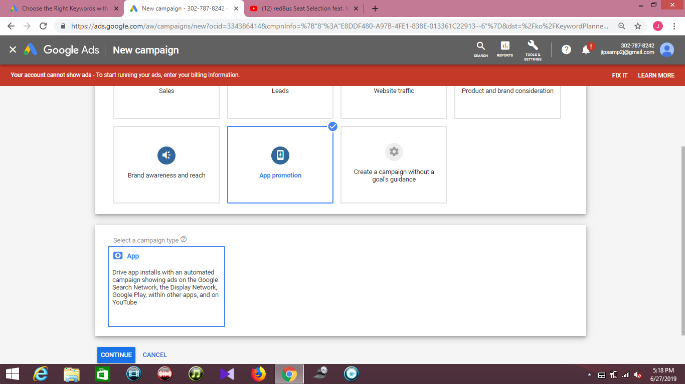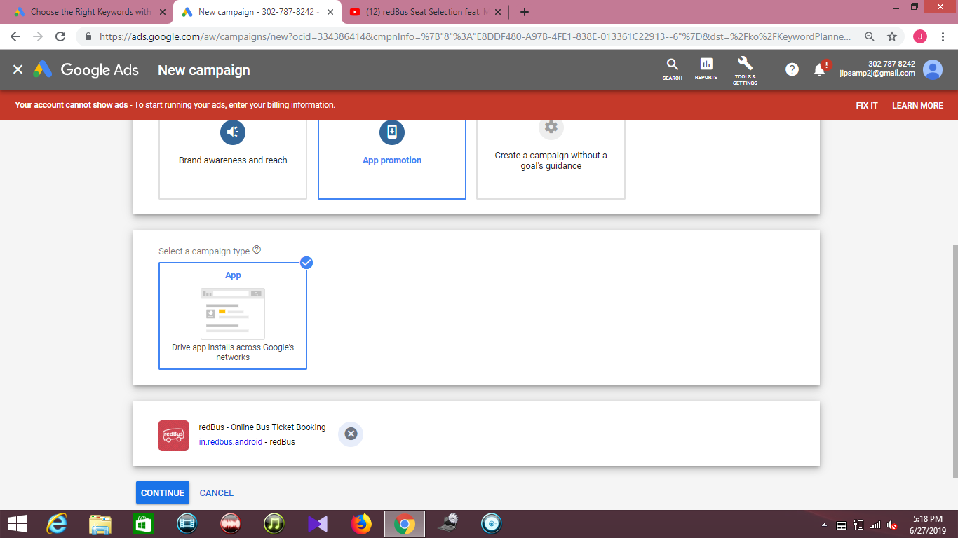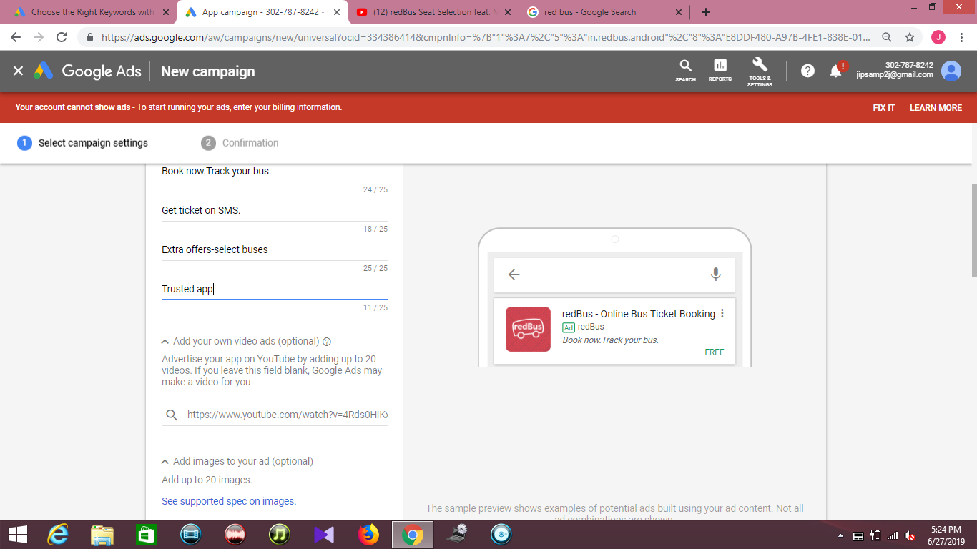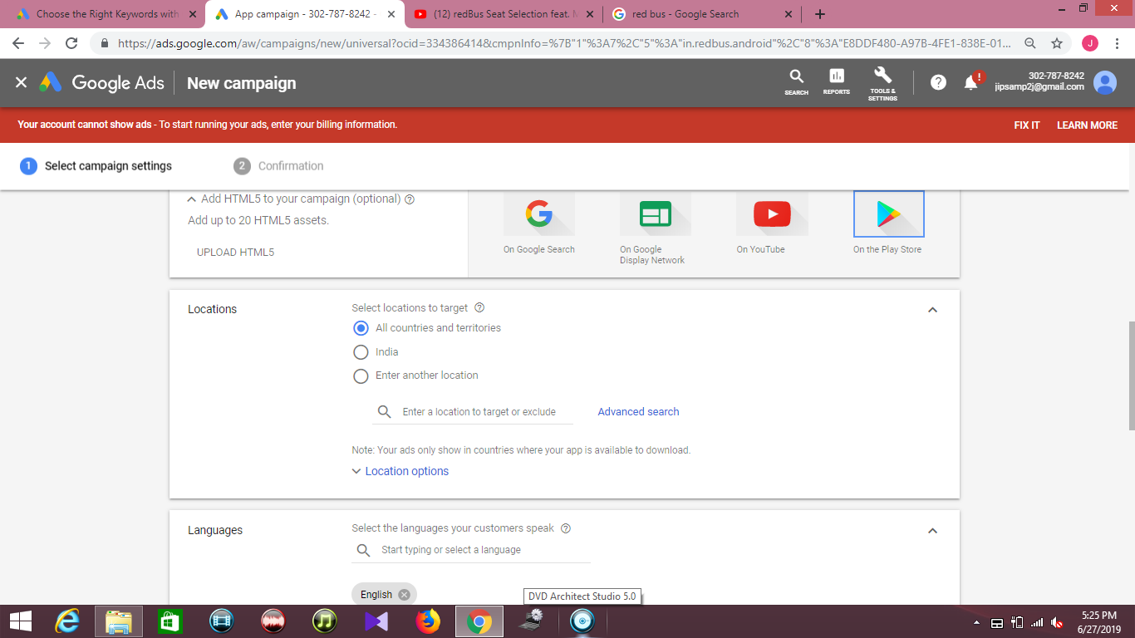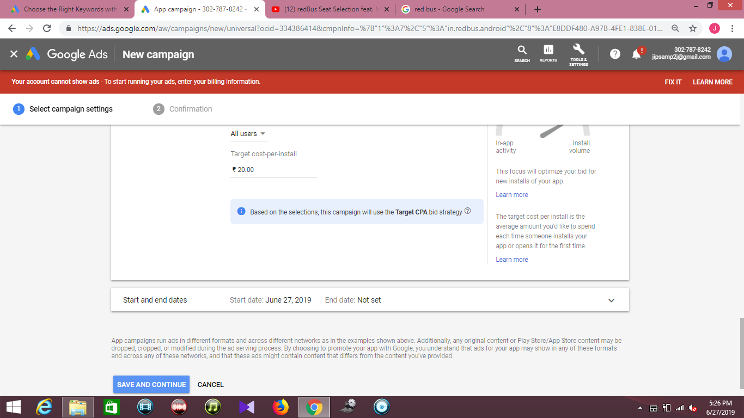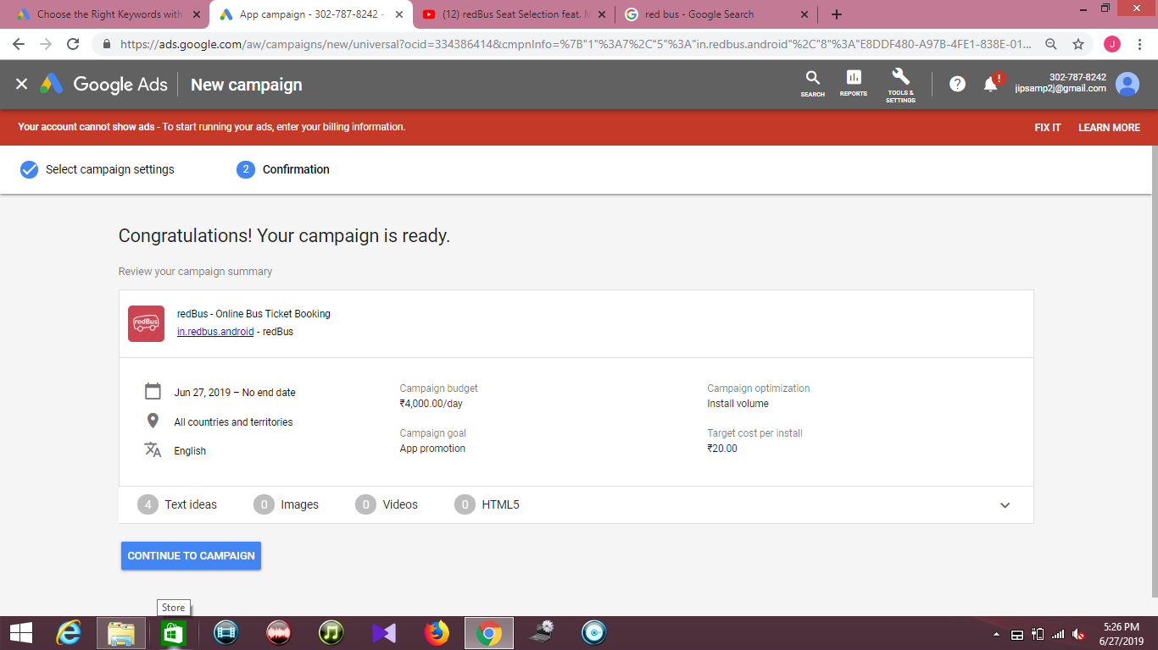**5) Shopping Ads**

Google Shopping ads don’t have much setup and there aren’t many features to select. If you want to show products from your eCommerce store in Google Shopping, then you’ll need to setup the Google Merchant Center. While the process is not difficult, there can be roadblocks depending on how your eCommerce store is setup. If Google Merchant Center is setup and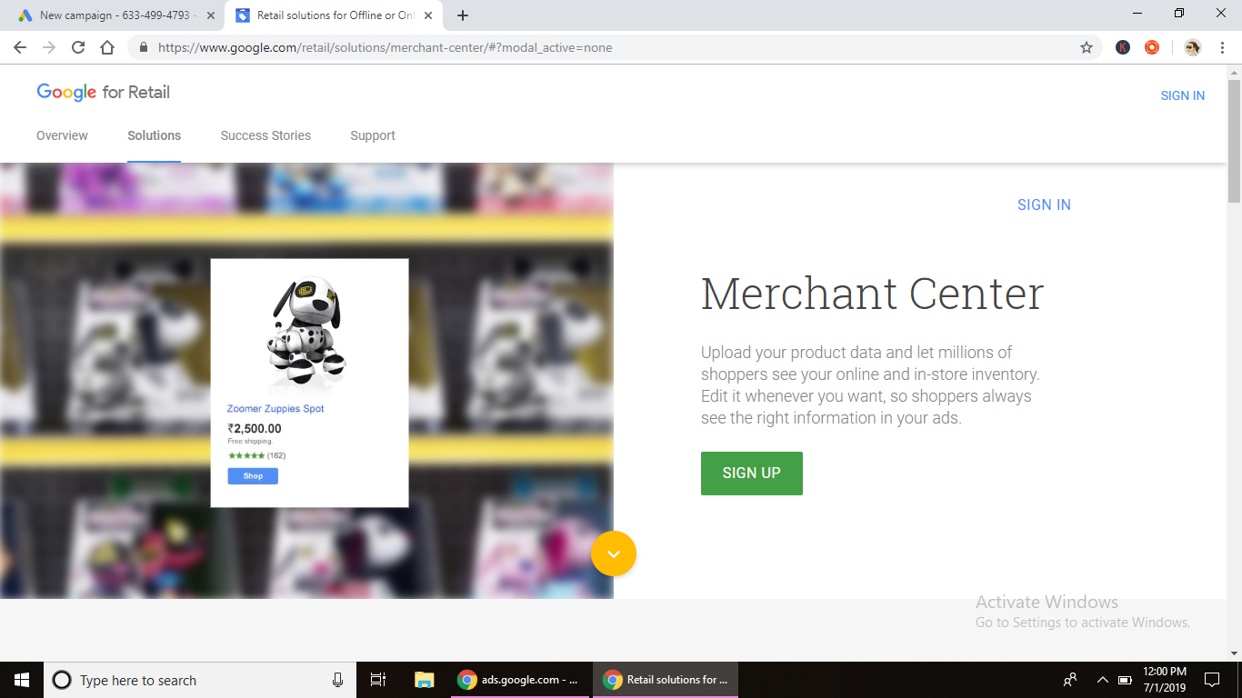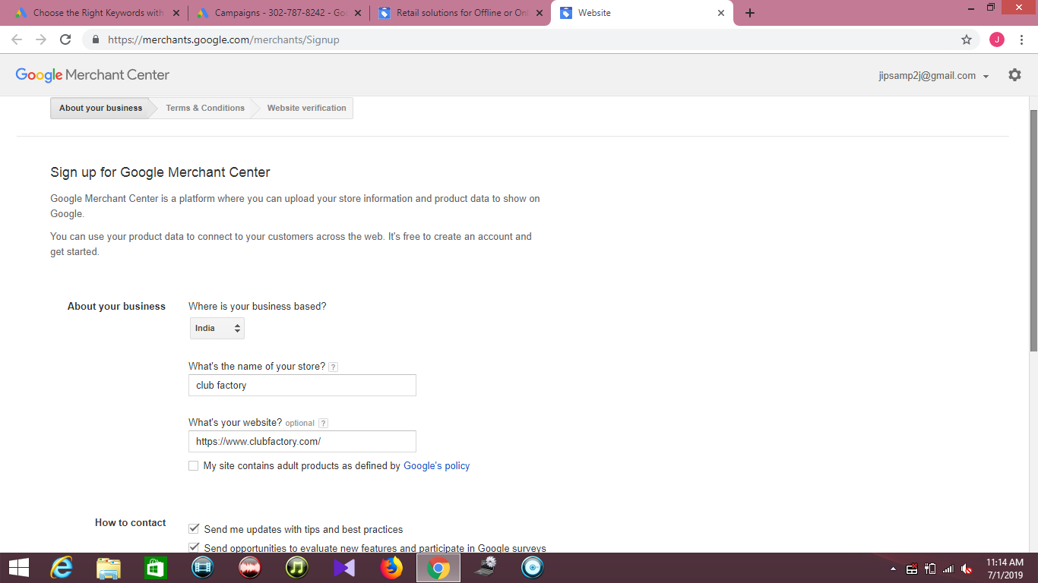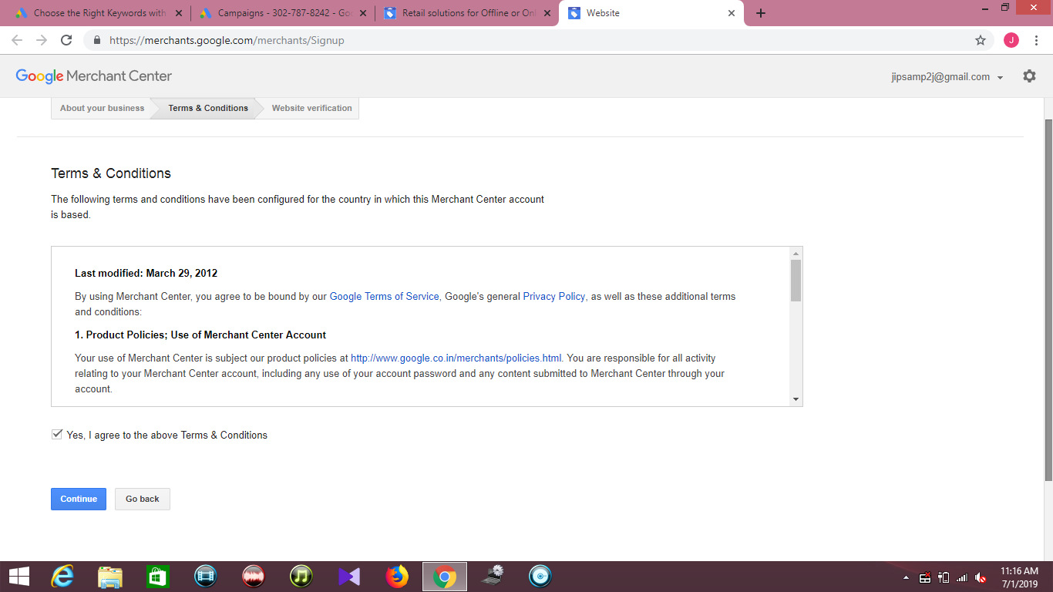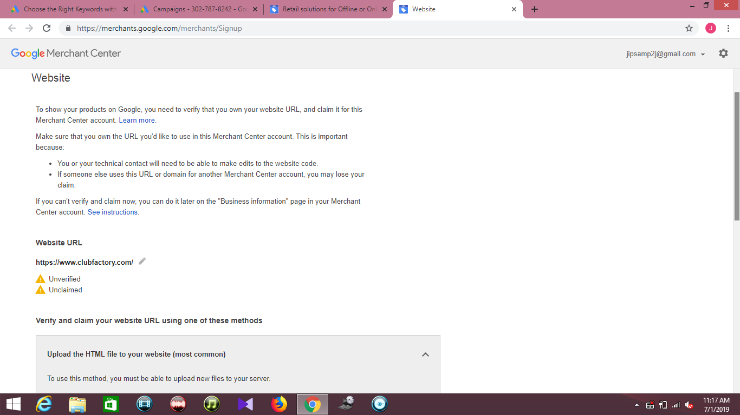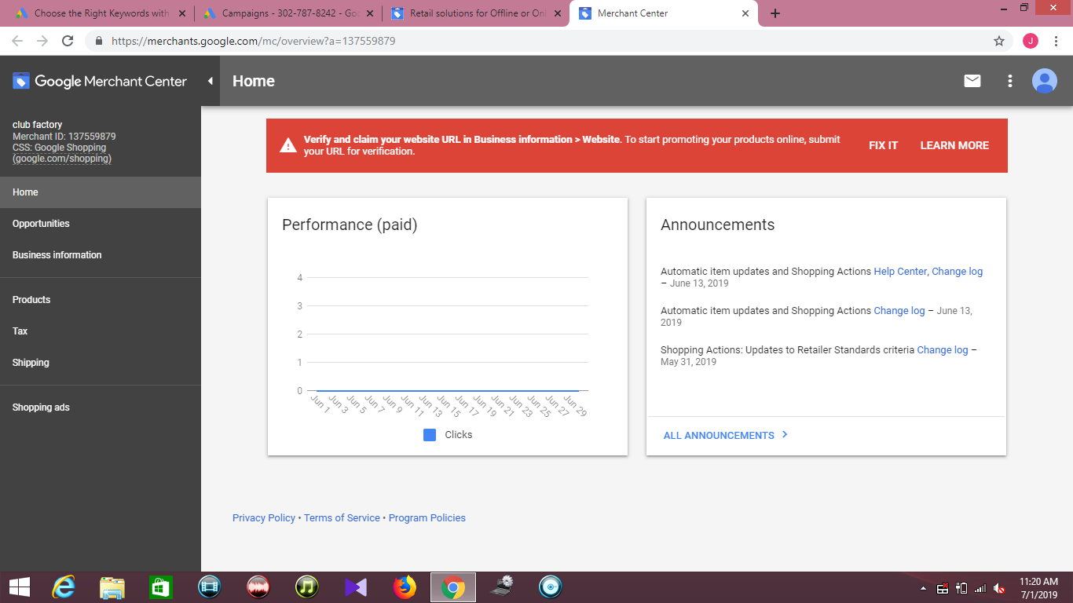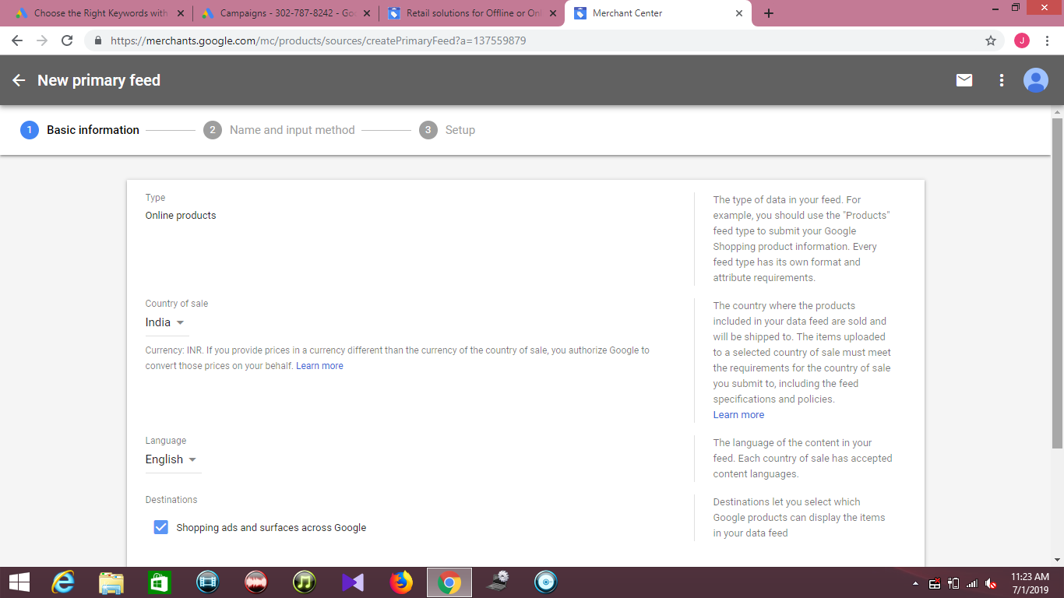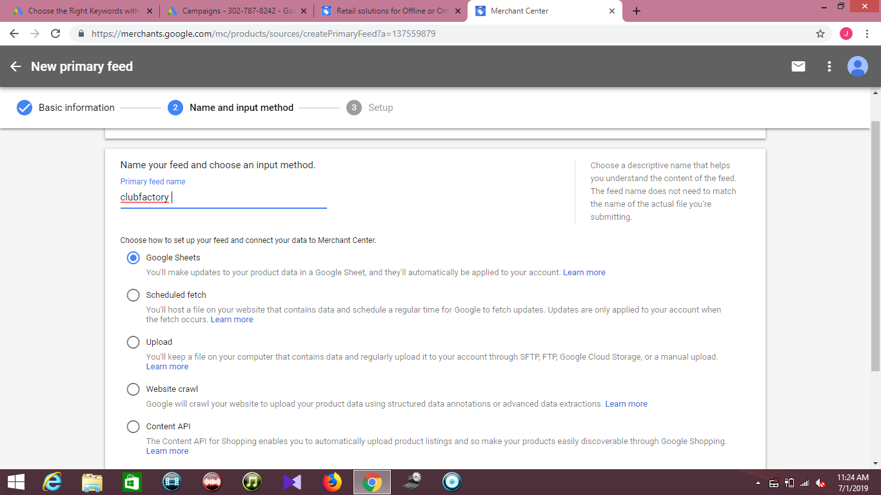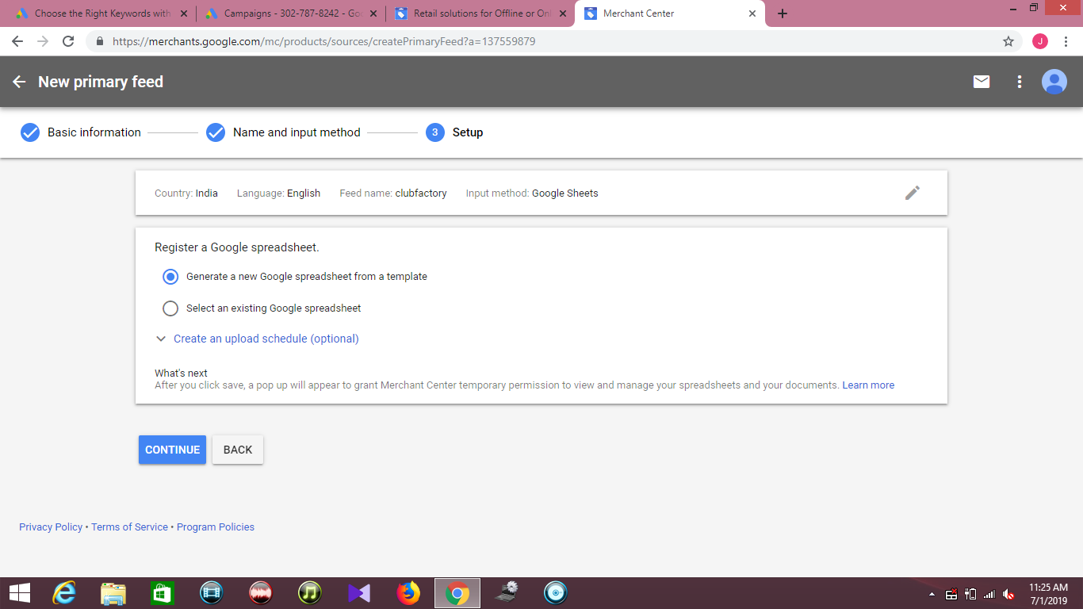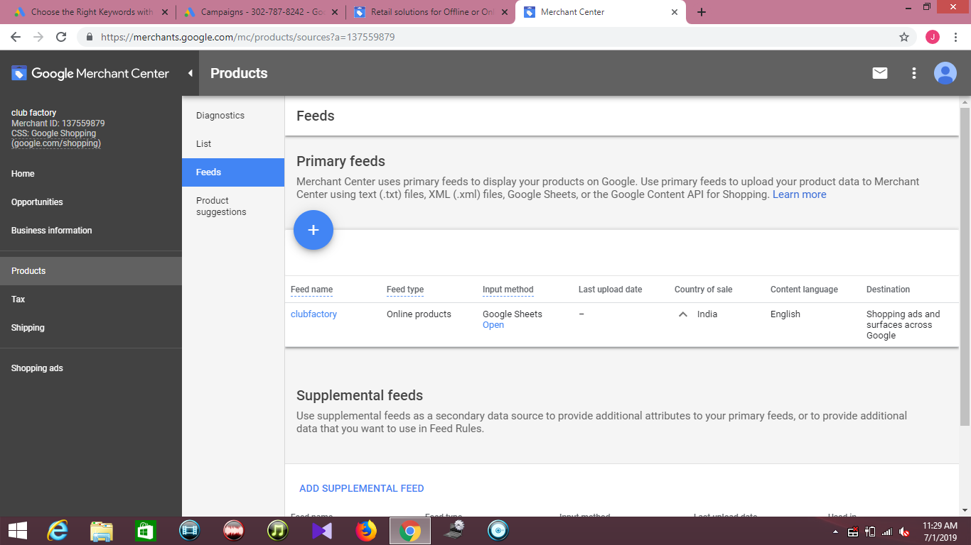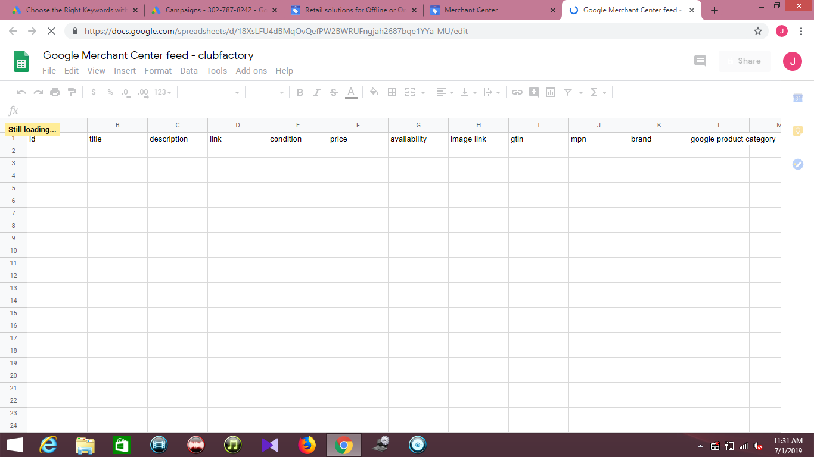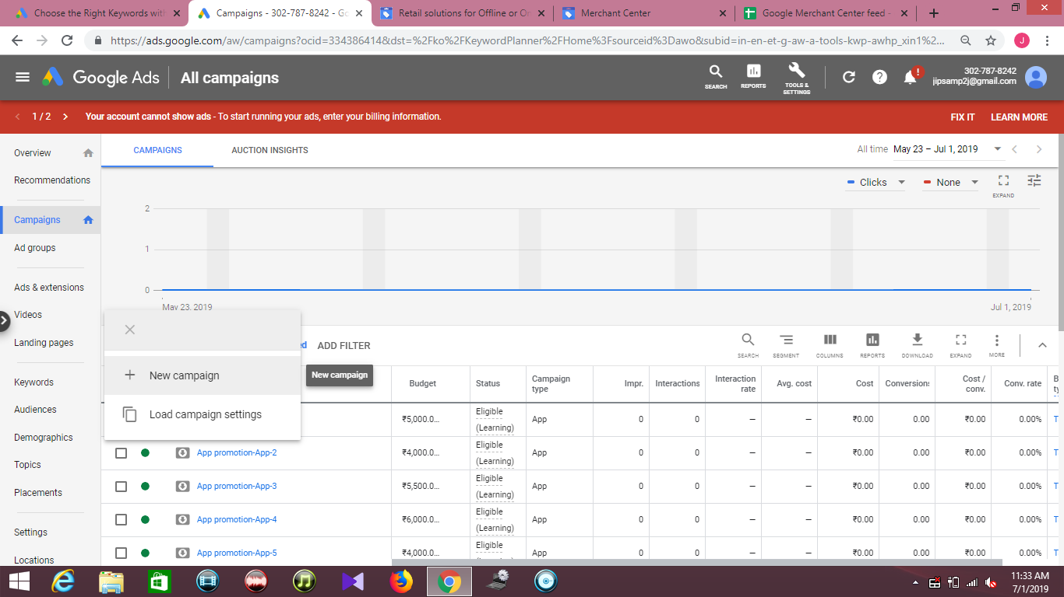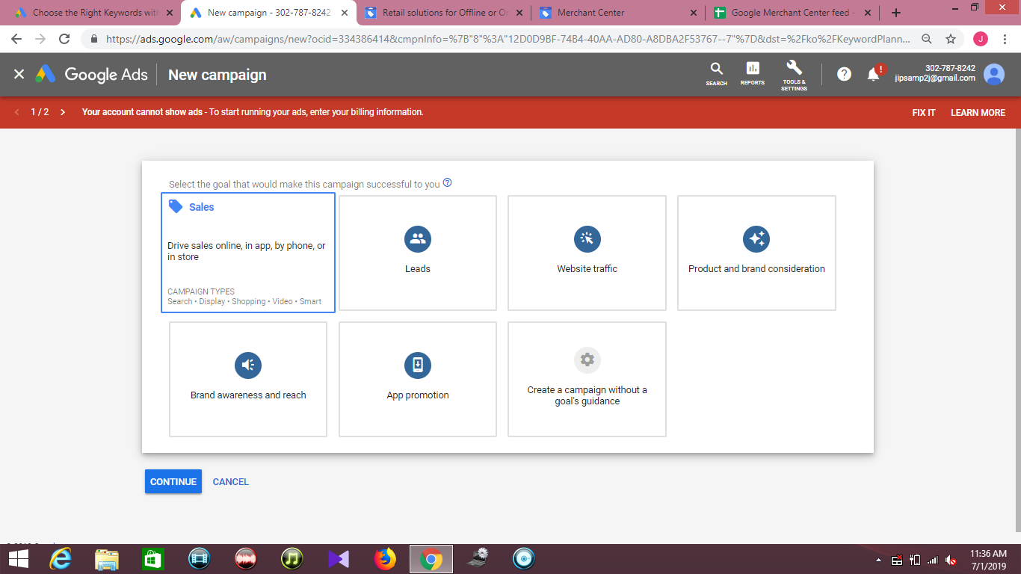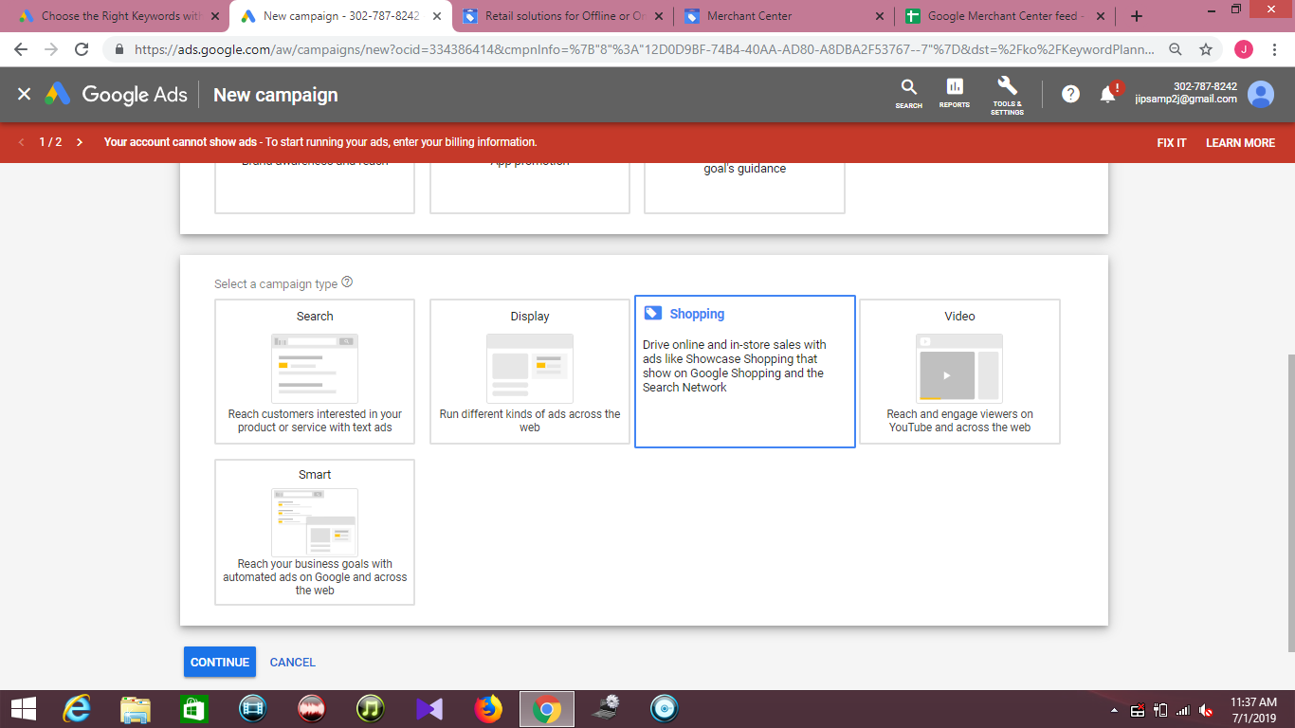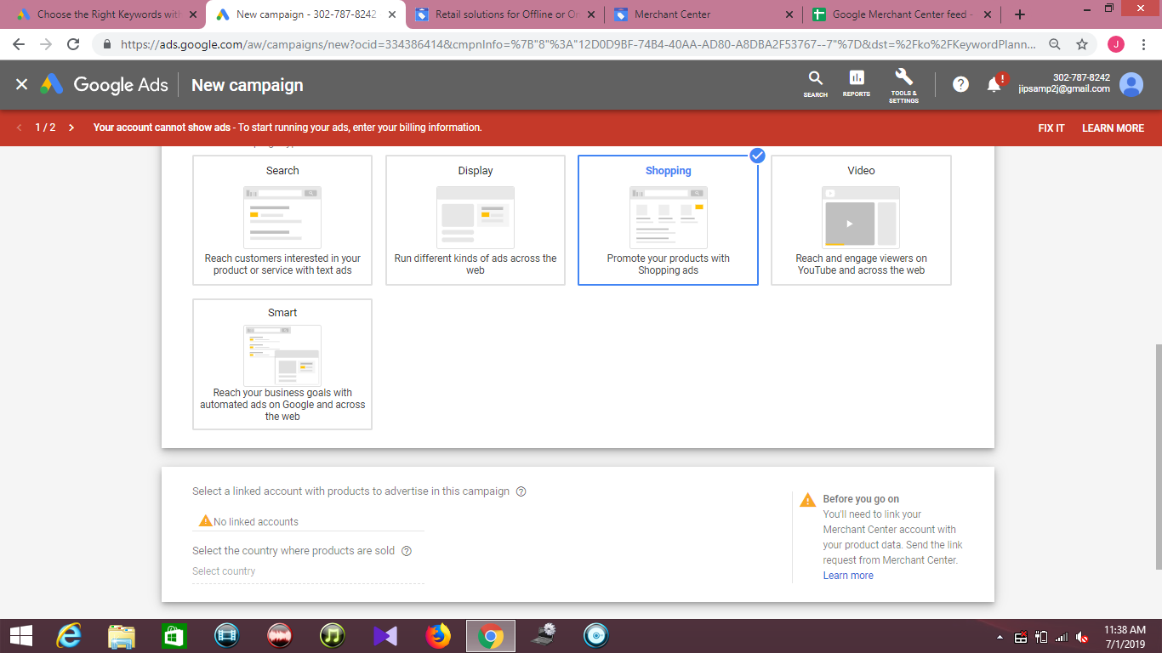

**Automated bidding**

Automated bidding is a Google Ads bid strategy designed to maximize results based on your set campaign goals. With automated bidding, Google automatically sets bid amounts based on the likelihood that your ad will result in a click or conversion. To do this, they analyze data such as a user’s device, operating system, the time of day they are searching, demographics, and location.

All of Google’s automated bid strategies are **portfolio bid strategies** (an automated, goal-driven bid strategy that groups multiple campaigns, ad groups, and keywords). This means that advertisers can apply their chosen strategy across all of their campaigns, ad groups, and keywords. Some are available as **standard strategies** (an ad strategy that can be used in single campaigns).

Automated bidding aims to solve two concerns that advertisers often face their campaigns:

* Whether or not their bids are high enough to compete for qualified buyers.
* Whether or not their bids are too high and possibly showing to people who have no interest in making a purchase.

By automating bids, there’s no need to update bids for keywords or ad groups manually. Bids are set automatically and are unique to each auction (the bid will be different for every auction).

Automated bid strategies analyze past data and learn over time, using performance to inform future bids. This performance is another indication of Google’s movement towards machine learning, which is also used by their Universal App Campaigns.

Finally, automated bids are available for both Search and Display ads depending on the bid strategy you are using.

**What is Smart Bidding?**

Smart Bidding is simply an automated bid category that includes only conversion-based strategies. Smart Bidding uses machine learning to maximize conversion results by tracking and analyzing data signals from every search and click. Using this data, Google will either increase or decrease bids based on whether or not it believes a click will result in a conversion. For example, it will set a higher bid for a searcher who is more likely to make a purchase.

There are currently four Smart Bidding strategies:

1. Enhanced CPC
2. Target CPA
3. Target ROAS
4. Maximize Conversions

**Requirements and recommendations**

To use Smart Bidding, you must have conversion tracking enabled (unless you are using Enhanced CPC with Display campaigns). Additionally, Google recommends that advertisers have at least 30 conversions in the past 30 days before using Target CPA and at least 50 conversions before using Target ROAS.

**The 7 types of automated bidding strategies**

There are seven different automated bid strategies:

**1. Maximize clicks**

**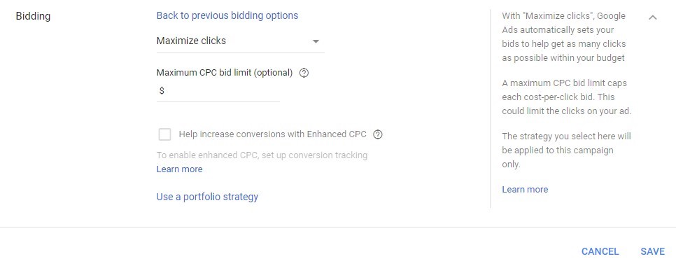**

**Goal:** Increase site visits

**Available In:** Single campaigns or across multiple campaigns, ad groups, and keywords

**Description:** The Maximize Clicks strategy aims to increase the number of visitors to your site. The strategy automatically sets bids to help you maximize clicks within your set budget. The strategy is available as a standard strategy in a single campaign or a portfolio bid strategy across multiple campaigns, ad groups, and keywords.

**Best Used When:** You have a solid conversion funnel and you want to send as many visitors to your website as possible.

**2. Target search page location**

**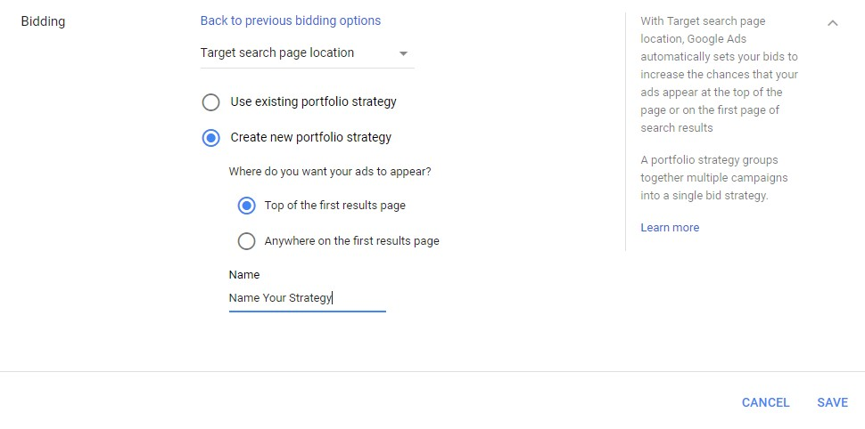**

**Goal:** Increase visibility on the first page of a Google search results page or show in one of the top positions

**Available In:** Campaigns

**Description:** Target Search Page Location automatically sets bids to help increase the chance that your ads appear on the first page of a Google searchor in one of the top ad positions. It is only available as a portfolio bid strategy on the Search Network.

**Best Used When:** You want to rank as one of the top positions in a Google search.

**3. Target outranking share**

**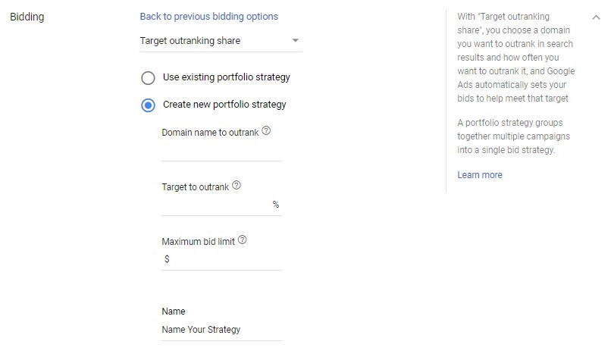**

**Goal:** Increase visibility over other websites

**Available In**: Campaigns

**Description**: With Target Outranking Share, you can choose another advertiser’s domain that you want to outrank in ad position and how often you’d like to outrank it. Google will then automatically set your search bids to help meet that objective. Target Outranking Share is only available as a portfolio bid strategy.

**Best Used When**: You want to outrank a specific competitor in your industry.

**4. Target cost-per-acquisition (CPA)**

**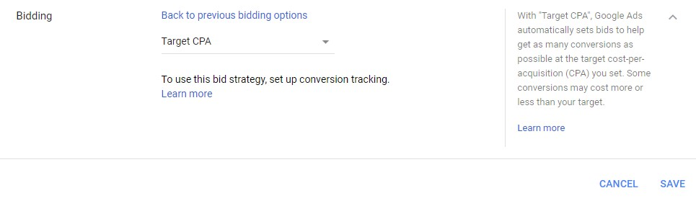**

**Goal:** Get more conversions with your target CPA

**Available In:** Campaigns and ad groups

**Description:** Target CPA allows for more control over your automated bidding. With the strategy, Google automatically sets Search or Display bids to help you receive as many conversions as possible at your set target cost-per-acquisition (CPA). Some conversions may cost more or less than your target. Target CPA bidding is available as a standard strategy in a single campaign or as a portfolio bid strategy across multiple campaigns and ad groups.

**Best Used When:** You’ve established a CPA that you know you can spend to acquire a customer while still maintaining a profit.

**5. Enhanced cost-per-click (ECPC)**

**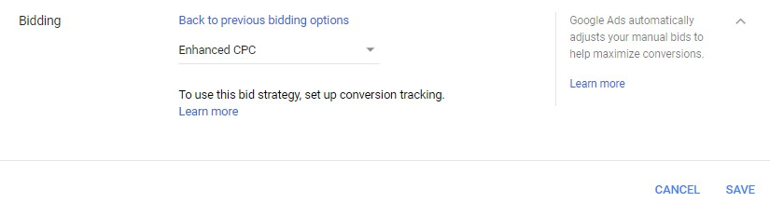**

**Goal:** Increase conversions while staying in control of your keyword bids

**Available In:** Campaigns, ad groups, keywords

**Description**: With ECPC, Google automatically adjusts your manual bids to help you generate more conversions while trying to achieve the same cost-per-conversion. ECPC is available as an optional feature when using Manual CPC bidding or as a portfolio bid strategy.

**Best Used When:** You are using a manual bidding strategy but still want to take advantage of automated bidding.

**6. Target return on ad spend (ROAS)**

**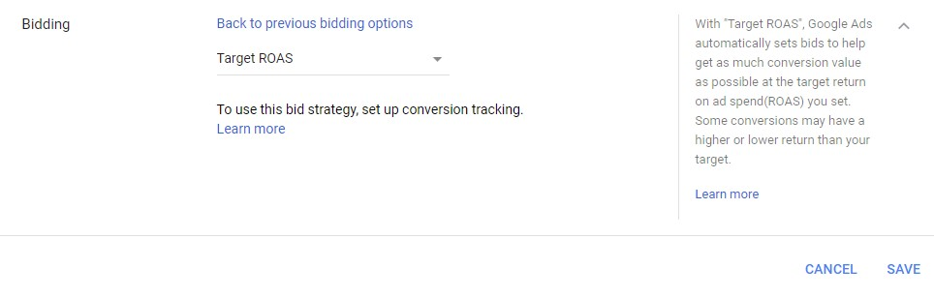**

**Goal:** Meet a target return on ad spend (ROAS) when you value each conversion differently

**Available In:** Campaigns, ad groups, keywords

**Description:** Target ROAS automatically sets your bids to help you receive as much conversion value as possible at your set ROAS (the average value you receive in turn for every dollar you spend on ads). Some conversions may have a higher or lower return than your target. Target ROAS is available as a portfolio bid strategy and a standard strategy for individual campaigns.

**Best Used When:** You want to focus efforts on driving the highest value of conversions versus trying to receive the highest number of conversions.

**7. Maximize conversions**

**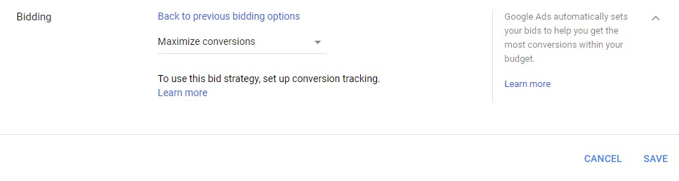**

**Goal:** Receive more conversions while spending your budget

**Available In:** Campaigns

**Description:** This strategy automatically sets bids to help you receive the most conversions for your campaigns while spending your entire budget. With this strategy, Google optimizes for a higher volume of conversions. Maximize Conversions is available as a standard strategy for individual campaigns, but not as a portfolio bid strategy.

**Best Used When:** You have a large budget and want to automate your ads to drive more conversions.

**Types of automated bid strategies**

|  |  |
| --- | --- |
| **Goal** | **Bid strategy** |
| Increase site visits. | Maximize Clicks automatically sets your bids to help get as many clicks as possible within your budget.  Maximize Clicks is available as either a standard strategy in a single campaign or portfolio bid strategy across multiple campaigns.  Learn more about [Maximize Clicks](https://support.google.com/google-ads/answer/6268626).  Learn more about [Maximize Clicks for Shopping campaigns](https://support.google.com/google-ads/answer/6309038). |
| Increase site visits. | Maximize Clicks automatically sets your bids to help get as many clicks as possible within your budget.  Maximize Clicks is available as either a standard strategy in a single campaign or portfolio bid strategy across multiple campaigns.  Learn more about [Maximize Clicks](https://support.google.com/google-ads/answer/6268626).  Learn more about [Maximize Clicks for Shopping campaigns](https://support.google.com/google-ads/answer/6309038). |
| Increase visibility. | Target Impression Share automatically sets bids with the goal of showing your ad on the absolute top of the page, on the top of the page, or anywhere on the page of Google search results.  Target Impression Share is available on the Search Network only, as either a standard strategy in a single campaign or portfolio bid strategy across multiple campaigns.  Learn more about [Target Impression Share](https://support.google.com/google-ads/answer/9121108). |
| Get more conversions with your target CPA. | Target CPA automatically sets Search or Display bids to help get as many conversions as possible at the target cost-per-action (CPA) you set. Some conversions may cost more or less than your target.  Target CPA bidding is available as either a standard strategy in a single campaign or portfolio bid strategy across multiple campaigns and ad groups.  Target CPA bidding was previously referred to as “Conversion Optimizer.”  Learn more about [Target CPA](https://support.google.com/google-ads/answer/6268632). |
| Meet a target return on ad spend (ROAS) when you value each conversion differently. | Target ROAS automatically sets bids to help get as much conversion value as possible at the target return on ad spend (ROAS) you set. Some conversions may have a higher or lower return than your target.  It's available as a portfolio bid strategy and a standard strategy for individual campaigns.  Learn more about [Target ROAS](https://support.google.com/google-ads/answer/6268637).  Learn more about [Target ROAS for Shopping campaigns](https://support.google.com/google-ads/answer/6309035). |
| Get more conversions while spending your budget. | Maximize Conversions automatically sets bids to help you get the most conversions for your campaign while spending your budget.  It's available as a standard strategy for individual campaigns, but not as a portfolio bid strategy.  Learn more about [Maximize Conversions](https://support.google.com/google-ads/answer/7381968). |

**Benefits and disadvantages of automated bidding**

Before you implement any automated bidding strategy, you should weigh the benefits and disadvantages equally:

**Benefits**

Since bids are set automatically, you’ll save time by not having to manually set bid amounts for ad groups or individual keywords.

Automated bidding uses machine learning to evaluate performance over time and optimize for your specific goal. Thus, in theory, you should see more conversions or clicks for your ads based on your set goal.

**Disadvantages**

Since Google will make optimizations on the spot, advertisers should expect drastic changes from time to time (e.g., a much higher bid than expected). Because of this, automated bidding is best suited for companies with a flexible and/or large advertising budget.

Google’s automated bidding requires historical data to optimize for your set goal and predict future bids. Therefore, for companies just getting started using Google Ads, automated bidding might not be the best strategy.

While bidding itself is automated, you still need to monitor your campaigns to evaluate if the bid strategy is meeting your desired goal.

**Manual CPC Bidding**

A bidding method that lets to set your own maximum cost-per-click for(CPC) for your ads. This differs from automated bid strategies, which sets bid amounts for you.

**Keywords Match Types**

**1. Broad Match Type**

Broad match is the default match type and the one that reaches the widest audience. When using broad match, your ad is eligible to appear whenever a user’s search query includes any word in your key phrase, in any order. Forexample, if you use broad match on "luxury car," your ad might be displayed if a user types "luxury cars," "fast cars," or "luxury apartments." Google may also match your ad to queries using synonyms – for example, your ad might display when someone searches for “expensive vehicles,” which doesn’t include any of the terms in your keyword.

Because broad matched ads are set up to reach the widest possible audience, searchers might see and click your ad when querying irrelevant topics, and these costs can add up surprisingly fast. Again, since broad match is the default match type, it’s important to be very careful. Broad match keywords are a great way to drive lots of clicks, but advertisers need to keep a close eye on their search query reports to ensure that they’re not paying for irrelevant traffic that doesn’t convert. For example, look at these Google ads triggered by a search on “piano benches”:

**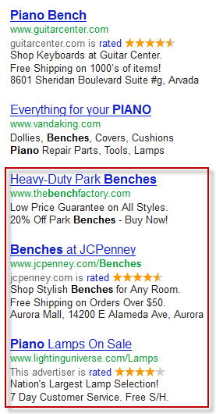**

Two of the ads that displayed are for other kinds of benches, and one is for piano lamps. These don't match the intent of the search query well.

**2. Modified Broad Match**

Modified broad match can be viewed as a sort of middle ground between broad match and the more restrictive match types below. It allows you to reach a similarly wide audience, but better control who sees your ad by“locking” individual words in a key phrase using the “+” parameter. When you add the plus sign in front of a term in your keyword, you’re telling Google that the search query must include that term.

**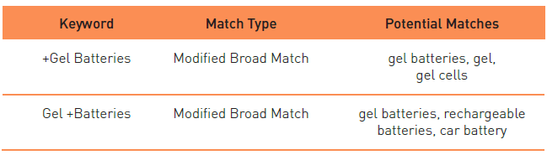**

For instance, let’s say you enabled modified broad match in AdWords for the keyword “gel batteries.” If you append the “+” parameter to the word “gel,” Google can only match your ads to queries that include the word gel. If you append it to the word “batteries,” search queries must include that word before you ad can enter the auction.

**3. Phrase Match Type**

Phrase match offers some of the versatility of broad match, but like modified broad match, introduces a higher level of control. Your ad will only appear when a user queries your key phrase using your keywords in the exact orderyou enter them, but there might be other words either before or after that phrase.

For example, if your key phrase was "pet supplies," your ad could appear when a user searched for "pet supplies," "discount pet supplies," or "pet supplies wholesale," but not for searches like "pet food," "pet bird supplies," or "art supplies." Since the query can contain text before or after your keywords, there is some flexibility, but you are leaving a lot of potential traffic on the table.

**4. Exact Match Type**

Exact match is the most specific and restrictive of the keyword match types. In previous years, with this match type, users would only see your ad when they typed your exact keyword phrase by itself. For example, if your keyword phrase was "black cocktail dress," your ad would only be eligible to show up when a user searched for "black cocktail dress" (those words in that exact order) and not for "cocktail dress," "black dress" or "expensive black cocktail dress."

However, Google has recently made changes to the exact match type so that even when using exact match keywords, your ads might match to searches containing synonyms, plurals, or other variations on your keyword.

**Keyword match type summaries**

|  |  |  |  |  |
| --- | --- | --- | --- | --- |
| **Match type** | **Special symbol** | **Example keyword** | **Ads may show on searches that contain:** | **Example searches** |
| Broad match | none | women's hats | Misspellings, synonyms, related searches, and other relevant variations. | * buy ladies hats * women’s clothing |
| Broad match modifier | +keyword | +women’s +hats | All the terms designated with a + sign (or close variations of those terms) in any order. Additional words may appear before, after, or between the terms. | * women’s scarves and hats * winter hats for women |
| Phrase match | “keyword” | “women’s hats” | Matches of the phrase (or close variations of the phrase) with additional words before or after. | * blue women’s hats * buy women’s hats * women’s hats on sale |
| Exact match | [keyword] | [women’s hats] | Exact matches of the term or close variations of that exact term with the same meaning. | * women’s hats * ladies hats * hats for women * hats women |

**Assignment – 22 DATE: 30/7/19**

**Assignment Name: GOOGLE UPDATES**

**Faculty- NIKAHATH**

**Q1. -**

**A1.**

1. **GOOGLE CAFFEINE UPDATE**

First announced back in August 2009, Caffeine is the new web indexing infrastructure that was designed to deliver faster and fresher results and enable Google to crawl and index more web pages. First Google [opened a developer's preview](http://googlewebmastercentral.blogspot.com/2009/08/help-test-some-next-generation.html) of the new index to collect feedback from the webmasters and power-users. After some testing Caffeine was rolled out on one data-center. Now it is the standard infrastructure across all Google's search properties. Before Caffeine Google used to update its index in portions. The G-bot would crawl a set of web pages (about 10% of the web every night) and index them extracting the content and additional information about it such as anchor texts of incoming backlinks and other references and determine what topics the page is relevant to. The processed pages were then queued to be added to the index. They would wait till the whole portion is complete before they were made available in the search results. With Caffeine Google is now able to crawl and process each web page separately streamlining it into the live index within seconds after it's been discovered.

1. **GOOGLE PANDA**

Google’s Panda Update is a search filter [introduced in February 2011](http://searchengineland.com/google-forecloses-on-content-farms-with-farmer-algorithm-update-66071) meant to stop sites with poor quality content from working their way into Google’s top search results. Panda is updated from time-to-time. When this happens, sites previously hit may escape, if they’ve made the right changes. Panda may also catch sites that escaped before. A refresh also means “false positives” might get released.

1. **GOOGLE PENGUINE** Google launched [the Penguin Update](http://searchengineland.com/library/google/google-penguin-update) in April 2012 to better catch sites deemed to be spamming its search results, in particular those doing so by buying links or obtaining them through link networks designed primarily to boost Google rankings. When a new Penguin Update is released, sites that have taken action to remove bad links (such as through the [Google disavow links tool](http://searchengineland.com/library/google/google-link-disavow) or to remove spam may regain rankings. New sites not previously caught might get trapped by Penguin. “False positives,” sites that were caught by mistake, may escape.

**4 . GOOGLE HUMMING BIRD**

Features. The "**Hummingbird**" **update** was the first major **update** to Google's search **algorithm** since the 2010 "Caffeine" search architecture upgrade, but even that was limited primarily to improving the indexing of information rather than sorting through information. **Hummingbird** is the codename given to a significant [algorithm](https://en.wikipedia.org/wiki/Algorithm) change in [Google Search](https://en.wikipedia.org/wiki/Google_Search) in 2013. Its name was derived from the speed and accuracy of the [hummingbird](https://en.wikipedia.org/wiki/Hummingbird). The change was announced on September 26, 2013, having already been in use for a month. "Hummingbird" places greater emphasis on [natural language](https://en.wikipedia.org/wiki/Natural_language) queries, considering context and meaning over individual keywords. It also looks deeper at content on individual pages of a website, with improved ability to lead users directly to the most appropriate page rather than just a website's homepage.

The upgrade marked the most significant change to Google search in years, with more "human" search interactions and a much heavier focus on conversation and meaning. Thus, web developers and writers were encouraged to [optimize their sites](https://en.wikipedia.org/wiki/Search_engine_optimization) with natural writing rather than forced keywords, and make effective use of technical web development for on-site navigation.

**5, GOOGLE EXACT MATCH DOMAIN**

On Thursday, **Google** announced another change to what are considered close variants of an **exact match** keyword to include variations that share the same meaning as the keyword, including implied words and paraphrases. The **exact** words are no longer the sole trigger for your ads to show on **exact match** keywords

Google’s exact match keyword targeting used to mean one thing: the keyword had to match exactly whatever query the searcher used. Then close variants came into the mix, and that definition has steadily morphed over the past few years. First, the inclusion of [plurals, misspellings](https://searchengineland.com/farewell-pure-exact-match-google-will-soon-force-campaigns-close-variants-enabled-200615) and other similar variants came in 2014, and then, in 2017, [different word order and function words](https://searchengineland.com/google-exact-match-close-variants-word-order-function-words-271395) took hold.

1. **GOOGLE PIGEON UPDATE**

**Google Pigeon** is the code name given to one of **Google**'s local search algorithm **updates**. This **update** was released on July 24, 2014. The **update** is aimed to increase the ranking of local listing in a search. The changes will also affect the search results shown in **Google** Maps along with the regular **Google** search results.

**Google Pigeon** is  given to one of [Google](https://en.m.wikipedia.org/wiki/Google)'s local [search algorithm](https://en.m.wikipedia.org/wiki/Search_algorithm) updates. This update was released on July 24, 2014.[[2]](https://en.m.wikipedia.org/wiki/Google_Pigeon#cite_note-2)The update is aimed to increase the ranking of local listing in a search.

The changes will also affect the search results shown in [Google Maps](https://en.m.wikipedia.org/wiki/Google_Maps) along with the regular Google search results. As of the initial release date, it was released in US English and was intended to shortly be released in other languages and locations. This update provides the results based on the user location and the listing available in the local directory.

1. **RANK BRAIN**

**Rank Brain** is a [machine learning](https://en.wikipedia.org/wiki/Machine_learning)-based [search engine](https://en.wikipedia.org/wiki/Web_search_engine) algorithm, the use of which was confirmed by [Google](https://en.wikipedia.org/wiki/Google) on 26 October 2015. [[1]](https://en.wikipedia.org/wiki/RankBrain#cite_note-1) It helps Google to process search results and provide more relevant search results for users.[[2]](https://en.wikipedia.org/wiki/RankBrain#cite_note-Bloomberg-2) In a 2015 interview, Google commented that Rank Brain was the third most important factor in the ranking algorithm along with links and content.[[2]](https://en.wikipedia.org/wiki/RankBrain#cite_note-Bloomberg-2) As of 2015, "Rank Brain was used for less than 15% of queries." [[3]](https://en.wikipedia.org/wiki/RankBrain#cite_note-Search_Engine_Land-3) The results show that Rank Brain produces results that are well within 10% of the Google search engine engineer team.[[4]](https://en.wikipedia.org/wiki/RankBrain#cite_note-4)

If Rank Brain sees a word or phrase it isn’t familiar with, the machine can make a guess as to what words or phrases might have a similar meaning and filter the result accordingly, making it more effective at handling never-before-seen search queries or keywords.[[5]](https://en.wikipedia.org/wiki/RankBrain#cite_note-5) [Search queries](https://en.wikipedia.org/wiki/Web_search_query) are sorted into word vectors, also known as “distributed representations,” which are close to each other in terms of linguistic similarity. Rank Brain attempts to map this query into words (entities) or clusters of words that have the best chance of matching it. Therefore, Rank Brain attempts to guess what people mean and records the results, which adapts the results to provide better user satisfaction.[[6]](https://en.wikipedia.org/wiki/RankBrain#cite_note-6)

1. .**GOOGLE MOBILE FRIENDLY UPDATE**

The term was then adopted by webmasters and web-developers to **Google**'s algorithm **update** of April 21, 2015. ... **Google** claims the transition to **mobile**-**friendly** sites was to improve user-experience, stating "the desktop version of a site might be difficult to view and use on a **mobile** device."

1. . **GOOGLE POSSUM**

“**Possum**” is the name given to an unconfirmed but documented update which appeared to most significantly impact **Google's** local pack and local finder results. ... Many have perceived **Possum's** purpose to be a diversification of local results.

10. **GOOGLE FRED**

**Google Fred** was a series of mysterious **Google** Search **updates** that occurred in March 2017. The name was given to these **updates** jokingly by Gary Illyes, webmaster trends analyst at **Google**. Illyes wrote that from now on every **Google**Search **update** will be called **Fred** unless stated otherwise.

**11. BROADCORE**

Google has previously shared this advice around **broad core algorithm updates**: “Each day, Google usually releases one or more changes designed to improve our results. Some are focused around specific improvements. ... Last week, we released a **broad core algorithm update**

**12. DIVERSITY**

**Google**: **Pirate Update**. **Google's Pirate Update** is a filter introduced in August 2012 designed to prevent sites with many copyright infringement reports, as filed through**Google's** DMCA system, from ranking well in **Google's** listings. The filter is periodically **updated**.

**13 GOOGLE DANCE**

In search engine optimization ([SEO](https://www.webopedia.com/TERM/S/SEO.html)), Google Dance is an out-dated slang term used to describe the period of time in which Google used to rebuild its rankings, and as a result of this rebuilding, rankings of Web sites on Google's SERP may fluctuate in order during a several day period. The "Google Dance" would happen anywhere up to 36 times per year, however in 2003 Google begun updating its index on a weekly basis, which all but eliminated the Google Dance.